Case Study of the Language Development of an ESOL Student
Andreany Arce
Mekayla Cook
Carolyn Romero
University of South Florida

Abstract
This case study examines the linguistic development of a kindergarten English language learner in the contexts of his school and home life. The learner and his corresponding situation is examined in 5 phases throughout the study with consideration for his linguistic development. The societal linguistic development is examined in an introduction to the ESOL student. The student’s linguistic background, history and development is analyzed. Language data is provided in the form of transcriptions, recordings and an analysis of the student’s syntactical abilities, morphology knowledge, phonological awareness, semantics and pragmatics is included. A problem scenario involving the student is addressed from the perspectives of various stakeholders involved in the student’s academic and social development. A proposed solution to the scenario is included. Areas of student improvement are considered throughout the case study. Finally, questions are provided based upon Bloom’s taxonomy, as well as reflective questions.

Case Study of the Language Development of an ESOL Student

Phase 1
Student introduction. For the purposes of this investigation, we have studied the personal life and academic achievement of a young English as a second language learner. The male kindergarten student was born June 25th, 2011 and is currently 5 years old. Jose* was born in Mexico and is of Spanish descent, much like the majority of the population in his country of birth. The student and his family identify with Mexican culture and heritage. Jose is currently in the speech emergence phase of linguistic acquisition. Jose has adequate comprehension and produces simple sentences, but makes frequent grammar and pronunciation mistakes. The student is full of personality, always smiling and optimistic. Jose likes to move around a lot, is highly energetic and prefers hands-on learning. Jose enjoys playing Mario Cart, Transformers, reading about Pete the Cat, hot dogs and Art class. Jose is smaller than most of his peers, but prefers to work with friends or in a group. Jose has many friends in the classroom and expands his socialization to include students in the other kindergarten classes. Often, his hyper disposition and social preferences leads him off task. Although Jose struggles academically and behaviorally, he is always excited to learn. He scored in the middle letter name-alphabetic stage of the Primary Spelling Inventory and receives tier 3 intervention, including working with a tutor twice a week. He is only reading at a level one, but making progress toward level two.
Jose immigrated to the United States at two years ago, at the age of three, as his family pursued access to a better lifestyle. Jose lives with his mother, Elizabeth*, and father, Jose Sr.*. Jose’s mother speaks minimal English, but is able to maintain casual conversation. She is in her mid-thirties, soft-spoken and kind. Jose Sr. is in his late forties and has acquired English as a second language with few grammar and pronunciation mistakes. Jose’s father works for a construction company, but his mother is present at home. Jose lives with two older sisters, Rosalba* and Adelina*. Rosalba is a junior in high school and Adelina is a seventh grader at the local middle school. At home, the family primarily speaks Spanish. However, casual conversation tends to be held in a hybrid combination of Spanish and English words and expressions, referred to as Spanglish. Jose’s parents and older sisters are supportive of his education and view achievement as a priority to advance Jose’s life. Jose’s parents attend conferences, or hold phone conferences, in which his Father is the primary voice for the family. At home, Rosalba and Adelina help Jose complete his weekly homework. Jose receives free lunch at the Title I school, implying that his family’s income meets the requirements for assistance.
After an investigation of Jose’s Elementary school’s community, it is evident that the area is still developing. The area is a small town, made up of numerous subdivisions with highway and interstate access. The area includes many neighborhoods, schools and churches, making it a welcoming place for families and a suburban area outside of a main city. There is no results for “Things To Do” on the area’s website for sports or recreation. In our investigation we saw many live oak trees, strawberry farms and lakes. Also, we were surprised to see new upscale communities dotting the mostly rural landscape. According to the Community Profile (2014) 88% of the population have attained a high school degree or higher, implying much of the population values education, but there is a lack of dedication in the community. 96.8% of 5-9 year olds are enrolled in school, 94.5% of 10 to 14 year olds are also enrolled in school. However, only 44.5% of 3 and 4 year olds are enrolled. This lack of preschool education could be setting students at a disadvantage when they begin Elementary school. The U.S. Census (2010) notes that 15.5% of the total population are individuals below the poverty level. 54.1% of those in the labor force are below the poverty level as of 2014. 20.1% of the population speaks a language other than English at home and 22.7% of those speak Spanish at home and speak English “less than very well.”
(*= Pseudonym, used throughout the study)

Phase 2
Linguistic background. In Mexico, the school system is divided in the following levels: Preschool, Elementary, Junior High, High School/Jr. College, and Universities. Also, in Mexico, their third year of preschool is equivalent to the United State’s kindergarten. Jose would be considered a preschool student if he had stayed in Mexico. Preschool in Mexico starts at age three and typically lasts for three years. Additionally, the elementary schools in Mexico, or better known as “la primaria”, goes from first through sixth grade. Prior to Jose attending elementary school Jose did not have any type of formal schooling. However, it is evident that Jose is fluent in speaking Spanish and his parents are very involved in his education. Jose’s classroom teacher is aware that Jose has more Spanish books at home than he does English. Thus, is the reason she lets Jose go to the school library whenever the opportunity rises in order for him to select English books. Jose loves going to the library and especially picking out books about Pete the Cat.
Prior to coming to the United States, Jose did not know or understand English due to his young age and lack of schooling. In Mexico if a parent wishes for their child to learn English they attend private schools instead of public schools. Furthermore, since Jose came to the United States at the age of three, he primarily socialized with his mom and siblings at home or other young relatives (first or second cousins) who would come visit his house occasionally. Hence, that is indicative of the reason Jose loves socializing with his peers at school.
Linguistic development history. Jose’s native language is Spanish and it is spoken mostly at home. Whereas, Jose is learning English at school for the past school year. During the oral reading performed for Jose’s miscue analysis, the student exhibited a few visual miscues. From Jose’s sight word memorization, he mistakenly said “purple” instead of “pink”, but quickly self-corrected. The student utilized his reading strategy of considering the illustration, which caused a visual miscue for the word “bubbles”, substituted by “kids”. Jose had one insertion, a syntactic miscue in the context. From this assessment, it was determined the learner was able to read this text independently with significant accuracy. Jose self-corrected at least one miscue, but neglected to self-correct all. However, the learner is able to utilize illustrations and recognize sentence patterns most of the time. The student has a strong printed language conceptual understanding, as well as comprehension. Jose was able to answer simple questions about the text. From the data provided by the running record and the miscues analyzed, it can be inferred that Jose was able to read a level 2 text independently with high comprehension.
Linguistic development. Since Jose is attending school he is currently in the ESOL program. The ESOL specialist comes into the classroom to work one on one with Jose. The ESOL specialist practices sight words and reading fluency when working with Jose. The specialist has observed that Jose has adequate comprehension and can produce simple sentences. However, Jose makes frequent grammar and punctuation mistakes. When Jose is reading, the specialist has observed that he pauses a lot and attempts to sound out words. Jose’s running record results show that Jose struggles with the syntax of words more than morphemes or phonology. This is due to the fact that Jose confuses words that sound similar. Jose seems to also struggle with reading in math since it involves pronouncing numbers which he has a hard time with. The one on one time with the ESOL specialist is producing satisfactory results since Jose has recently moved up from a level 1 sight word bank to a level 2. Thus, proving that Jose is expanding his vocabulary and becoming familiarized with new terms. Jose’s native Spanish language knowledge affects him when he is writing. For instance, often times Jose confuses the words him for his or her for she in his language arts assignments. Jose’s writing consists of big handwriting and often lacks space between words. Since Jose is in Kindergarten his penmanship skills will improve. Also, Jose’s writing skills in math is decent since he is acquainted with number words.
According to BICS (basic interpersonal communication skills) analysis, Jose is socializing with his peers at specials (art, music), at the park and when at lunch. With consideration for the CALPS (Cognitive Academic Language Proficiency), Jose socializes with his peers when working on group assignments and utilizing academic vocabulary. When Jose does not understand what his peers are saying, he reads their mannerisms and facial expressions to attempt comprehension of their intended communication.

Phase 3
Speaking transcript. Instructor: What did you do this weekend?
Student: I did, I did this weekend… I was, I was, I, on this week-
Instructor: Or last weekend? Or this weekend? What’re you doing lately?
Student: We was, we was building these hats on Dr Seuss’ birthday.
Instructor: Oh that’s awesome!
Student: You didn’t, you didn’t, you didn’t got here for Dr Seuss birthday
Instructor: I know, I didn’t get to be here for Dr Seuss’ birthday, but I’ve celebrated his birthday before and it was a lot of fun. What did you do?
Student: We made hats
Instructor: Oooooh hats?
Student: We made hats and we was doing important stuff on Dr Seuss’ birthday
Instructor: Ohh did you read books?
Student: Yeah! Of Dr Seuss!
Instructor: Ohh, Dr Seuss books! What’s your favorite?
Student: I, I like the, the shoe one
Instructor: The shoe one? [Wacky Wednesday]
Reading transcript. Instructor: Go ahead
Student: My, brother
Instructor: Okay
Student: Mine brother. We, we can build
Instructor: Ned
Student: Ned, can build with me.
Instructor: A house. [Student name], you know how to read this. Go back and read this page
Student: Ned can bake a cake. Ned can bake, Ned can paint a picture.
Instructor: What does this say?
Student: We
Instructor: With
Student: With. We
Instructor: No
Student: Me. Ned can read a book with me. The end.
Instructor: Nice! Will you read me another one? Pick any one you want. Alright go ahead, what’s it called?
Student: My family.
Instructor: Family fun
Student: Family fun. Dad said we can climb. Dad said we can swim. Dad said we can fish dad said we can eat. Dad said, dad said we can basketball.
Instructor: What does that, does that look like that word?
Student: No
Instructor: What’s it start with? Stretch it out.
Student: p-p
Instructor: play
Student: play and have a good time.
Instructor: Nice job! Alright go ahead.
Student: My…
Instructor: What’s the first word? Packing
Student: Packing my bag. Packing my bag! Packing. I pack my sandwich into my bag.
Instructor: That says I put my sandwich into my bag.
Student: Okay. I put my drink into my bag. I put my, my hat into my bag. I put my book into my bag. I put my picture into my bag I put my spider into my bag. My…
Instructor: Look. [points to illustration]
Student: For my teacher! That was scary!
[Recordings of the transcriptions have been attached to this file’s submission]
Writing sample. Student response to Sheila Rae, The Brave.
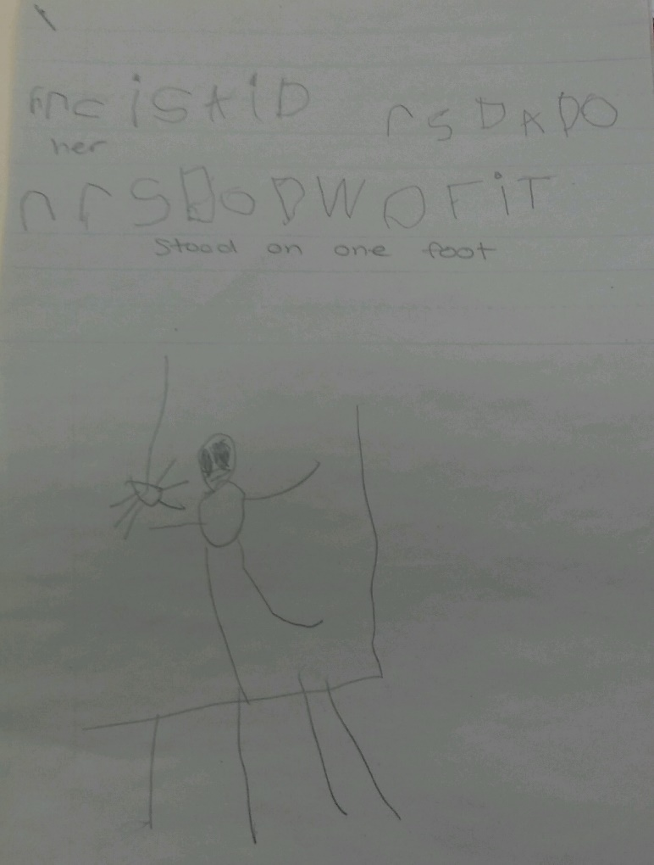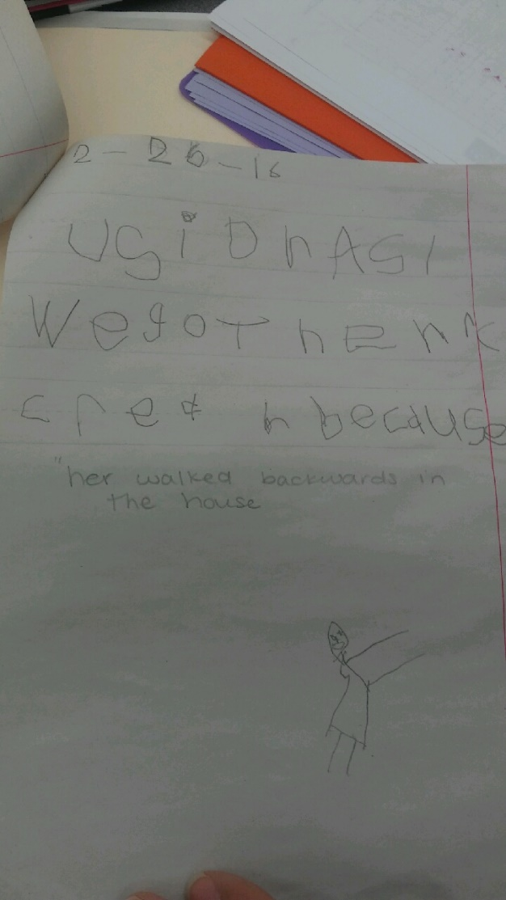
Analysis. The data provided supports that Jose is in the speech emergence phase of second language acquisition. The student has a vocabulary of about 3,000 words and can communicate effectively though phrases. Conversations with the student demonstrate that he is able to produce simple sentences. Jose frequently repeats himself and mimics what the instructor said in his response. For example, in casual conversation the instructor asks, “What did you do this weekend?” Jose’s response was hesitant, “I did, I did this weekend… I was, I was, I, on this week-“ It can be inferred that Jose lacks confidence in his speech, but is willing to participate in and initiate conversation. Jose makes errors in tense, evident in his phrase, “We made hats and we was doing important stuff.” Jose’s sentences lack variety. He often answers in short phrases. Occasionally, the student will speak in syntactically-errored run-on sentences as his excitement grows. Jose frequently places the noun before the adjective in speech, which is common of Spanish speaking natives.
While reading, Jose is able to infer meaning through illustrations. English language learners in the speech emergence phase understand stories that are supported by pictures. While reading, the instructor reminded Jose to refer to the illustration when he encountered an unfamiliar word. The student appealed for help after pausing at “My…” in the text. The instructor pointed to the illustration and reminded the student to look. Jose was able to complete the reading with enthusiasm, “For my teacher!” As a kindergarten student, some errors in pronunciation are understandable. However, according to Jose’s results on the Yopp-Singer Phoneme Awareness test and the county-provided Kindergarten Reading tests, Jose struggles greatly with phonemic awareness. Jose’s inability to identify phonemes and morphemes in words lead to his poor performance with rhyming. Jose’s practice with morphology is also limited by his underdeveloped second language acquisition. Recognizing word parts in order to break words apart or “chunk” when young learners encounter unfamiliar words is especially difficult for English language learners. These students do not have the necessary background knowledge to recognize prefixes or suffixes, or determine their meaning. Through explicit instruction of suffixes and meaning, Jose will acquire the skills necessary to determine the morphology of words and combine the meaning of word parts. Semantics involves Jose’s vocabulary knowledge. The student demonstrates comprehension, but struggles to determine the meaning of unfamiliar words. Additionally, extensive reading, pre-teaching vocabulary and building background knowledge through front loading will ensure Jose makes appropriate gains in determining word meanings. Mastery of morphological knowledge will be evident when the student can flexibly use words in different parts of speech.
Syntactical knowledge addresses sentence structure and the appropriate placement of words within a sentence. Speech emergence language learners make short sentences and begin writing. Jose’s writing sample is evident of his construction of short phrases. Though grammatically incorrect, his response indicates that Jose understood the character development of Sheila Rae in the story. Due to the complexity of English’s grammar and structures, the kindergartner is still mastering writing. Also, Jose’s native Spanish language knowledge interferes while he is writing. Language minority students frequently make the mistake Jose did in his response when he utilized the pronoun “her” instead of “she.” Providing sentence starters for Jose will improve his syntactical knowledge while writing, as well as speaking.

Phase 4
The problem. Jose has lots of energy and often encounters dilemmas while paying attention in class or staying on task. Jose also enjoys working in groups with his peers and loves activities that are hands on or involve kinesthetic learning. However, not every assignment is designed or meant to work with group members. After the classroom teacher finished teaching a math lesson on 3D geometric shapes, she handed out worksheets that all her students had to complete. Jose did not pay any attention to his worksheet for more than five minutes before he began looking around the classroom, distracted by the sights and sounds. While, the teacher was walking around she caught Jose’s wanderings eyes and attempted to redirect the student’s attention. Again, Jose paid little attention to his worksheet and began trying to strike a conversation with Dylan*, the student seated next to Jose. His elbow neighbor, a male student who frequently converses with Jose, engaged in conversation with Jose but then told him to finish his work or the teacher was going to get upset. Jose looked blankly at his page and exhibited a distinct lack of interest. Five minutes passed and when the teacher went around the classroom collecting everybody’s worksheet, she noticed that Jose’s was incomplete and hardly written on. The student showed little attempt to complete his assignment.
Stakeholder opinions. When Jose’s classroom teacher contacted Jose’s father about the incomplete worksheet she was very worried and asked what she could do to prevent this from happening again. Jose’s father and mother inquired for resources they could use to help Jose with his studies and homework. Jose’s father said he was going to have a serious talk with Jose at home.
The school principal’s opinion differed from the student’s parents. Mrs. Catalina* believes that Jose has behavioral issues and must be placed in the front of the classroom or next to the teacher's desk to prevent this from happening again. By minimizing potential distraction factors, like peers, the principal implies that Jose will be forced to remain on task.
The school counselor, Mr. Banks*, thinks that it will benefit Jose to see him once a week in case he might want to express himself about his worries or concern about school. The counselor believes this interaction will encourage Jose to aspire for academic achievement. Additionally, Mr. Banks proposes that Jose shows a lack of interest in school because of his own low aspirations. Meetings with the counselor will guide Jose to finding the intrinsic motivation to succeed and reach his goals.
The classroom teacher, Mrs. Thurston, believes that Jose should present self-motivation and take responsibility for his learning. The teacher plans to instill this intrinsic drive with the student by setting goals together. Mrs. Thurston also thinks if Jose does not improve his behavior it will affect his academics greatly. Distraction from coursework as a result of a lack of paying attention will negatively impact the student’s performance throughout his school years.
Lastly, the ESOL resource teacher strongly believes that Jose does not fully understand the instructions that are given orally for assignments, like the worksheet. The fact that Jose could not communicate with his peers about the assignment frustrated him and caused him to shut down. The school’s ESOL professional, Mr. Lopez*, has suggested that Mrs. Thurston make instructions implicitly clear and ensure the comprehension of directions for each student. Introducing an aide to the classroom during assessment or independent work to provide Jose with individual instruction will further Jose’s chances for success.
The child’s perspective. The following is a direct quote from an interview between the ESOL resource teacher and Jose. “I, I was confused with the worksheet and with the directions Mrs. Thurston told me. Some of the words the teacher used confused me and sounded the same. I wanted to ask Dylan what we were supposed to do but he said we were going to get in trouble if we talked. I didn’t know what to do and that's why I didn't get to do the paper. Also, the 3D shapes look similar to the 2D shapes, I wish I saw what it was.” Clearly, Jose desires to improve his performance, but is frustrated from his lack of understanding and the absence of individualized support provided by the teacher.

Phase 5
Problem scenario solutions. According to the scenario presented, a solution that could potentially have the most significant impact would be to provide explicit, comprehensible instruction for Jose in class. Offering a more individualized instructional approach for explaining directions will ensure that Jose is able to provide his best effort while completing his assignments. The ESOL teacher believes that Jose has difficulty understanding the work he is given. With consideration for Jose’s position on the issue, he supports the ESOL specialist’s theory that he was “confused with the worksheet.” After his teacher delivers directions to the class, she should go to Jose and offer him one-on-one instruction to make sure he understood the directions given and the next steps for improvement. Further individualized assistance could be provided with the addition of an ESOL professional to act as an aide during instruction, independent work time and assessments. If Mrs. Thurston still finds a continuing problem with him talking with his classmate, then she should take into consideration what the principal, Mrs. Catalina, recommended. Repositioning Jose to be closer to Mrs. Thurston’s desk, or separate him from his classmates could minimize the distractions he is exposed to.

Reflective questions. 1. Discuss your opinion of who should have the most impact on determining what best fits the academic and social developmental needs of an ESOL student. Additionally, consider who could have the most influential authority and power to ensure these adjustments would be initiated.
2. How does Jose’s, or other high-energy, frequently active students’, personalities affect their school work? How could educators modify instructional strategies to meet the needs of energetic and kinesthetic learners?
3. Reflect upon the influence of Jose’s upbringing and cultural background in his linguistic development. Provide strategies that would reinforce Jose’s linguistic development with consideration for his culture and home background.
Bloom’s taxonomy questions. Knowledge Recall, compare and contrast the suggestions made by the principal, parents and classroom teacher when they were asked to consider the problem presented by Jose’s behavior.
Synthesis Modify Jose’s current educational situation with appropriate accommodations to support his linguistic development.

Evaluation What judgment could you make about Mrs. Thurston based on the case study? What would you change based upon the teacher’s involvement, parental involvement and ESOL specialist’s involvement presented in the case study?
Comprehension Which statements (relevant to Jose’s linguistic development and attitude toward learning) support that the one-on-one time with the ESOL specialist is producing good results?
Analysis What inference can you make about Jose’s support system at home? What constitutes positive or negative at-home support systems and how could Jose’s family be directed toward assisting the student’s linguistic development?
Application What questions would you ask in an interview with Mr. Banks, the school counselor, in regard to Jose’s academic, personal (attitudes toward school) and linguistic development after meeting with the professional? What would result if the counselor was not working with Jose’s classroom teacher and the ESOL specialist?
Do you agree or disagree with the actions proposed in this case study? What would you recommend to benefit Jose’s linguistic development in the classroom and at home and how could you prove the effectiveness of these accommodations?

