Intermediate Inclusion: Effective Strategies

Mekayla I. Cook

University of South Florida

Background
There is nothing more empowering than a room full of people clapping for a single scholar. A community of educators, board members, professionals and support staff were brought to tears and compelled to thunderous applause as we watched a Senior student with Autism learn that he was accepted to the University of Central Florida. My attendance at the 2016 Florida Council for Exceptional Children (CEC) Conference was an exceptional professional development experience and an inspirational weekend that supported my passion for an equitable education for all students. “The CEC’s mission is to improve, through excellence and advocacy, the education and quality of life for children and youth with exceptionalities and to enhance the engagement of their families,” (Council for Exceptional Children, 2016). The conference promoted innovation, involvement and inclusion for the success of students with disabilities access to a legally-mandated free and appropriate public education in the least restrictive environment (IDEA, 2004), the general education classroom. New legislation, including the Every Student Succeeds Act (ESSA, 2015), advances equity in education by maintaining protections for America’s high-need students through holding all learners to high standards (Hall, 2016). The Every Student Succeeds Act (ESSA, 2015) adds Universal Design for Learning (UDL) concepts, which originated from brain research and architecture, to encourage course materials that are customized to ensure every student receives an adequate education. The inclusion mindset promoted at the conference endorses that all students achieve expectations that will further their academic, social and lifelong success, through innovations like UDL that result from legal action to promote student success.
Dr. Monica Terra-Virado, the chief of the Florida Department of Education’s Bureau of Exceptional Student Education and Student Services, prescribes that educators make the least dangerous assumption, in which decisions are made based on data that will have the least dangerous effect on a student’s ability to function independently as adults (Verra-Tirado, 2016). Applying this idea, teachers should assume student competence and that poor performance is due to instructional inadequacy between the curriculum, instruction and student, not as a result of student deficits. In order to offer an equitable access to the curriculum, educators should provide accommodations so students of all abilities will be included in the lesson.
This inquiry has been implemented at a Title I school in a rural community, where 22.1% of the population speaks a language other than English at home (United States Census Bureau, 2010). According to the United States Census Bureau (2010), 17.3% of the population in the area lives in poverty. At the Elementary School I have been researching within, the school reflects the varying demographics of the community. Of the 641 students, the Elementary School population includes 37.9% white, 31% Hispanic, 22% black, 3.7% Asian, 018% Indian and 5.1% of students who identify as multiracial (SDHC, 2017). I teach two 4th grade English Language Arts blocks to groups of mixed ability students. More than one-third of students in the classroom are Hispanic, with 4 white, 5 black, and 2 students of other ethnic identities. There are three students in the general education classroom with Individualized Education Plans who have been identified as a student with exceptionalities. These learners have been identified as those with specific learning disabilities.
Wondering
In my opinion, every child is entitled to being part of a learning community with opportunities to further their attainment of knowledge with consideration for individual needs, interests and strengths. In the United States, about four of every five students with disabilities spend 40% or more of the school day in a general education classroom (McLeskey, Rosenberg & Westling, 2013). From my observations and experience in a 4th grade classroom, traditional classroom instruction and materials do not make the general education curriculum accessible to students with disabilities. With this purpose, to best meet the needs of learners with disabilities in the general education classroom, I am seeking appropriate and effective accommodations and strategies to promote student success and academic achievement.
Methods/Procedures
To gain insight into my wondering, I consulted literature to inform my practice with research-based strategies in my classroom context. From textbooks, including "Inclusion: Effective Practices for All Students," (McLeskey, Rosenberg & Westling, 2013); Eggen and Kauchak's (2012) Strategies and Models for Teachers: Teaching Content and Thinking Skills, (6th ed.); Campbell, Wang and Algozzine's (2010) "55 Tactics for Implementing RTI in Inclusive Settings," and Brain-friendly Strategies for the Inclusion Classroom: Insights from a Neurologist and Classroom Teacher, (Willis, 2007), to practitioner articles, like Pickett's (2014) "Additional Needs - It's All In The Attitude," I explored strategies and practices to support students with disabilities in the general education classroom. Across the literature, the promotion of differentiation is evident. To best meet the needs of students with disabilities in the general education classroom, research recommends consideration for unique student abilities in all phases of the teaching and learning process. The classroom environment, planning of lessons, delivery of instruction, and feedback models should all accommodate the varying needs of students. Principles of Universal Design for Learning were evident in the literature, as UDL provides multiple opportunities, multisensory input, for students to comprehend information and present knowledge (Algozzine, Campbell & Wang, 2010; Eggen & Kauchak, 2012; McLeskey, Rosenberg & Westling, 2013; Pickett, 2014 & Willis, 2007). Direct instruction was also present across multiple texts, including components of effective feedback like test and homework review, as well as involving students in goal setting.
Throughout my instruction, I have applied the four components of effective instruction: planning, managing, delivering, and evaluating (Algozzine, Campbell & Wang, 2010). This has been accomplished through remaining mindful of deciding what to teach, deciding how to teach, and communicating realistic expectations (planning). In the classroom, I follow the principles of preparing for instruction, using time productively, and establishing positive environments (managing). During instruction (delivering), I consider effective practice when presenting information, as well as while monitoring and adjusting presentations. While evaluating, I will monitor student understanding, monitor engaged time, keep records of student progress, and use data to make decisions.
As I engaged in the inquiry process, I collected data to answer my wondering by considering field notes, student work, test scores, reflective blogging, and professional development experiences. While I rotate the room and work with students, I take notes on my CT's practice on the left side of a sheet of paper. I write her instructional routine, as well as any notable higher order thinking questions or student interactions that occur. On the right side of the paper, I record my thoughts, reflections, suggestions for improvement, and accommodations I will provide regarding the recording to the left (see image below). I use these notes to inform my teaching in the afternoon. I believe that student engagement is heightened as I am confident in my practice, I know what should be taught, and I have been given time to reflect on best practices and what will effectively engage my students in learning.
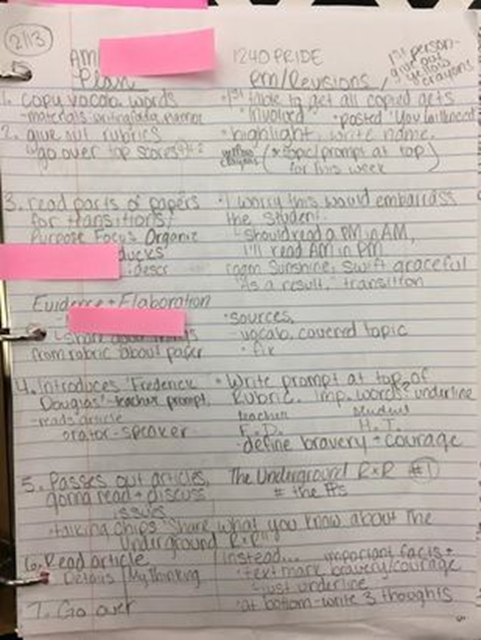
Below, you can view a section of my field notes (2/21/2017) where I decided to make a change in instruction, based on student performance in the morning.
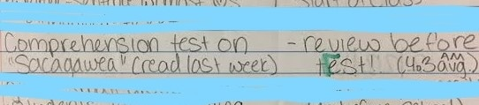
The students' average test score on the comprehension test for their reading, "Sacagawea," was only a 4.3 (out of 10). To demonstrate understanding, the objectives state that students should score at least a 70%. To accommodate the students with disabilities, and ensure their academic success, I decided to include a review of the main idea of the story. Principles of Universal Design for Learning as a strategy to engage and offer effective instruction to students with disabilities includes providing a variety of ways to present material to students, including the use of charts, graphs, and graphic organizers (McLeskey, Rosenberg & Westling, 2013). To effectively engage the learners, I used a cooperative anchor chart. The main idea web that we created together is pictured below. We determined the main idea through collaborative discussions. Students provided details from the text, on index cards, to support the main idea in their table groups.
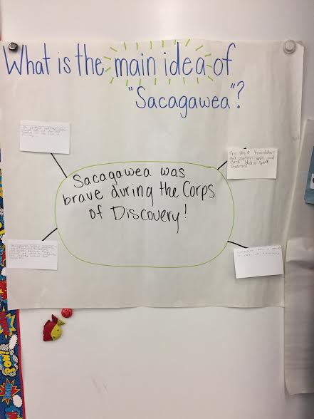
“Students should receive individualized opportunities to verbalize, write, or otherwise create something using the lesson’s material,” (Willis, 2007, pp. 110). Informing my instruction with this accommodation was practiced during a lesson on Langston Hughes' poetry, when students determined Hughes' message, then wrote their own poems to be displayed in the school. The students took pride in their work, knowing it will be displayed in celebration of Black History Month. These poems promoted the same principles of Hughes' poetry, including justice, equality, the pursuit of dreams, and community.
I planned an ELA lesson on idioms with consideration for research promoting pre-teaching new topics (Pickett, 2014). Together, the students and I created an anchor chart and discovered examples of idioms they may be familiar with (see image below). To include principles of Universal Design for Learning, we watched a humorous video based on the notion of taking common idioms literally that contributed to student understanding of the literal and figurative meanings of idioms.
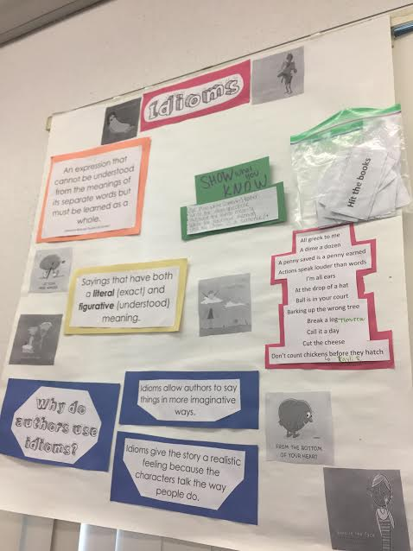
I analyzed my data throughout. For example, I would read my field notes before the afternoon class and underline instances in which I could include an accommodation for the afternoon class. I wrote further strategies to be implemented on the right side of the paper, like including anchor charts, adding another layer to the lesson for Universal Design for Learning, or a review activity. Test or quiz data was analyzed weekly by grading each assessment numerically and keeping track of each learners’ score, then finding the average of the class. In this way, I was able to compare student learning in the morning to analyze the effectiveness of accommodations in the afternoon. While teaching, I recorded my own field notes of student responses, engagement, and understanding. I did this by carrying around a clipboard to copy student quotes, as well as using checkmarks on a roster to present comprehension of the day’s objectives.
Findings
Through my research and while facilitating learning in the classroom, I learned a multitude of new strategies and tactics to include in the construction of my lessons. I learned that inclusion is an attitude, something teachers should constantly be mindful of, not a program to be delivered (Pickett, 2014). I believe this was important for my inquiry because consulting the literature of other professionals has allowed me to make connections to previous practices, as well as inform my wondering with new strategies to try. As I observed my Collaborating Teacher’s practice with the initial block of learners, I applied the research I have done to provide accommodations to the students with disabilities that were clustered in the afternoon class.
Learning Statement 1
Reflective field notes allowed me to improve my practice and differentiate instruction to address my students’ needs, particularly those with disabilities in the general education classroom.
Through the field notes and reflections I gathered throughout the inquiry, I have been better informed of the principles of my teaching practice. By examining what another professional does, I am able to identify appropriate instructional practices and provide students with the content area knowledge they need. Furthermore, examining my own opinions and ideas allows me to grow as an educator, establish future routines, and further develop my personal practice. This data collection strategy has informed my inquiry topic by providing practical situations and contexts in which to apply the strategies and tactics I have encountered in literature. I learned that accommodations, whether simple or complex, can be conveniently incorporated in the general education classroom setting with a little reflection and creative thinking. I believe this learning was important for my inquiry because it has opened daily opportunities for data to drive instruction and to include effective strategies in every lesson.
For example, in the field notes pictured below (see Image 1), I witnessed my CT draw students' attention to the Rubric before beginning their new writing piece. In order to provide students with color-coding as a tactic for effective instruction in inclusive settings (Algozzine, Campbell & Wang, 2010), I decided to provide each learner with a yellow crayon to "highlight" key words and details within the rubric. Working in their mixed ability table groups, the learners identified important information to consider during their future writing. By making the information easily identifiable, through color, the students can better recognize what they are being asked to do. Based on my learning this week, I will continue the field notes method while co-teaching.
Image 1.
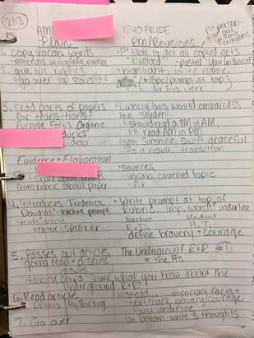
Demonstrated in a post-observation conference reflection following a lesson on idioms, I recognized the impact of including a video to further students' depth of understanding and present content area information on idioms in a visual/auditory way. From the Reflection Guide: "From this lesson, I have recognized the value of adding layers to support understanding through principles of Universal Design for Learning! By incorporating kinesthetic, auditory, and visual components, I was able to effectively engage all students. I believe including a funny video to analyze excited the students and engaged them in the lesson. I'd like to incorporate more videos in the classroom to introduce new materials and get students excited" (3/5/2017). To introduce a Social Studies lesson on the civil war, I played a video that highlighted Florida’s role in the war. The students answered all of the video questions accurately, confirmed by 100% of the students completing the 3 question guide correctly. While the students completed lesson activities in their booklets, field notes indicate that learners were actively engaged in the civil war readings and tasks, promoting their academic achievement.
Learning Statement 2
Principles of Universal Design for Learning, including investigating content area knowledge through presenting information in a variety of ways, promotes academic success.
With consideration for aforementioned data analysis of student comprehension test scores, I incorporated the main idea review anchor chart prior to a test. This strategy is a part of direct instruction, which is “a model that uses teacher demonstration and explanation combined with student practice and feedback to help learners acquire well-defined knowledge and skills needed for later learning” (Eggen & Kauchak, 2012, p. 266). By reviewing the story before the test, I ensured adequate time for review and practice through direct instruction. The students enjoyed working with their peers to create a chart together. By displaying their chart, the students have a visual cue to remind them of previous learning and allow them to feel a sense of ownership in the classroom. Below, I have graphed the number of students who scored between 10%-100% on the comprehension quiz, comparing the morning (CT, blue) and afternoon (my instructional time, including SWD's, orange) classes. The average score of the afternoon class was a 7 out of 10 possible earned points, which demonstrates understanding.
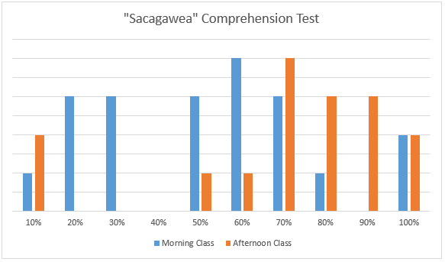
Our classroom includes a "Wall of Fame" where students display work that has met the requirements of demonstrating understanding and that they are proud of. Excitingly, one of the students with disabilities in the afternoon class received an 80% on her comprehension test. Such a high score is generally unfamiliar for the student, whose average score on comprehension tests ranges between a 5 and 6, out of a possible 10 points. The learner was visibly excited to add the test to her designated spot on the "Wall of Fame." Valuing student effort and sharing her celebration was certainly the most rewarding part of the lesson.
“Students should receive individualized opportunities to verbalize, write, or otherwise create something using the lesson’s material,” (Willis, 2007, pp. 110). Students created their own image to depict an idiom and write their “understood” meaning in context. Based on the Exit Ticket provided at the end of the lesson, observations during the lesson, and student's Reading Journals, students were able to identify and understand the meaning of idioms and why an author uses them, including in "The World According to Humphrey." Only 2 students earned less than a 100% on the exit ticket, demonstrating the ability to select idioms from the lesson, as well as unfamiliar idioms, that would apply in context. I have had multiple students tell me about idioms they've encountered since the lesson, which indicates that the learning has been embedded into student knowledge.
Learning Statement 3
Including Universal Design for Learning for instruction with all students in my class facilitated higher levels of engagement in the general education classroom.
From my experiences, implementing opportunities for choice and varying the presentation of lesson materials, principles of UDL, has improved student engagement, demonstrated by higher levels of time on task and student-reported enjoyment. From observations evidenced by my own field notes throughout instruction, there have been less off-task behaviors in the classroom since the implementation of UDL-based lessons. Field notes from a lesson in the beginning of each month were examined and tallied for noted behaviors that did not indicate engagement in the learning process. In this case off-task behaviors have been considered as unrelated conversation, irrelevant doodling, wandering around the classroom without true need, and not participating in the lesson’s conversations or written work. Demonstrated in the graph below, change over time can be indicated by examining the number of off-task students during a 40 minute language arts period. Beginning in December of 2016, the students were exposed to UDL lessons that offered multiple means of expression, representation, and engagement. Throughout the following months, students received choice in their expression of understanding, as well as a variety of presentation formats in an increasing number of subject areas, including writing, reading, and social studies. From the data, it is evident that Universal Design for Learning minimized off-task behaviors, indicated a maintenance of student interest in the lesson’s materials as they were invested in the task at hand.

Based on the observational notes of a peer in the classroom, my co-teacher, as well as our daily reflective discussions, student engagement and enjoyment has increased as students are provided opportunities for choice in their learning and the portrayal of content area material through relevant media. My co-teacher’s notes have remarked, that my lessons “keep students engaged with relatable and fun lessons.” By involving multiple layers of presentation of content area learning, students find joy in learning through multimedia and relatable materials. In addition, my co-teacher has remarked that I “take the time to make sure every student understands before moving on,” ensuring that inclusion in the classroom is effective. From our reflective conversations, I have been ensured that all students, including those with disabilities, are actively involved throughout my teaching and are contributing to the lesson, while demonstrating understanding. Having a peer’s perspective allowed me to analyze student behavior, their off-task tendencies, and assess the effectiveness of Universal Design for Learning in the general education classroom.
Finally, students were able to recall their own evaluation of the effectiveness of a UDL-based learning environment by responding to written surveys and sharing during structured conversations. By completing the simple, scaled survey in April of 2017, students were able to rate their opinions of layers in lesson design (videos, graphic organizers), choice in representative of knowledge (report style), and reflect on their own level of engagement during instruction. Below, a few examples of student responses are provided. With consideration for 17 students’ responses, the average response to the 4 UDL-based questions was above a 4, which implies that learners found UDL enjoyable and effective, and therefore were engaged in the learning process.
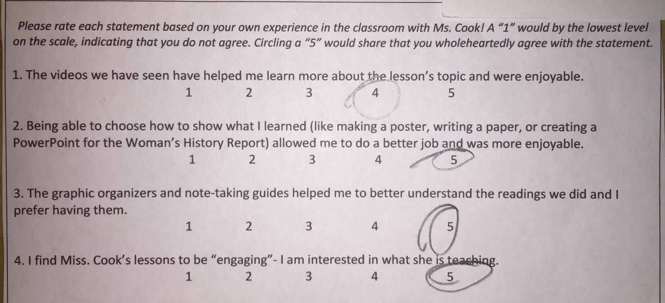
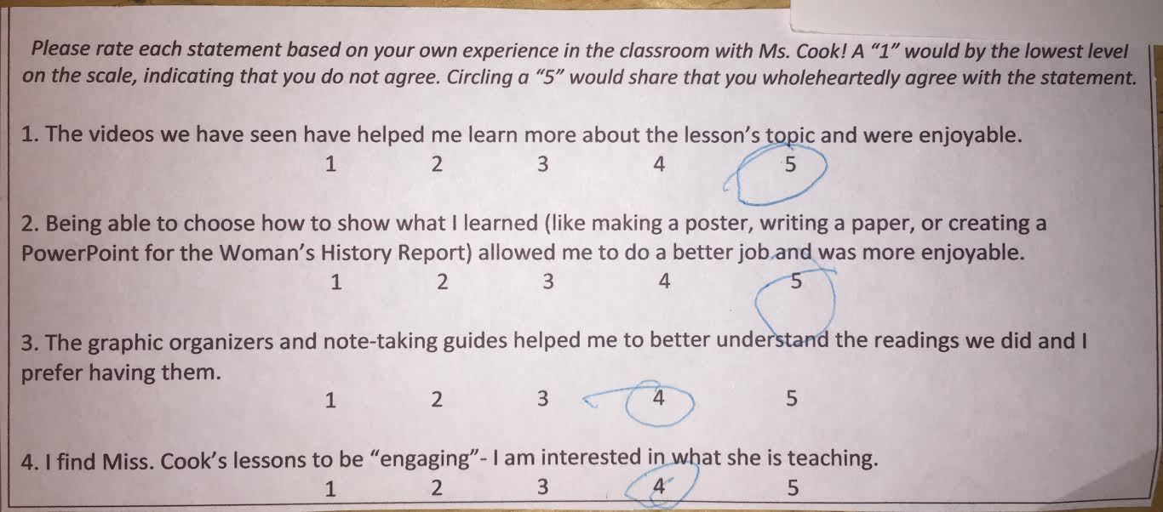
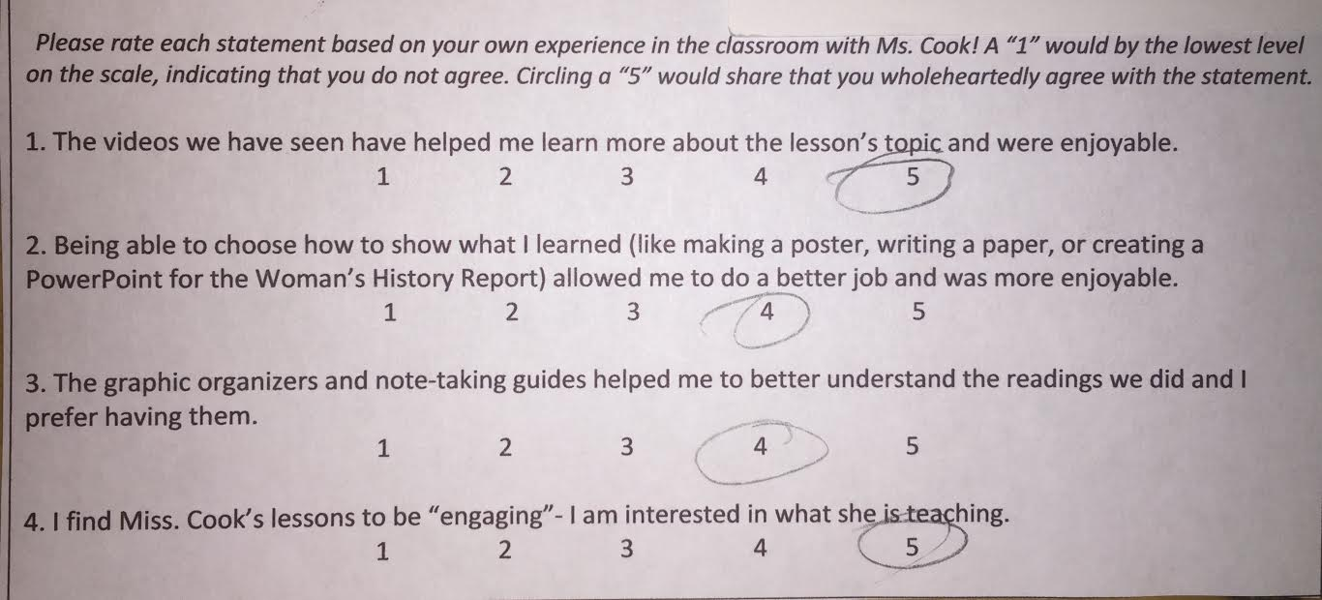
During conversations with students, I collected positive feedback as well. When I asked students what their favorite part of the day was, one student shared “I really liked when we watched the Youtube video with the two guys and when they were hitting the books.” With prompting, the student recalled that they were learning about the literacy concept of idioms. At the end of a social studies reading, that was accompanied with a note-taking guide, I asked learners what they thought about the lesson. One student with disabilities remarked, “The guide helped me to pay attention and know what to think about.” While students were presenting their collaborative theme posters during an extensive Dr. Seuss unit, a learner remarked “being able to draw helped me remember the story and think about how the characters felt.” From students’ verbal responses, implementing concepts of Universal Design for Learning were reinforced and reported as engaging in the classroom context.
Conclusion
My students have shown me smiles that I will not forget. Their excitement during my lessons, and while reflecting on their own learning, truly drives my work as a teacher researcher and educator. When one of the students with disabilities was able to put her assessment on the “Wall of Fame,” we shared a celebration of success that inspired me to continue my research to best promote every learner’s accomplishment. I learned the compassion that comes naturally from children as the students and I worked in cooperative groups with a variety of initial levels of understanding. As much as I taught the 4th graders I have worked with, they have demonstrated the importance of growth in my teaching practice and inspired me to continue researching to best meet their unique learning needs.
By engaging in this inquiry, I have recognized the impact of considering each learner’s unique strengths in the classroom. While I continue my practice in education, I will maximize student potential by differentiating instruction and providing accommodations that allow all students to succeed. Supporting the academic achievement of every learner in the classroom is the job of the general education teacher. As presented by the Exit Tickets and formative assessments from various lessons I have facilitated, by including Universal Design for Learning, individual students of a wide variety of learning styles and initial ability level are guided to lesson objective attainment.
As always, I will continue to strive for professional development opportunities that will further my practice as a teacher researcher. By presenting my inquiry at the NAPDS Conference, I had the opportunity to collaborate with colleagues and professionals to support the development of my inquiry process. By reviewing my peers' work from all over the nation, the approach I have taken (including strategies applied) were reinforced by the experiences of student-teachers in a variety of contexts. Through conversations and data analysis, I was led to claims about the effectiveness of implementing strategies in the general education classroom. By engaging in presenting my inquiry, I could collaborate with like-minded educators who are passionate about providing all learners with an equitable education. I believe that sharing your work as a teacher researcher is the most valuable aspect of the inquiry process. 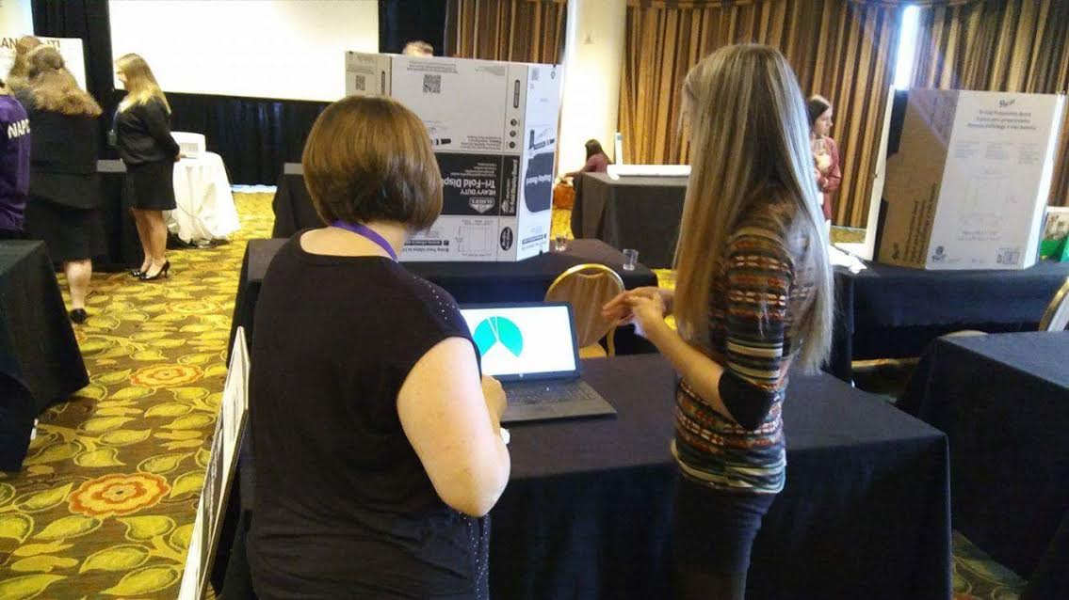 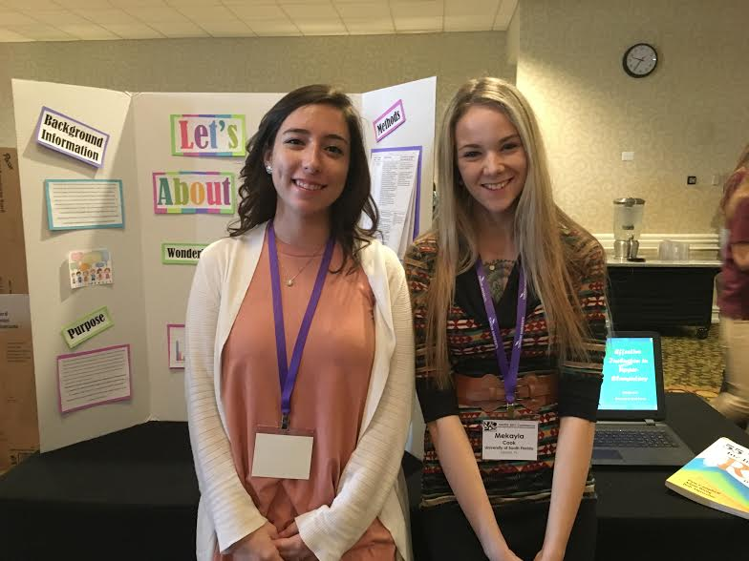
Upon conclusion of this inquiry, I am wondering how I can support other educators in embracing the students with disabilities in their general education classrooms, with an inclusion mindset, through promoting Universal Design for Learning. Moving forward, I am excited to continue my practice of inclusion to welcome each learner in the classroom and support their success. Each year, and even day, in a learning environment is different and I look forward to encountering new students with unique needs and talents. My teaching practice will be furthered by the students I encounter and how I will best facilitate their learning.

References
Algozzine, B., Campbell, P., & Wang, J. (2010). 55 tactics for implementing RTI in inclusive settings. Thousand Oaks, CA: Corwin.

FCEC. (2016). Council for exceptional children florida. Retrieved October 30, 2016 from http://www.floridacec.org/

Hall, R. (2016, October). Town hall meeting. Presentation at annual conference for the Council for Exceptional Children, Lido Beach, FL.

Individuals With Disabilities Education Act, 20 U.S.C. § 1400 (2004).

Eggen, P., & Kauchak, D. (2012). Strategies and models for teachers: Teaching content and thinking skills (6th ed.). Upper Saddle River, NJ: Pearson Education.

Every Student Succeeds Act of 2015, Pub. L. No. 114-95 § 114 Stat. 1177 (2015-2016).

McLeskey, J., Rosenberg, M.S., & Westling, D. (2013). Inclusion effective practices for all students (2nd ed.). Upper Saddle River, NJ: Pearson Education.

Pickett, S. p. (2014). Additional Needs -- it's all in the attitude. Teacher Learning Network Newsletter, 21(1), 28-29.

SDHC. (2017). Ethnic enrollment by school. Retrieved from https://www.sdhc.k12.fl.us/assets/pdf/SE0016B.pdf

United States Census Bureau (2010). Quick Facts Seffner CDP, Florida. Retrieved from https://www.census.gov/quickfacts/table/PST045215/1264925

Verra-Tirado, M. (2016, October). FCEC fall meeting. Presentation at annual conference for the Council for Exceptional Children, Lido Beach, FL.

Willis, J. (2007). Brain-friendly strategies for the inclusion classroom: Insights from a neurologist and classroom teacher. Alexandria, VA: ASCD.

