Mekayla Cook
SSE 4313
Fall 2016

Inspired by Ivan: Creating Change through Advocacy
Characteristics of Learners
This third-grade lesson is tailored to meet the needs of sociable 8-9 year olds, who love explaining their ideas and will work well conferring in groups or with partners to promote comprehension. Social-emotionally, third graders are concerned with issues of fairness and justice, as well as excel with enthusiasm when participating in group work (Anderson, 2011). By investigating the equity in past mistreatment of Ivan, these logical thinkers will collaborate effectively to foster further awareness of civic values. Developmentally, these enthusiastic students are quickly growing their vocabulary, so they will discover content area vocabulary in stride. Third graders are in the Concrete Operations stage of thinking, complimented by the interactive timeline in this lesson that provides an active, concrete learning experience (GCISD, 2007). In the previous year, third-graders have already developed an understanding of responsible citizenship (SS.2.C.2.2) and an ability to identify ways citizens can make a positive contribution in their community (SS.2.C.2.4). To expand upon this knowledge, learners will explore their ability to advocate for animals through petitioning and protesting by learning about Ivan, the “Shopping Mall Gorilla.” In the third grade, learners are asked to identify group and individual actions of citizens that demonstrate civility, cooperation, volunteerism, and other civic values (SS.3.C.2.1). Civic values like advocacy, civility and compassion can be examined by exploring and reflecting on Ivan’s story. Third-graders are also expected to read and comprehend informational texts within student’s grade band independently and proficiently (LAFS.3.Rl.4.10), which this lesson will promote through the inclusion of Ivan: The Remarkable True Story of the Shopping Mall Gorilla (Applegate, 2014). Vocabulary discovery in the lesson helps students determine the meaning of general academic and domain-specific words and phrases in a text (LAFS.3.Rl.2.4).

The creation of this lesson has been based upon my experiences as a Senior intern, associated with the University of South Florida’s College of Education. The school from which my preservice professional experience has occurred thus far, is a Title I Elementary school in my community with a 71% economically disadvantaged (FRL) rate (HCPS, 2016). The inclusive school invites students who are blind, or deaf/hard of hearing, and provides exceptional student education services to the diverse learners in the school community. The school has a 57% minority rate; of the 630 students, 39% are considered Caucasian, 30% are Hispanic, and 21% are of African American descent (HCPS, 2016). For the past two academic years, the school has earned a B grade, while following their vision to empower students to achieve success. The students boast exceptional school spirit, as they work together to A.C.H.I.E.V.E., or be part of “a community of high-performing individuals emphasizing the value of education.”
Rationale
By pairing the engaging nonfiction text Ivan: The Remarkable True Story of the Shopping Mall Gorilla (Applegate, 2014) and higher-order thinking practices, this lesson focuses on developing literacy skills and fostering compassion and activism for animal welfare. Nonfiction texts naturally engage students as they discover more about the world around them. Standards in literacy require reading texts with academic language, responding to literature with text evidence and building knowledge through content-rich nonfiction. Ivan: The Remarkable True Story of the Shopping Mall Gorilla (Applegate, 2014) introduces students to new vocabulary and concepts as they discover gorillas, their habitats and societal structure. Students practice strategic thinking and complex reasoning through describing events sequentially, by identifying key details in informational text. The students will identify the sequence of events in Ivan’s life, as well as make connections between the text and civic virtues. Children will synthesize information gathered from the text to form their own reflective opinion of the ethical treatment of animals. Civic virtues, as understood by children, are habits that contribute positively to society. Addressing inequity is an important component of responsible citizenship. There is nothing more important than speaking up for those who cannot. “Ivan's case is a shining example of the amazing change a caring community can inspire. His story helps us teach kids in our community that they truly can make a difference in the lives of others,” (PAWS, 2016). Through examining Ivan’s heart-touching story, students will recognize their responsibility as citizens, as well as the potential for activism to drive social change in communities.
Standards
LAFS.3.RI.1.3 Describe the relationship between a series of historical events, scientific ideas or concepts, or steps in technical procedures in a text, using language that pertains to time, sequence, and cause/effect.
SS.3.C.2.1 Identify group and individual actions of citizens that demonstrate civility, cooperation, volunteerism, and other civic virtues.
Objectives
L.A.: Students will be able to write to sequence events in Ivan’s life, using context-specific vocabulary (petition, protest), based on a narrative nonfiction text and research, using temporal words (first, next, finally) that pertain to time and sequence.
S.S.: Students will be able to identify how group actions can be taken to demonstrate civic virtues like respect and advocacy.
Materials and Resources
A white board (or a plastic red plate will work), dry erase marker, and black sock (or an eraser) for each student.
A printed copy of: Miss. Cook’s Trip to Zoo Atlanta (See page 15 or digital images from http://zooatlanta.org/), Ivan’s Life Timeline Events (See pages 11-14).
Index cards with a vocabulary term or definition on each card.
Ivan: The Remarkable True Story of the Shopping Mall Gorilla (Applegate, 2014)
A world map
A large bulletin board or whiteboard, with room for a long number line. Markers to write the dates. Cardstock for each event. Tape to put each event on the timeline.
The teacher should have enough mini-books made for each student (see instructions below):
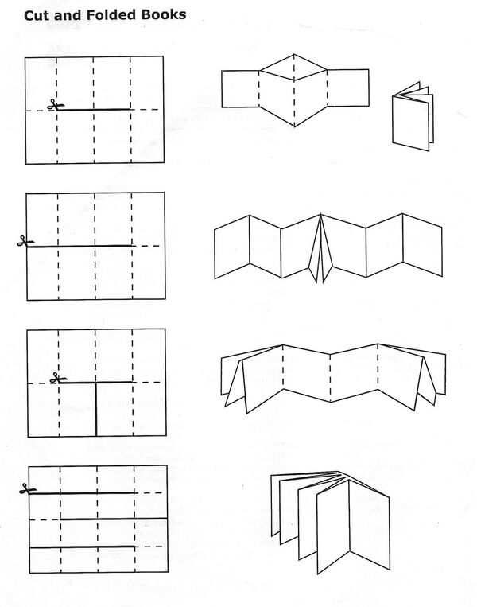(Swickheimer, n.d.).
Access to the internet and a display monitor. A camera or mobile phone with uploading capabilities.
The students should have crayons, pencils, pens, markers, or other coloring utensils.
Preparations
The materials necessary to adequately complete this lesson should be reviewed and prepared prior to the commencement of the lesson. The various technological aspects should be prepared, ensuring an internet connection and working display monitor, on the appropriate device so that the educator may initiate the technological component promptly. To maximize student achievement and engagement during the lesson, the room should be organized to accommodate various grouping methods and foster collaboration. In order to support cooperative learning during this lesson, there should be a large meeting space identified by a rug. Also, a world map should be within student’s view of the rug. The room should also have a large bulletin or white board within reach of students. There should be places for students to work in small groups of 2-4. Different work stations should be available that allow students a flexible choice in seating and learning areas. Student work should be displayed in the room, as well as primary source materials. The Library of Congress would be an excellent resource for photographs, videos, music and other primary sources. Students would engage in discussions, reflective writing and analysis of the primary sources throughout the month. Students should have access to resources that accommodate research. Students should have background knowledge from exposure to a variety of texts about animals, their habitats, conservation and activism.
Prior to the lesson, the teacher will need to prepare materials. The teacher will write each vocabulary term on its’ own index card. The teacher will write each definition on its’ own index card. The teacher will print out the materials listed above under “A printed copy of.” The teacher will draw a large timeline on the large display board with the dates and tick marks: 1964, 1967, 1970s-1980s, 1987, 1988, 1991, 1994, 1995, 2012. The teacher will print and cut out the events of Ivan’s life timeline (See pages 11-14), then paste on cardstock for sturdiness. The teacher will create enough mini-books for each student (see instructions above).
Introduction
1. (2 minutes) Students will be gathered on the carpet as a whole class with their own white boards, dry erase marker, and black sock (eraser). The teacher will ask students if they have ever been to a zoo or seen a gorilla. The teacher will share the handout “Miss. Cook’s Trip to Zoo Atlanta,” (See page 15) so students will be provided with background knowledge to understand the story.

2. (4 minutes) Each student will be given an index card. Some cards will have a vocabulary term, while others will have a definition. Each learner will read their index card aloud. The teacher will direct students to find their matching term or definition, then use the white boards to draw a picture of the term. The teacher will start a timer for two minutes and students will begin. At this time, the teacher will rotate the carpet to ensure students find the appropriate match and are able to provide an accurate visual cue. After the 2 minutes are up, students will share out the term, definition and illustration with the class.
Vocabulary
Term | Definition
Poachers | Illegal hunters
Petition | A formal request, with signatures, asking an authority to support a cause
Protest | An action by a group of people expressing disapproval
Troops | A group of gorillas, led by an adult male
Gorilla | A powerful primate from Africa
Strange | Different, unfamiliar
Procedures
3. (~13 minutes) The teacher will now read Ivan: The Remarkable True Story of the Shopping Mall Gorilla (Applegate, 2014) out loud to the students.

- Read pages 1-3: Share with students where central Africa is located on the map (posted on the wall). Ask the learners to make a text-to-self connection by considering, “How is this gorilla family like your family?” and “How do you think Ivan feels?” Students will think to themselves and 3 students will share with the class.
- Read the next two pages: Ask students to further their text-to-self connection by thinking about similarities between the baby gorilla’s life and their own. Each student will write 1 connection on their white boards and show the teacher.
- Read the next two pages: The students with the “poachers” term and definition cards will share their illustration and restate the definition for the class.
- Read the next page: The teacher will ask the students, “Now, how do you think the baby gorillas are feeling? How do you know?” Three students will respond out loud and provide text evidence.
- Read the next page: Show students on the world map where the baby gorillas are at now. Ask students to form an opinion and write “Yes” or “No” on their white boards, then show the teacher: “Do you think people should be able to order gorillas like that?”
- Read the next three pages: The teacher will ask students to turn and talk with their neighbor about, “How do you think Ivan feels now?” and “Do you think he feels any different than when he first got to the shopping mall? Why or why not?” While students discuss, the teacher will rotate the carpet to check for understanding and student’s thought processes. The teacher will ask students to think about the author’s use of the word “strange” and write a synonym on their white boards to share.
- Read the next three pages.
- Read the next page: Ask students: “Why can’t Ivan live in a house anymore?” Have 2 students share with the class.
- Read the next two pages: Students will turn and talk with a neighbor about: “Do you think Ivan likes living in the shopping mall more than in a house? Why or why not?”
- Read the next page: The teacher will tell students to look at Ivan’s face and think about how he is feeling. Students will then show the teacher their own face, mimicking Ivan’s feelings.
- Read the next page: The teacher will ask the group “Why are people becoming angry?” Three students will share their answer with the class. Students will be asked to reflect on then turn and talk with their neighbor: “What do they think will happen by writing letters, signing petitions, and holding protests?” The teacher will guide students to understand that it is a community’s responsibility to show compassion for all life and to stand up for those who can’t stand up for themselves (advocacy).
- Read the next two pages: Ask the students to write “Yes” or “No” on their white boards to show the teacher: “Do you think Ivan will like this place better than the shopping mall?” Students will then turn and talk with a neighbor to answer: “Why or why not?”
- Read the next two pages.
- Read the last page: The teacher will ask the students: “Why do you think the author say Ivan’s life is beginning again?” Three students will share with the class.
Closure
4. (6 minutes) Students will be put into 9 groups through a random count off. Each group will be given a part of Ivan’s life timeline (See pages 11-14). The students will decide where their event goes and tape their event on the large timeline the teacher created on the board. This will require students to work in small and large groups to construct the timeline. The teacher will rotate the room at this time to guide student’s thoughts and ensure the timeline is correct.

5. (2 minutes) A student from each of the groups will read their event on the timeline aloud, ordered sequentially. The student will be required to use a temporal or transition word, like “First,” “Next,” or “Last.” The other group members will share any text connections they can make to the story Ivan: The Remarkable True Story of the Shopping Mall Gorilla (Applegate, 2014).

6. (20+ minutes) Students will now have a choice in how they will display their knowledge and how they have been “Inspired by Ivan,” to promote social activism and advocacy for animals. The teacher will make sure students know to synthesize information from the picture book and historical timeline in their writing. Students may write a letter to Ivan that includes their response to at least 3 of his life events and an illustration, using at least 3 transition/temporal words. The learners will be provided an authentic context for writing by the teacher posting their letter to: http://weloveivan.com/. Or, students will be able to make their own mini-book by writing about at least 3 of Ivan’s life events with illustrations, using at least 3 transition/temporal words. Students will be required to consider how people were able to help Ivan in their writing. Finally, students may choose to begin their own campaign for animal rights by following the guidance from DoSomething.org (https://www.dosomething.org/volunteer/animals). They will present a campaign promoting advocacy for animals and explain how they have been inspired by Ivan’s story.

The teacher will share the assignment rubric (see Assessment: ‘Rubric for the Written “Inspired by Ivan’ Assignment”) with the students. If students do not have adequate time to complete the activity, the lesson can be continued over an extended period of time.

For students needing support while writing, the teacher could provide the following sentence stems, in a mixed order:
“First, Ivan was ______ and he ______.” “Then, Ivan felt/was ______ because __________.” “Next, people took action by ____ to ______.” “Finally, Ivan felt _____ because _______.”

While students are writing, the teacher will play videos of Ivan (muted):
Ivan the gorilla lived alone in a shopping mall for over 20 years (The Urban Gorilla) (argofilms, 2014): https://www.youtube.com/watch?t=34&v=OYYL2LxotA8
Ivan the gorilla (Zoo Atlanta, 2012): https://www.youtube.com/watch?v=FF1oWHL-lSs
Assessment
Throughout the lesson, the teacher will consider formative assessment to guide instruction. The students’ understanding of vocabulary knowledge, answers to discussion during reading, contributions during pair/group discussions, and effective participation during the timeline activity will be considered by keeping anecdotal notes. During the read aloud, students’ responses will indicate if they understand the potential for civic action to inspire change (SS.3.C.2.1). The timeline activity will indicate if learners have conceptual understanding of event sequencing (LAFS.3.RI.1.3). The teacher’s consideration of students’ verbalizations during pair or group work will also imply their level of understanding.
Content mastery is evidenced through the student’s self-created written work. Students’ depths of knowledge will be analyzed through their completion of the writing assignment. The student’s ability to apply language relative to time or sequence while writing about events from multiple sources of text, the historical timeline and Ivan: The Remarkable True Story of the Shopping Mall Gorilla (Applegate, 2014), will indicate a learner’s ability to synthesize knowledge (LAFS.3.RI.1.3). The written assignment will also give students the opportunity to demonstrate their understanding of how group and individual actions that display civic values, like responsibility and advocacy, make a positive impact through petitioning or protesting (SS.3.C.2.1). The rubric below will be used to score the “Inspired by Ivan” writing assignment.

Rubric for the Written “Inspired by Ivan” Assignment
Category | 3 | 2 | 1 | 0
Transition Words  (LAFS.3.RI.1.3) | The student correctly used 3 transition words. | The student correctly used 2 transition words. | The student correctly used 1 transition word. | The student did not correctly use any transition words.
Life Events  (LAFS.3.RI.1.3) | The student wrote about 3 correct events in Ivan’s life. | The student wrote about 2 correct events in Ivan’s life. | The student wrote about 1 correct events in Ivan’s life. | The student did not correctly write about any events in Ivan’s life.
People’s Impact  (SS.3.C.2.1) | The student described how people took action to help Ivan, including both petitions and protesting. | The student described how people took action to help Ivan, including only one (petitions or protesting). | The student described how people took action to help Ivan. | The student did not describe how people took action to help Ivan.
Illustrations | The student included at least one illustration. |  |  | The student did not include any illustrations.

A summative assessment that could be provided for students would be the “Animal Ambassadors Performance Task,” (See additional document, “Performance Task”). This task will require students to demonstrate advocacy, as well as synthesize information from multiple sources to detail the relationships between concepts from a cause/effect perspective.
Extensions/ Modifications for Differentiated Instruction
In addition to the language arts and social studies/civics standards being addressed in this lesson, there are opportunities for other content area learning, including concepts from science and geography. While students are learning about Ivan, they are introduced to concepts of gorillas, habitats, maps and gorilla’s societal structures. Additionally, addressing civics standards provides an opportunity for character education. Students will understand the importance of speaking up for those who cannot advocate for themselves, which can be transferred to addressing bullying in schools. In completing the writing assignment, students are engaging in creative writing, as well as visual arts by illustrating.
For learners who grasp the conceptual knowledge quickly, finish early, or would benefit from enrichment, the teacher can offer more opportunities for literature or research experiences. Students can view “The One and Only Ivan – Official Book Trailer” (2011) released by Katherine Applegate (https://www.youtube.com/watch?v=UtPdqV2crQ0). From this video, or reading the novel if possible, the learners can compare components on nonfiction and fiction stories. Or, the learners could write their own fiction story from Ivan’s unique perspective. Students can conduct research on the World Wildlife Fund’s website and read the article “WWF’s work to save gorillas”(http://wwf.panda.org/what_we_do/endangered_species/great_apes/gorillas/save_solutions_gorillas/) to learn more ways that members of society are advocating for gorilla’s rights. The learners can then make a poster to be displayed that inspires people to get involved in animal welfare.

For students needing further instruction, the teacher can apply individual and small group interventions. To develop further understanding of poachers, gorillas, and taking civic action, students could read about another gorilla, Dunia’s, rescue story on National Geographic Kid’s website (http://kids.nationalgeographic.com/explore/nature/gorilla-rescue/#baby-gorilla.jpg). The learners can then compare and contrast Ivan’s life with Dunia’s, or write their own story book “Inspired by Dunia.” Individual students can listen to Katherine Applegate discuss her book and the true story behind Ivan: The Remarkable True Story of the Shopping Mall Gorilla (Applegate, 2014) for further review of the novel and Ivan’s life (https://www.youtube.com/watch?v=Ez6t1G_1eLE). The teacher could also pull a small group of learners who are struggling with the material for explicit instruction during student’s independent work time to review the timeline and any connections to the picture book. These students may benefit from guidance while they are writing. The teacher could provide sentence stems to begin students’ in the process of second language acquisition, or any other learners who are challenged by writing, work on the assignment. The teacher could ensure student’s comprehension of transition words by asking the learners to order the sentence stems themselves. The sentence stems provided would be:
“First, Ivan was ______ and he ______.” “Then, Ivan felt/was ______ because __________.” “Next, people took action by ____ to ______.” “Finally, Ivan felt _____ because _______.”

In order to conduct this lesson in a manner that is appropriate for the varying needs and abilities throughout the general education classroom, it is important to consider alternatives or adaptations that would benefit students with exceptional needs. Students in the process of second language acquisition will benefit from the sentence stems, as well as their own copies of the vocabulary terms with illustrations. Working with a variety grouping patterns during instruction and discussion allows students to talk about and validate their understandings with different peers, as well as receive feedback. A multisensory approach works best for students with learning disabilities (McLeskey, Rosenberg & Westling, 2013). Our lesson integrates literature, graphic organizers, photographs and videos to promote student understanding. Providing a rubric will increase the reliability of constructed response assessments, like the “Inspired by Ivan” writing assignment. With rubrics, learners are not compared to other students, but to a specific level of expectation that they will need to succeed. As students accomplish the learning goals highlighted by an analytic rubric, teachers and students are able to identify areas of strength, as well as areas to improve. This scoring style allows the teacher to provide feedback that will benefit the student’s growth in regard to performance, as well as state-mandated standards. By working in groups, or reflecting in pairs, students of all academic levels benefit from informal cooperative learning groups. Cooperative Learning is a grouping strategy that uses mixed-ability groups for instruction to ensure all students learn assigned content (McLeskey, Rosenberg & Westling, 2013). Cooperative learning improves the achievement of students across a range of content areas, and results in greater achievement gains than traditional, whole-group instruction (McLeskey, Rosenberg & Westling, 2013). Cooperative learning supports improved prosocial interactions among students who differ with regard to achievement, gender, or ethnicity. Improved acceptance of students with disabilities among peers without disabilities and improved student self-esteem, academic self-confidence, motivation for learning, and value for shared academic work also result from cooperative learning.

Text Complexity Rubric
Ivan: The Remarkable True Story of the Shopping Mall Gorilla, a children’s nonfiction narrative picture book by Katherine Applegate.

Quantitative: 680 AD Lexile score. Grade band K-4.
Qualitative:
- Knowledge demand: Subject matter common or familiar to many readers who possess some discipline-specific content knowledge and text includes few references or allusions to other texts or ideas.
- Meaning/Purpose: Multiple levels of meaning or purpose distinguished from each other with a concrete theme or point implied in language with some subtlety but easy to identify based upon context or source.
- Text structure: Organization of main ideas, events, or plotlines is explicit, clear, chronological or easy to predict, rendering text features non-essential to understanding content.
- Language features: The language is fairly explicit and literal with some more complex
meaning; vocabulary is mostly familiar, contemporary, and conversational; the text employs primarily simple and compound sentences.
- Visual supports: In literary text there are extensive graphics that support the text, whereas in informational text there are minimal graphics that are unnecessary for understanding.

Reader and Task
- The teacher will provide vocabulary and primary source images as background d for interpreting the content knowledge presented in the text. To foster understanding of the text’s theme, discussions will be held to allow students to process the meaning of the story. The teacher will help students make connections among details in the story by constructing an interactive timeline that supports the story’s sequence. For children who lack visualization skills, illustrations are provided. The teacher will ask open-ended questions that promote higher-order thinking skills like analysis or comparison. Additionally, simple questions will be asked and considered as formative assessment to determine student understanding. Student interest in the content will be peaked with primary source photographs, as well as the children’s developmental interest in concepts of fairness or equality. The teacher will assist students in accommodating lacking background knowledge by offering opportunities from peer and group discussions for comprehension. The teacher will provide students with writing supports, access to the novel and opportunities for enrichment or further exploration of the topic.

Final Placement: Recommended for students of all achievement levels in grades Kindergarten to fourth. I believe this text accommodates third grade developmental characteristics, as well as engages their interests.

Ivan’s Life Timeline Student Cards

Ivan and his companion are brought to the U.S. and sold by wildlife traders to the owners of the B&I department store in Tacoma, Wash. In the beginning, Ivan spends his early years as a pet in a human household.

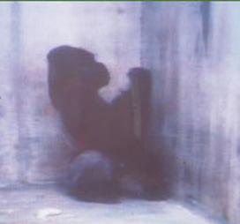
Great apes make poor pets, and Ivan is no exception. Although only 5, he is already too large, strong and boisterous for life with a human family. As a solution, Ivan is moved to an indoor enclosure inside the B&I department store.

Ivan is the star attraction of the B&I store, and he becomes Tacoma’s most famous non-human resident. Over the next two decades, he is visited by thousands of friends and fans, an adoring public who may not realize at this time that Ivan’s lifestyle is not compatible with the physical, social and behavioral needs of his species.

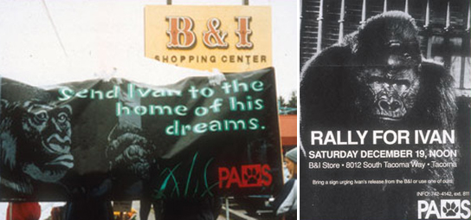
P.A.W.S. began a campaign to free Ivan. It took more than seven years. Thousands of members of the Tacoma/Seattle community got involved to help make the campaign to free Ivan a success—they collected signatures for petitions calling for his release, donated money to PAWS for the placement of newspaper ads, and took part in protests and boycotts.

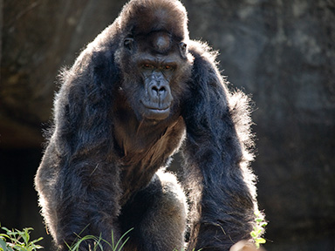
Meanwhile, across the U.S. in Atlanta, Ga., another solitary gorilla, Zoo Atlanta’s Willie B., enters a natural habitat for the first time after more than 25 years in a small indoor enclosure.

National Geographic Explorer aired a documentary entitled "The Urban Gorilla" that contrasted shots of a sad, lonely and listless Ivan with shots of Willie B., another lowland gorilla shown taking his first tentative steps outdoors in Zoo Atlanta's natural gorilla habitat after 27 years of his own solitary confinement. Ivan's story was covered across the nation, from People Magazine to the New York Times.

Ivan’s lonely existence has by now provoked national outrage within the zoological and animal welfare communities, and his owners donate him to a zoo.

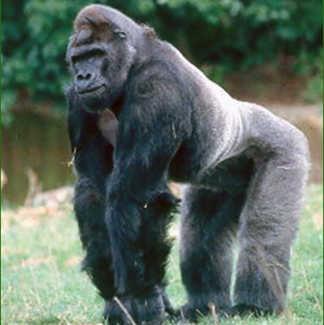
Ivan explores The Ford African Rain Forest at Zoo Atlanta in spring– the first time he has been outdoors in more than 27 years.

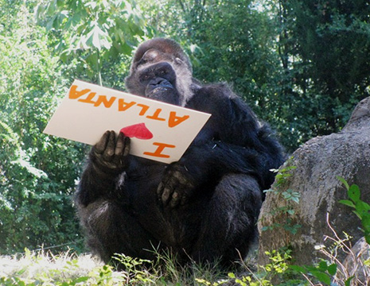
In the end, Ivan, a 50-year-old male western lowland gorilla, died at Zoo Atlanta following a health decline, while peaceful and asleep, during surgery.
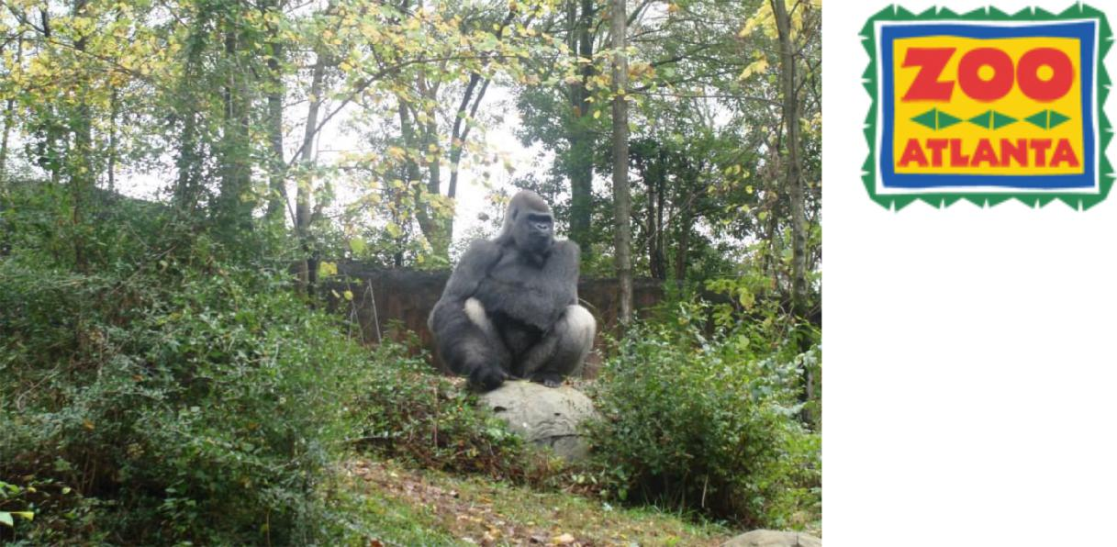
Miss. Cook saw Gorillas​ when
she went to Zoo Atlanta in November, 2015!
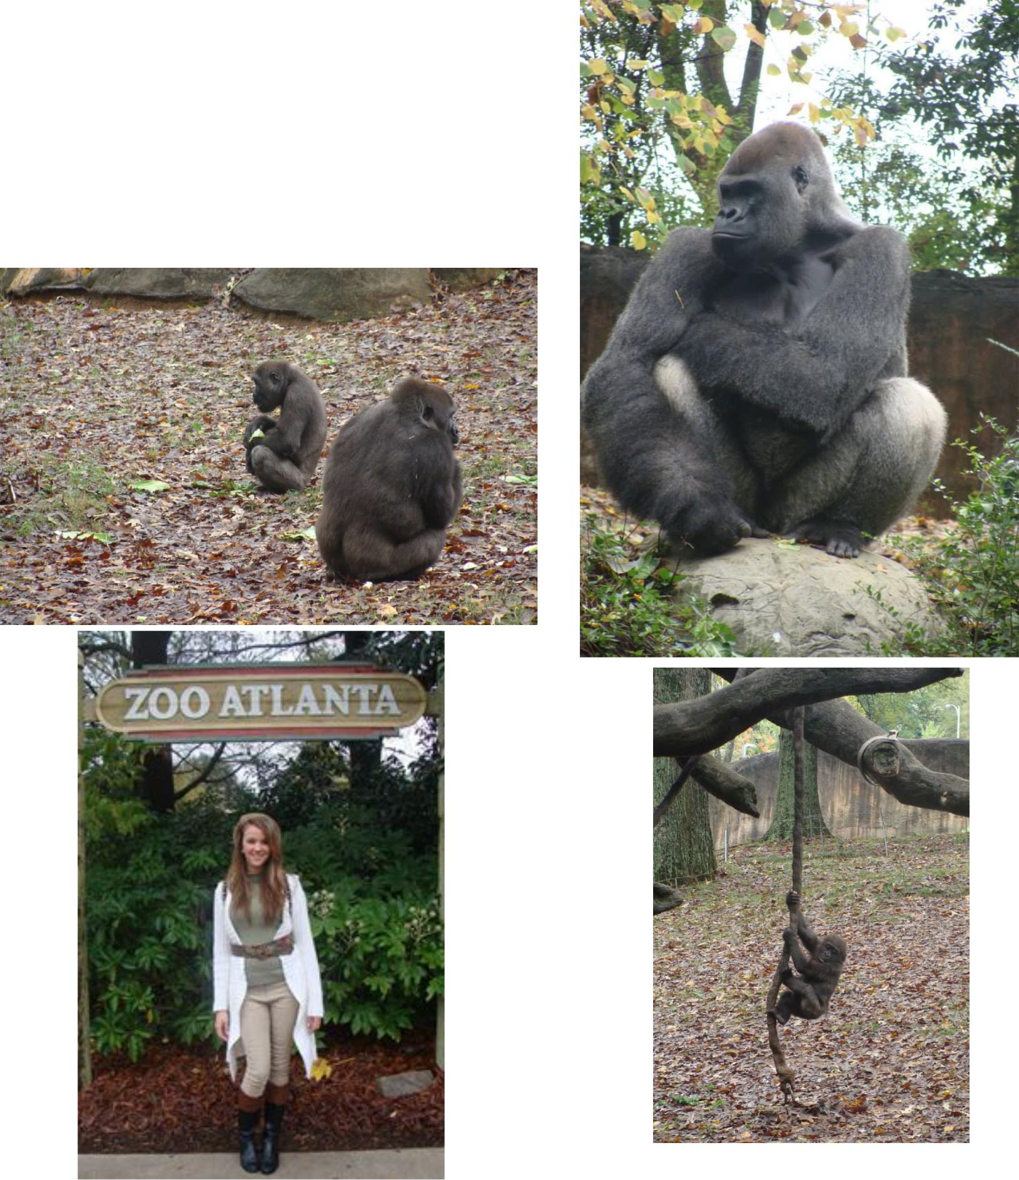

References

Anderson, Mike. (2011, April 18). What every third grade teacher needs to know about setting up and running a classroom (1st ed.). Turners Falls, MA: Center for Responsive Schools, Inc.

Applegate, K. (2014). Ivan: The Remarkable True Story of the Shopping Mall Gorilla. New York, NY: Clarion Books.

Argo, A. [argofilms]. (2014, March 28). Ivan the gorilla lived alone in a shopping mall for over 20 years (The urban gorilla). [Video file]. Retrieved from https://www.youtube.com/watch?t=34&v=OYYL2LxotA8.

Atlanta, Zoo. [Zoo Atlanta]. (2012, August 20). Ivan the gorilla. [Video file]. Retrieved from https://www.youtube.com/watch?v=FF1oWHL-lSs.

Applegate, K. [Katherine Applegate]. (2011, December 30). The one and only ivan – Official book trailer. [Video file]. Retrieved from https://www.youtube.com/watch?v=UtPdqV2crQ0.

Books, HMH. [HMH Books]. (2014, February 6). Katherine applegate tells the true story of ivan in her new picture book. [Video file]. Retrieved from https://www.youtube.com/watch?v=Ez6t1G_1eLE.

Elder, Scott. (2016). Gorilla rescue. Retrieved from http://kids.nationalgeographic.com/explore/nature/gorilla-rescue/#baby-gorilla.jpg).

GCISD. (2007, December 7). Curriculum guides and developmental characteristics. Retrieved from http://www.chesterbrookacademy.com/wp content/uploads/sites/2/2015/09/Developmental-Characteristics-of-Third-Graders.pdf.

HCPS. (2016, September 19). Ethnic enrollment by school. Retrieved from http://www.sdhc.k12.fl.us/assets/pdf/SIP/0931.pdf.

HCPS. (2016, November 3). 2016-17 school improvement plan. Retrieved from http://www.sdhc.k12.fl.us/assets/pdf/SIP/0931.pdf.

Kindig, J. (n.d.). Educator’s guide ivan: The remarkable true story of the shopping mall gorilla. [PDF file]. Retrieved from https://www.teachingbooks.net/media/pdf/HMH/Applegate_Ivan.pdf.

McLeskey, J., Rosenberg, M.S., & Westling, D. (2013). Inclusion effective practices for all students (2nd ed.). Upper Saddle River, NJ: Pearson Education.

PAWS. (2016). Ivan the gorilla. Retrieved from https://www.paws.org/about/paws/history/ivan-the-gorilla/.

Swickheimer, R. (n.d.). Mini book idea updated. [Online image]. Retrieved from https://www.dropbox.com/s/tc427npxeae90fj/Mini%20book%20idea%20Updated.jpg?dl=0.

World Wildlife Fund. (2016). Wwf’s work to save gorillas. Retrieved from http://wwf.panda.org/what_we_do/endangered_species/great_apes/gorillas/save_solutions_gorillas/.

ZooAtlanta. (2014). Celebrating ivan. Retrieved from http://www.zooatlanta.org/home/animals/mammals/gorilla/meet_the_gorillas/ivan.

