Lesson Content
What Standards (national or state) relate to this lesson?  (You should include ALL applicable standards. Rarely do teachers use just one: they’d never get through them all.) | LAFS.K.RI.1.2: With prompting and support, identify the main topic and retell key details of a text, LAFS.K.RI.1.1: With prompting and support, ask and answer questions about key details in a text, LAFS.K.RI.4.10: Actively engage in group reading activities with purpose and understanding, LAFS.K.SL.1.2: Confirm understanding of a text read aloud or information presented orally or through other media by asking and answering questions about key details and requesting clarification if something is not understood.  SC.K.L.14: All plants and animals, including humans, are alike in some ways and different in others. All plants and animals, including humans, have internal parts and external structures that function to keep them alive and help them grow and reproduce. Humans can better understand the natural world through careful observation,  SC.K.L.14.3: Observe plants and animals, describe how they are alike and how they are different in the way they look and in the things they do,  SC.K.L.14.2: Recognize that some books and other media portray animals and plants with characteristics and behaviors they do not have in real life.
Essential Understanding  (What is the big idea or essential question that you want students to come away with? In other words, what, aside from the standard and our objective, will students understand when they finish this lesson?) | Students will understand how to use main idea and key details from a text to understand new information, by asking themselves: “How do the main idea and details help me to know about new information that is read?”  Students will understand how to identify the main idea by examining key details and the relationship between the two.  Additionally, students will be able to identify frog, spider, snail, hare, beaver nuthatch (bird), bat and human houses. Students will understand that animals have homes for shelter, safety, comfort and sleeping, just like they do.
Objectives- What are you teaching?  (Student-centered: What will students know and be able to do after this lesson? Include the ABCD’s of objectives: action, behavior, condition, and degree of mastery, i.e., "C: Given a sentence written in the past or present tense, A: the student B: will be able to re-write the sentence in future tense D: with no errors in tense or tense contradiction (i.e., I will see her yesterday.)."  Note: Degree of mastery does not need to be a percentage.) | While reading for informational text for comprehension, students will be able to identify the main idea and provide 3 key details from an informational text selection, Whose House Is This? by Elizabeth Gregoire in this lesson, that is read to them. The students will be able to identify the animals included (frog, spider, snail, hare, beaver nuthatch [bird], bat) and their specific homes.
Lesson Implementation
What will you do if… | …a student struggles with the content?  Teachers can foster equality of opportunity in response to the achievement gap in education (regardless of poverty in the classroom) by holding high academic expectations for all students (Gorski, 2008). If a student struggles to identify animal homes or the main idea, they will be given a series of choices to identify the main idea from details. That way, the student can talk with the teacher to determine which of the phrases provided are details that support the main idea.
What will you do if… | …a student masters the content quickly?  Students will be encouraged to reflectively journal about how their environment has impacted themselves, and how their behavior would be impacted if they were to live in the home/habitat of another animal.
Meeting your students’ needs as people and as learners | If applicable, how does this lesson connect to the interests and cultural backgrounds of your students?  - One female student wears different animal jewelry and seems to always know a fun fact about what she’s wearing. For example, she had on a fox necklace and told me: “A fox’s den is a burrow underground.” (FN 5/18/16)  - Two students have cats and they compared their cat’s lives, one lives inside, the other’s is an outdoor cat. (FN 5/18/16)  - Most students are from Florida. (FN 5/18/16)  - One student has a litter of kittens at home and she often has small scratches on her hands from them. (FN 5/26/16)  - Four students have dog(s) at home, they share responsibilities for taking care of the dogs. Some of the students walk their dog, play fetch or feed them. (FN 5/18/16, 5/25/16, 6/1/16)  - Three students love to swim and two of those have been to the ocean. Some of the animals they’ve seen at the beach include: seagulls, fish, crabs and even a stingray. (FN 5/25/16, 5/26/16)  - One student wants to be a veterinarian when they grow up. (FN 5/26/16)  - One student likes to read books about animals. (FN 5/26/16)  - One male student likes studying animal habitats in Science. (FN 5/26/16)  - Some students are familiar with/can imitate animals like sugar gliders, beetles and bears that catch salmon. (FN 6/1/16)  - Four students like doing science experiments, especially those that involve hands-on activities. (FN 5/18/16,5/26/16, 6/1/16,  - Two students have fish as pets or enjoy fishing. (FN 5/19/16,  - One student demonstrated that she can “ROAR” like a lion.  - Three students like Pokemon cards and games. These students could tell me all kinds of facts about the fictionally-based animals. (FN 6/8/16)  Writing instruction…  - In order to allow these students an opportunity to enhance their technological literacy, I plan to incorporate research time in the media center. Many of the learners don’t have a computer with internet access at home. Students will be able to find articles from reliable sources, like National Geographic/NatGeo Kids, that give information on animals and animal habitats.  - The young students are not always confident with their spelling, so I believe reviewing key words like habitat, frog, spider, snail, hare, beaver, nuthatch, bat and their corresponding habitats will develop student’s confidence. We will illustrate and spell the words together.  - To support the Pokemon fans, I will encourage them to write about a habitat/home that would be suiting for their favorite Pokemon. They will apply information they know about the creatures to create a suitable environment.  - To incorporate hands-on learning into instruction, students will craft the animal (or Pokemon) habitat/home they write about. Students love to go outdoors, so I would encourage including Earth materials, like dirt, rocks, leaves, etc.  - Students who can recall a place they enjoy visiting, like the beach, will be encouraged to write details that paint a picture of their favorite place. The more details they can provide, the better!  - Students will explore future careers that involve animal sciences, including veterinarians, environmental scientists, researchers, farmers, animal behaviorists and zookeepers. They will write lists that tell how to become a professional in that field, usually encouraging obtaining a college degree.  - According to student-indicated preferences, (FN continuum 6/2/16, pictured below) there will be plenty of opportunities for reading and group work, but independent activities to demonstrate learning. Since music is enjoyed, we will listen to animal calls and bird songs. "One way of planning for the inevitable variety of approaches to learning in culturally diverse classrooms is to develop a series of continuums along which students may work and which reflect cultural as well as personal patterns... The idea when using the continuums is to plan for a range of approaches that reflect a variety of points on these spectrums, rather than favoring only those approaches that are familiar and comfortable for the teacher," (Dack & Tomlinson, 2015).  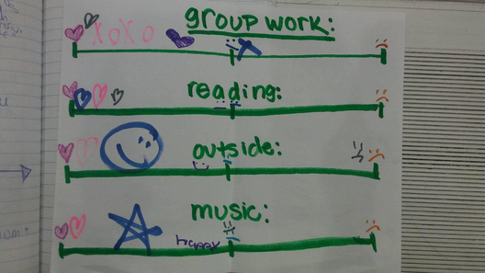
If applicable, how does this lesson connect to/reflect the local community?

Most of the students are Florida natives (FN 5/18/16), so I would like to introduce them to natural Florida wildlife, like: black bears, cougars, raccoons, possums, the red fox and deer. They will write about potential encounters they could have with these animals, based on the environment their back yard provides and what the animal prefers. Other animals relevant to the Southern United States should be discussed as well, since students have family in Georgia (FN 6/8/16) and Texas (FN 6/8/16). One student’s family is from Puerto Rico and they practice the corresponding culture. (FN 6/8/16) I would like to incorporate Puerto Rican animals, habitats and the environment as well through a compare/contrast Venn diagram.

The local community includes a few of the animals mentioned in the book: bats, beavers, snails and spiders. Students enjoy going outdoors (FN 6/2/16), so we will go outside to investigate our immediate habitat and the animals who live there.

Gorski (2008) gives suggestions for how teachers can eradicate the system-wide problems that influence low-income students in the classroom, including teaching about environmental injustice. The Florida Panther and Black Bear’s habitats are being destroyed at an alarming rate. Students will be made aware of habitat destruction, as well as the negative impacts of disregarding specific hunting laws.

I will be working as a Coach at the Boys and Girls Club over summer, so I look forward to working with these children and getting to know their place in the community. The Boys and Girls Club goes on various field trips over the summer, since I am also volunteering at Nature’s Classroom, I have suggested we visit the environmental education center (Nature’s Classroom) to allow children to experience learning about wildlife and the environment in their community- by the Hillsborough River.

How will you differentiate instruction for students who need additional challenge during this lesson (enrichment)?

Students that would benefit from enrichment will be encouraged to seek other sources of information about animals in the community, including local environmentalists and news casts/online journals from local animal behaviorists or bird watchers.

Students who need enrichment will be encouraged to create an informational video about an animal from their community’s habitat, compared to one in Gregoire’s book OR from another culture/country, like Puerto Rico. (FN 6/8/16)

How will you differentiate instruction for students who need additional language support?

-Diverse linguistic and cultural practices are a barrier to involvement because of a lack of English fluency, but teachers should develop trust between parents and the school by building upon home experiences (Finders & Lewis, 1994). I will inform parents ahead of time and encourage them to send in information they have about their country of origin’s popular animals and corresponding habitats. This is also following Finders and Lewis’ (1994) advice that parents can contribute to lessons as funds of knowledge in the community.
- Group work will ensure ELL’s do not feel isolated.
- Visual aides are provided to ensure students recognize the animals and their homes:
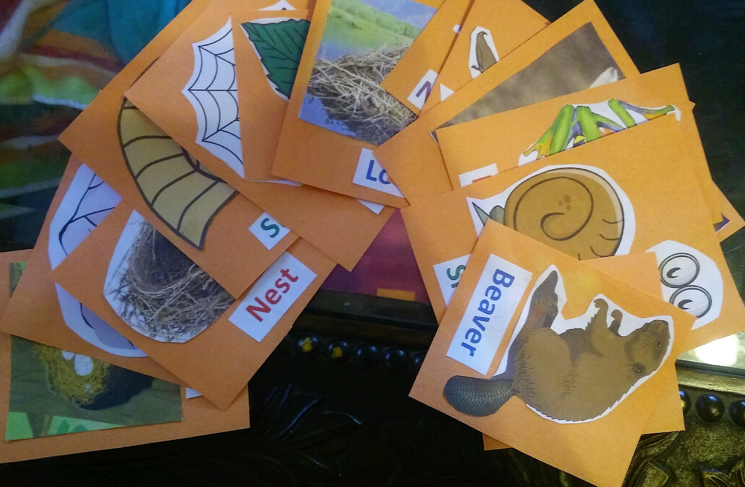
- These cards will be distributed as writing prompts:
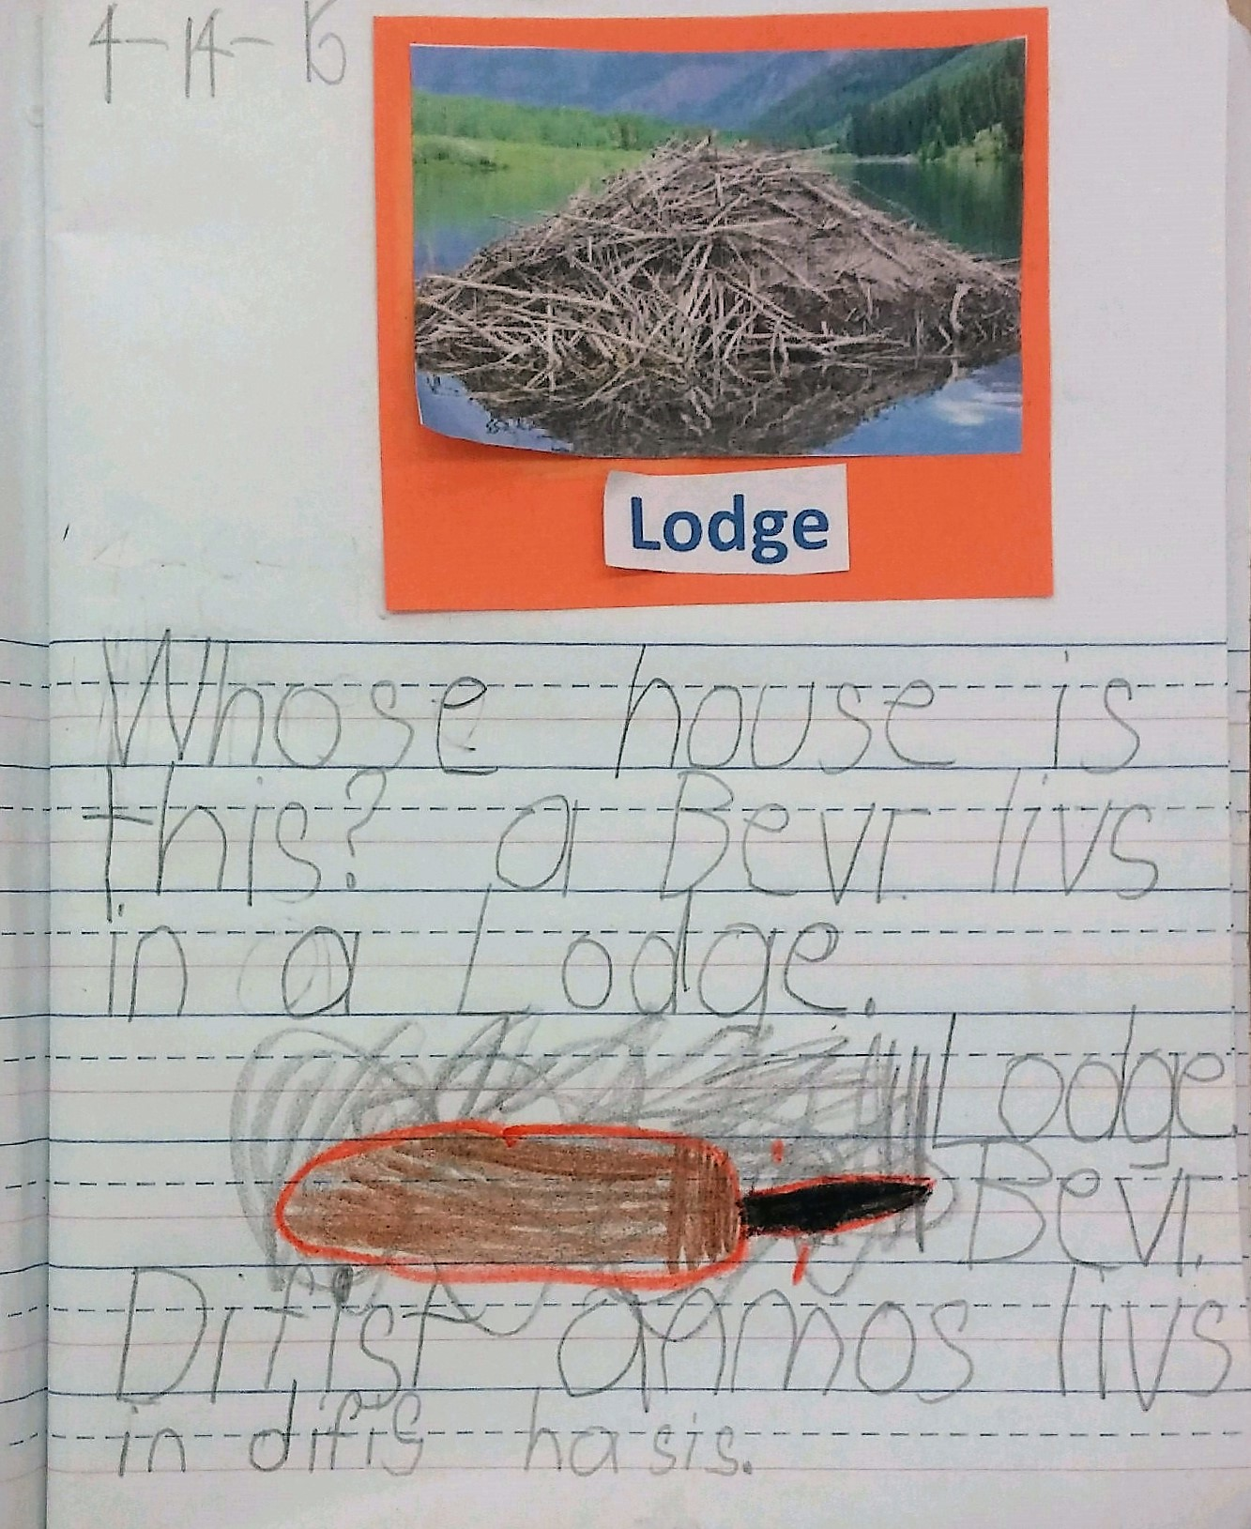
- Scaffolding through the “I do, We do, You do,” process.
- For the summative assessment, students can demonstrate understanding orally. Instead of filling in the graphic organizer the teacher can read an informational text to the students and ask questions from the guided question section to determine their understanding.
- Students will be permitted to write in their L1 (native language), then work with a partner to translate. This will be especially considerate of the student of Puerto Rican background, whose family speaks Spanish at home (FN 6/8/16).

