Mekayla Cook
CT Lesson Plan
Topic: Historical Fiction- Riding Freedom
Grades: 4th |  | Date: October 18th, 2016  Time: 65 min.s  HOT Questions:  - What are elements of historical fiction?  - How do elements of historical fiction impact Riding Freedom?  - How can I analyze the R.A.F.S. of a text to understand characters?  - What is alike and different between Charlotte and James?  - Create a poster that describes a character using text evidence.  Assessment:  How will this assessment show you that students have mastered the objective?  Exit Question:  Students will be given the “Riding Freedom Exit Ticket” (see below) about the story and characters. (Answers: 1 b, 2 c, 3 a)
Standard(s):
LAFS.4.W.1.1 Write opinion pieces on topics or texts, supporting a point of view with reasons and information.
LAFS.4.RL.1.3 Describe in depth a character, setting, or event in a story or drama, drawing on specific details in the text (a character’s thoughts, words, or actions).
LAFS.4.SL.1.1 Engage effectively in a range of collaborative discussions (one-on-one, in groups, and teacher-led) with diverse partners on grade 4 topics and texts, building on others’ ideas and expressing their own clearly.
Essential Question: What are the characteristics of historical fiction? How can I use R.A.F.S. to understand characters?
Objective: Students will be able to identify characteristics of historical fiction in Riding Freedom and consider the impact on the story. Students will be able to understand characters with text evidence.
Vocabulary: escorted, swelled, relied, reputation, worthy, churning, situation, deserve, defended, satisfied.
Materials: anchor chart paper, markers, the Teacher Edition of Journeys Unit 4, the student Journeys textbook, reading journal, teacher-created parchment paper for all students (http://www.dltk-kids.com/fantasy/parchment.html), crayons, markers, copies of the Riding Freedom Exit Ticket for all students
Opening (Engage)
Time  6 min.s  T/S  1 min.  S | Task  The teacher will ask students if they’ve ever read a historical fiction book or seen a historical fiction movie. (Pocahontas is a great example)  Together, the teacher and students will create/discuss an anchor chart displaying the Elements of Historical Fiction:  A fictional story that takes place in a real historical time period and setting.  - Based on historical events  - Authentic setting that shows something about a period or place in history  - Mix of real and imagination  - Characters: are realistic and may resemble or talk like people of the past  - Plot: includes a problem the character faces that is realistic for the time period  Together, the class will revisit questions from the pre-quiz. Students will respond thumbs up for true or thumbs down for false.  “In historical fiction, the characters are realistic.” (True)  “In historical fiction stories, the events could never have happened.” (False)
Building Understanding (Whole Group Exploration / Core):
Time  4 min.s  S  2 min.s  T  30 min.s  T/S | Task  Students will open their Journeys textbooks to page 473, Riding Freedom by Pam Munoz Ryan. Students will preview the text in small groups to look for elements of historical fiction. The groups will then share with the class what they found. (The illustrations- people look real, older clothes, stagecoaches, text on parchment paper, italics text In the mid-1800’s)  The students will be reminded of the R.A.F.S. strategy for understanding characters through: relationships, actions, feelings, and spoken word. Students will take notes in their reading notebook in a t-chart on character traits of Charlotte and James. The teacher will model creating the chart on the ELMO. The teacher will read the italicized text on page 474 aloud then add traits to Charlotte: goes by “Charley,” partially blind. At the bottom of the chart, the teacher will add a similarity: friends.  Charlotte: prideful, brave, responsible, polite, tough, understands horses, determined, persistent, calm, drives by sense of smell and hearing  James: worried, nervous, drives by sight  Both: stagecoach drivers, nervous, friends  Students will take notes during the read aloud about character traits of Charlotte and James. Throughout the text, the teacher will have students Turn & Talk about the setting, characters, and plot development and their connection to elements of historical fiction.
Lesson Closure
Time  15 min.s  S  3 min.s  S | Task  Students will be told to imagine that Riding Freedom was being turned into a movie. The students will create a character poster for Charlotte. They are to include at least 3 details from the text that tell you more about Charlotte. The poster should have her name, illustrations and text evidence. Students will be given parchment paper to design their poster on, and access to crayons and markers.  Students will be given the “Riding Freedom Exit Ticket” (see below) about the story and characters. (Answers: 1 b, 2 c, 3 a)
Differentiation: The teacher will differentiate and provide support in the following ways:
Reteach (Greatest Support) While students are working on their posters, these learners will be given individual tutoring focusing on finding character traits in the text.
Core low These students will work in a small group to share the character traits they found and locate more.
Core high These students will be asked to write a paragraph about Charlotte on the back of their poster, including text evidence of a minimum of 3 character traits.
Enrich (Least Support) These learners will retell their favorite part of the story from the perspective of a stagecoach passenger by writing a short story on the back of the Charlotte poster.
Accommodations:
(What students need specific accommodation? List individual students (initials), and then explain the accommodations you will implement for these unique learners.)
English Language Learners (3):
Use of a variety of strategies and approaches to teach reading, make sure that students are being taught vocabulary through meaningful context (not in isolation), provide background knowledge necessary in order to understand (pictures of stagecoaches, previewing the text), reading strategies that enable them to predict, connect, question, and visualize a story, extended time, working with their bilingual shoulder partner, formative assessment/checking for understanding.
Connections:
How does this lesson connect to the real world? How does this lesson connect to the
interests and/or cultural backgrounds of your students?
This lesson will address issues of gender equity that are still present today. Also, students will be presented with traits of successful people (Charlotte). Students will read or watch movies that are historical fiction throughout their lives, academically and in personal time.
The focuses of this lesson were centered around student’s responses to a Pre-Quiz given a week prior.

Notes for Teaching: Students are accustomed to working with partners and small groups, as well as being called upon by the chip selection method.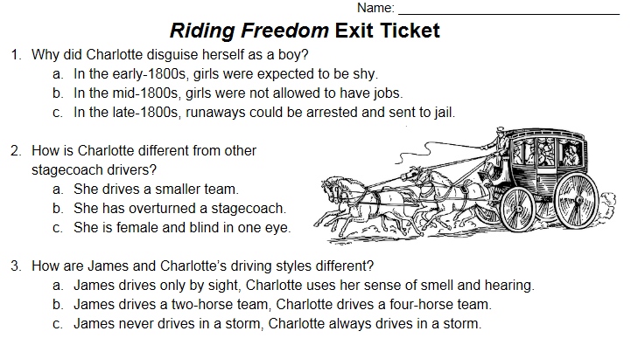
Riding Freedom Exit Ticket-
Answers: 1b, 2c, 3a

