See, hear, do! Instruction for me and you!

Promoting achievement through instruction with consideration for learning styles

Mekayla Cook

Elementary Education Intern, Hillsborough County

University of South Florida

mekaylacook@mail.usf.edu

See, hear, do! Instruction for me and you!
Background.
Spending time with fifteen five and six year olds has stimulated my own adoration of learning. The kindergartners I work with in my internship are inspirational and the insight I have gained through teaching is a result of their smiles, curiosities and learning experiences. The students attend Forest* Elementary is a Title 1 school in an area stricken by poverty. According to the area’s Community Profile of 2014, 54.1% of those in the labor force are below the poverty level. 69% of Forest’s student body receive free or reduced lunch benefits. The area is rich with diversity, 20.1% of the population speaks a language other than English at home (U.S. Census, 2010) and Forest Elementary reflects the community’s rich resource of multicultural inhabitants. The school’s population includes a 54% minority rate. My internship is fulfilled with the dedication of Mrs. J*, a Caucasian female who has been teaching kindergarten for 10 years. In the classroom, there are only 5 females. One student is Hispanic, two are African American and two are Caucasian. 40% of the remaining 10 males are white, with Hispanic and African American both equivalent to 30%. Two males are classified as English language learners. One of those, Jose*, is an energetic learner that falls below-level according to the Primary Spelling Inventory, Kindergarten Reading Test and the Yopp-Singer Phonemic Awareness assessment. According to the same assessments and other formative observations, one bright and independent African American female is notably above level, Paris*. Additionally, upon collaboration with Mrs. J, Caleb* has been identified as a friendly student of Hispanic descent that enjoys soccer and has been identified as performing consistently on level according to kindergarten standards.
After reviewing assessment data and analyzing my own observations of Mrs. J’s classroom, I witnessed unique characteristics for each student. Some students, like Paris, showed a distinct preference for working alone and participating in spoken activities. Paris is “very linguistic” according to Mrs. J and exhibits high intrapersonal skills. Other students’ enthusiasm is clear during activities that involve rhythm, songs and rhyme. Caleb exhibited high involvement and interest during a song I introduced when teaching the students about clouds in the daytime sky. Experiments and activities that involved movement or hands-on learning have been adored by nearly all students in the classroom, but especially those who fall victim to misbehavior as a result of their own energy. For students like Jose*, having the opportunity to learn with movement promotes engagement, as well as an increased level of focus that is typically absent. The learning preferences of these young students are already becoming evident in their first year of schooling. Upon realization of each student’s unique learning needs, I became intrigued by the potential for learning styles to impact student achievement. Therefore, the purpose of my inquiry was to explore the impact of instruction that considers the unique learning preferences of students for increased academic achievement and involvement. With this purpose, I wondered how I could meet the needs of my students through differentiation with consideration for learning styles?
Literature Connections.
To learn more about my wondering, I consulted literature by researching the following key words “learning styles”, “elementary” and “differentiation” through the University of South Florida library’s online article resource search engine. Three articles in particular influenced the development of my inquiry.
Eric Collinson (2000) conducted a study solidifying the fact that understanding the ways in which students learn is a key element to education improvement. Learning styles have been defined by various researchers in multiple ways, but all include the biologically and developmentally imposed set of personal characteristics that make certain teaching/learning strategies effective for some students and ineffective for others. Learning style also refers to an individual’s methods of gaining, processing and storing information. Learning style includes cognitive style, which involves reception and retention of information. In that way, learning style is a compilation of many cognitive, affective and physiological factors that combine to describe an individual’s optimum learning pattern. “Significant differences in learning style preferences are apparent in both high and low achieving students” (Collinson, 2000). This research-supported statement captured me, as I have been focusing on three students this semester, all at varying levels of achievement (above, on and below). Collinson’s article also mentions the Learning Style Inventory (LSI) by Dunn, Dunn and Price that defines learning style in environmental, sociological, emotional and physical conditions. I would love to administer the LSI to my Kindergarten class to check for consistency in the results from the article. Reported patterns of high achieving students include a preference for independent study, tactile instruction, flexibility, self-direction and minimal structure and lecture. My above level Kindergartner indicates these preferences. Collinson’s research verified that high achieving students would prefer an informal classroom design. Low achieving students learn best in groups, require variety and mobility to maintain attention and have poor auditory memory. Consistent with the study, the low level learner I work with would most likely benefit from instruction tailored to those indicated needs. Collinson’s (2000) research found that the low achieving group prefers a more formal learning environment, a preference to work with one or more peers and learning during the afternoon hours when energy levels are highest. My low level learner is very high energy, which is classroom teacher has said interferes with his learning. Perhaps instructing new, challenging topics in the afternoon would benefit his academic growth. The article verifies that learning style research can play an important role in improving teaching and learning in the classroom (Collinson, 2000).
Brenda Moustafa’s (1999) article supports the notion that “learning style theories have been found to be effective in developing strategies to teach diverse learners in the elementary school setting.” Research has found that many diverse students learn differently (Moustafa, 1999). I have witnessed the great diversity in my Kindergarten classroom, but I have not observed differentiation to meet the student’s potential varying needs in learning. Moustafa acknowledges various reading styles that can identify a child’s strengths and the best way of teaching that learner to read: visual, auditory, tactile, kinesthetic, global and analytical. Included in Moustafa’s research is the multisensory approach to teaching, which considers learning styles, and its’ effectiveness in improving achievement. The visual-auditory-kinesthetic-tactile (VAKT or multisensory) approach implies that students learn best when information is presented in different modalities (Moustafa, 1999). This concept directly relates to my wondering of how to include learning styles in differentiation for students. With the technology available today, there are limitless possibilities for modalities to present information. “A multisensory approach is an eclectic approach that teaches all children regardless of their preferred learning style” (Moustafa, 1999). This approach makes differentiation practical in the classroom and equally exposes children to multiple modes of learning. The kindergarten students are often too inexperienced to of developed all aspects of their unique learning styles, so I wonder if a multisensory approach would be the most beneficial for the classroom? This approach has provoked a dramatic increase in standardized test scores, as well as student satisfaction and motivation (Moustafa, 1999). I am now more curious about the impact of a multisensory/VAKT approach in meeting student’s learning styles and academic needs.
Jennifer Lauria (2010) is a former elementary school teacher who restates the value of differentiation through learning-style responsive strategies. Differentiated instruction strives to maximize student’s growth by recognizing student’s unique ways of learning and expressing themselves. Lauria suggests individualized learning-style homework and study strategies to build student awareness of how they learn best to increase their potential and capitalize on their strengths, as well as improving student attitude and motivation. Utilizing individualized homework prescriptions allows students to learn how to differentiate for themselves which will build student confidence in their learning. The Dunn and Dunn Learning-Style Model is mentioned as it examines the way each individual concentrates on, processes, internalizes and retains new and difficult information. The model consists of five elements: environmental, emotional, sociological, physiological and psychological. Research mentioned in the articles states that students who study according to their learning styles achieved statistically higher on achievement-test scores (Lauria, 2010). Lauria suggests that teachers use learning-style responsive approaches to differentiate instruction effectively. When students are given access to study and homework skills that build on their unique talents they can become active participants in their own educational journeys.
Each researcher values a student-centered approach that supports facilitating the needs every unique and diverse learner brings to the classroom. Learning style is clearly a complex web of various factors that can be supported through instruction and classroom settings to maximize student’s academic growth. The multisensory approach is practical to apply in each classroom, including primary grades like Kindergarten, and will allow for accessible differentiation for each student. Administering the Learning Style Inventory is a valuable asset to building responsive teaching strategies to meet the needs of learners. Additionally, what research has told us about the preferences of above level and low level learners can capitalize on the effectiveness of Response to Intervention groups. Learning-style responsive activities, instructional strategies and homework assignments are essential to promoting student’s academic development.
Thus, the actions I decided to take based on the literature were to further explore the identified above, on and below level learners’ preferences for learning in the classroom and tailor instruction accordingly through learning style responsive activities that stimulate various senses, instructional strategies that support learning and the inclusion of flexible grouping.
Methods/Procedures.
To gain insight into my wondering, I introduced strategies to assist student understanding in my own teaching, conducted various forms of data gathering (interviews, field notes, an analysis of student work, reflective blogging, considered the critique of a peer and test scores) and analyzed the data comparatively. I identified a below, on and above level Kindergartner by examining student’s test score data. The learners I chose, Jose*, Caleb* and Paris*, each demonstrated their appropriate level on the Kindergarten Reading Assessment, Primary Spelling Inventory and other unit tests the students have taken in math and science.
On the Primary Spelling Inventory given earlier this year, Paris exceeded expectations by scoring in the Late Letter Name-Alphabetic category. The kindergartner showed mastery of initial and ending consonant sounds, as well as short vowels. Additionally, she was able to identify a few consonant digraphs and blends. On the Developmental Reading Assessment, Paris was able to accurately connect to the text and answer comprehension questions. For Paris’ low number of miscues throughout the DRA, she scored in the advanced range for oral reading with 98% accuracy. The reader is still developing her monitoring or self-correction skills, as well as her ability to preview the text. Paris is currently reading on a level 8, well above the level 6 requirement for the end of kindergarten. On unit tests for math and science, Paris performs consistently above level or demonstrates adequate understanding. For example, while sorting shapes, Paris received a perfect score on the unit 5 test, as well as a perfect score on the unit 3 test involving counting. The unit 3 test only required a passing score of 11, but Paris achieved a full 16 points. The same performance was given on the unit 2 test of comparing sets. While writing, Paris’ work displays an ability to write with proper conventions (spacing, capitalization, punctuation) and utilizes sight words appropriately and accurately. Paris is currently on list 5 of sight words. Paris receives high-level enrichment during schoolwide designated Response to Intervention.
After an analysis of various test scores and student work, Caleb demonstrates learning consistently on level for Kindergarten. On the student’s progress alert, his classroom teacher reported his performance as satisfactory and on level. On the Primary Spelling Inventory, Caleb’s score ranged him in the Middle Letter Name-Alphabetic stage of spelling acquisition. For Response to Intervention at Caleb’s school he benefits from a small group focusing on low-level enrichment. Caleb has obtained passing scores on unit tests involving comparing sets, counting, the five senses, the nature of science and identifying numbers. During the student’s Developmental Reading Assessment, Caleb demonstrated proficiency in reading engagement and printed language concepts, but obtained a 7/9 score for oral reading. The student made two miscues, but read with 96% accuracy which placed him in the independent reading level for the level 3 text. Caleb is currently reading at a level 3 during guided reading time. Caleb masters sight word lists after an average of two weeks of studying and is currently on list five.
Jose has been identified as performing below level or needing improvement for his lack of phonemic awareness. According to Jose’s performance on the Primary Spelling Inventory, he has recently emerged to the Middle Letter Name-Alphabetic stage. He was unable to spell any words correctly, but could recognize most beginning consonants, a few final consonants and a single short vowel sound. On the DRA, Jose acts as an emergent reader who self-corrects at least 1 miscue, but neglects to self-correct all. Jose read a level 2 during the DRA and read at a low independent level, demonstrating an ability to read with 94% accuracy. Earlier in the year, Jose received progress monitoring as part of his Tier 2 Response to Intervention for letter sounds. After two weeks of interventions, the student made minimal gains. Now, Jose receives Tier 3 intervention and works with a Language Master to help him recognize sight words. Jose has an ESOL specialist who acts as aide throughout the week and works with a small group and tutor twice a week. . Through daily observation of student work, use of screening assessments, placement tests and other measures of academic achievement, Jose’s classroom teacher has recognized that he has a deficiency in reading. The county mandates that his parents are notified, so they are aware that Jose shows weakness in: phonemic awareness, fluency, comprehension and phonics.
In addition to considering student’s test scores for their placement in my study, I observed their behaviors. I began my inquiry process by investigating student’s learning patterns. I accomplished this through field notes, surveys/interviews with the students and engaging in nonacademic related conversations with the young learners. Additionally, I interviewed their classroom teacher for any further interpretations of their learning preferences.
​From the interview, I was able to gain insight I am not exposed to from my once/week time in the classroom. Paris is an above-level kindergartner who has perfectionist tendencies. Paris will shut down when she is frustrated or unable to complete a task to the highest standard. She enjoys reading and writing. Paris is very well-behaved and benefits from the structured environment the classroom teacher has created. She is generally on-task, but requires occasional redirection. Paris frequently needs reminded to be patient or kind to her peers, as she will laugh when she thinks they have done something dumb. Paris has even laughed when others are wrong. Paris can work well with others, depending on the peer she is paired with. An interview with the learner indicated that she preferred working alone. The student has claimed that during Daily 5 reading time, she prefers to read to self because she “doesn’t always get a turn,” when she reads with a peer. Paris can be a great leader when she is in the mood, but needs to work on encouraging others. Oddly, Paris does not complete her homework. However, the student’s classroom teacher does not push the subject since Paris is exceeding academic expectations. In the interview, the teacher remarked that Paris is an independent learner who is intrapersonal and very linguistic.
From a synthesis of interview data with Caleb, and his classroom teacher, it is implied that Caleb is an interpersonal learner who enjoys kinesthetic learning activities. The student is well-behaved and receptive to learning, which led his teacher to describe him as “perfect.” The student has disclosed to me his adoration of playing soccer, he frequently plays soccer on the playground during recess and is part of a community team. During lessons in which I utilized hands-on activities, like a science lesson on gravity, the learner was engaged and participated appropriately. During a science lesson that included a song to comprehend various cloud types, the learner displayed particular interest. From my observations of other songs involving movement, rhyme and music, the learner demonstrates auditory learning qualities. Caleb gets along well with his peers and does well in group activities. His interpersonal skills are evident. In an interview with the student, he claimed to enjoy working with a friend for activities and disliked alone time.
Jose demonstrates enthusiasm for learning, but is often led to misbehavior by his troubles with focusing. The student’s teacher says that he lacks self-control and struggles with following directions from his high energy disposition. In an interview with the student, he indicated a preference for moving around a lot and even got up and spun to demonstrate his adoration for movement. Therefore, it is clear that the kindergartener is highly kinesthetic. An interview with Jose revealed that he very much enjoys group work and prefers to read with a peer.
With consideration for the kinesthetic, auditory and grouping preferences of my focus students, I planned my lessons to meet their preferences. During a science lesson on the daytime sky focusing on clouds, I included an outdoor investigation, visual indications, a song and plenty of hands-on learning opportunities. I collected student work examples and reflected on my lesson to consider student’s learning preferences, which can be witnessed at the following link: http://mekaylaintheclassroom.weebly.com/mekayla-in-the-classroom/university-supervisor-observation. The instructional materials seemed to resonate with the students. Caleb enjoyed the song and chart with visual indications of cloud types. The investigation utilized kinesthetic, auditory and visual aspects. The worksheets and cotton balls offered opportunities to work on their writing skills, as well as practice their creativity while engaged in hands-on learning. For the next science lesson, exploring gravity and mass, a vocabulary term poster was made and a kinesthetic activity engaged students. Also, they were instructed to write or draw about the experiment in the science notebooks, an independent activity that offered flexibility in how learners can demonstrate their knowledge of the subject. Upon reflection of the lesson (which is included here: http://mekaylaintheclassroom.weebly.com/mekayla-in-the-classroom/collaborating-teacher-observation), I recognized the impact of hands-in activities in engaging all my focus students. Through collaborating with a peer and discussing the lesson’s adherence to learning styles, I recognized the potential to further this lesson for auditory learners, like Caleb, by including a song (http://mekaylaintheclassroom.weebly.com/mekayla-in-the-classroom/peer-coaching-blog). I also considered learning styles while designing and implementing a lesson on decomposing numbers. The lesson included technology, education videos (including a song), hands-on learning with manipulatives and discussion opportunities to meet various students’ learning preferences. The first worksheet allowed for group work, which meets Caleb and Jose’s preference for peer collaboration. While the second worksheet, my formative assessment for the lesson, allowed for an independent demonstration of comprehension of decomposing numbers. A reflective blog post is available here: http://mekaylaintheclassroom.weebly.com/mekayla-in-the-classroom/ct-observation-2. Additionally, I made a chart to analyze the data gathered through a teacher comprehension checklist and the student’s worksheets to gather understanding. My above, on and below level learners confirmed comprehension as a result of the lesson’s ability to meet various learning preferences.
While analyzing my field observation notes, formative assessment tools (charts, checklists) and student work examples, I highlighted and organized the data according to the student and what style they were indicating a preference for learning with. Also, I created charts to compare data. Below, you can witness a record of my data collection and analysis throughout the duration of this inquiry.
Date | Data Collection strategies | What I’m Looking For/How It Relates to My Wondering | I’m Noticing/ Data Analysis and Claims | Next Steps/Plan To Try
1/21/16 | Test scores | Finding students of different achievement levels to consider for differentiation and if their learning styles vary | Above level student: female, African American, independent  Below level student: male, Hispanic, ELL, group work  On level: male, Hispanic, peer collaboration | Gather data of writing samples, student preferences  Information of learning style varieties and correlation to achievement level
1/28/16 | Pictures of student work/free write examples  Article | Evidence of learning styles  Collinson, E. (2000). A survey of elementary students’ learning style preferences and academic success.  Classroom environment and grouping preferences of students AL/BL and their learning styles | BL student chose to sketch for prewrites- more visual learner  AL/OL student chose to write lists  Students can write sentences with proper capitalization and punctuation when prompted. Lower level still struggles greatly. | Continue focus on sight words on most recent student lists.  Encourage the use of punctuation (!) and elaboration while writing for AL/OL  Improve BL through phonemic awareness, consider ELL needs  Give multiple intelligences test and home background survey
2/4/16 | Home survey  Multiple intelligences test, given orally with simplified language for grade  Articles | Background info- live with, favorite color/game/  sport/movie/food/subject/  song/book to BL student  Intelligences test for preferences/learning styles: music, body, nature, word, math, self, people and picture/visual  Articles on learning styles/differentiation opportunities | BL lives with 2 older sisters, Mom and Dad. Enjoys art, Pete the Cat, transformers, Mario Kart, soccer, red, hot dogs and The Cat in the Hat  Article synthesis/analysis  http://mekaylaintheclassroom.  weebly.com/mekayla-in-the-classroom/article-summaries | Interview CT for more info on AL learner (also OL and BL)
2/11/16 | CT Interview notes | What the classroom teacher notices about students’ learning styles, behavior, grouping preferences, achievement and social interactions | See pdf of raw interview data (AL and BL learner) and my analysis of answers for the Above level learner  http://mekaylaintheclassroom.weebly.com/mekayla-in-the-classroom/inquiry-student-interview-blog | Give home survey to AL student  Gather homework data  Create/give students homework preference survey
2/18/16 | AL home survey  Homework data:  Pictures, Interviews with students and CT | Learning preferences, background information  Homework is given on Fridays and collected the following Friday. There is a poem for reading and 2 math sheets. A monthly HomeFUN project goes home to encourage home/school relationship. The AL learner doesn’t do homework, occasionally she does the math homework on her own. BL and OL work with their parents to complete homework | The student lives with her Mom, Dad and Sister. She likes reading (The 3 Little Pigs), soccer, black/blue, Rugrats, chicken/shrimp and Super Mario.  The BL learner does homework with his Dad, prefers drawing over writing, likes reading and wants to make something with his hands. He is allowed to use the computer at home to do iStation when he behaves in school. The AL student enjoys science, reading and writing, but her Mother does not check her planner. She wishes to make a craft and has internet/computer access sometimes to play chess. | Incorporate a significant amount of hands-on learning. Consider differentiating homework for student’s interests and to allow more independence when completing homework.
2/25/16 | Photos, Internet research (US Census, City’s website, Community Profile, SDHC) | How student’s environments influences their learning, home life and consideration of academics | See reflective blog post including photos: http://mekaylaintheclassroom.weebly.com/mekayla-in-the-classroom/community-investigation-blog  15.5% of the total population are individuals below the poverty level. 54.1% of those in the labor force are below the poverty level as of 2014. 20.1% of the population speaks a language other than English at home and 22.7% of those speak Spanish at home and speak English “less than very well.” There are 662 students enrolled: 18.88% African American, 30.51% Hispanic, 43.35% white. The school is a Title I school, 69% free and reduced lunch and a 54% minority rate. The school grades have been decreasing: 2013-14: C, 2012-13: C, 2011-12: B, 2010-11: B. | How can we incorporate the natural surrounding environment into the classroom?  Lessons on natural resources, habitats, life cycles and locally-grown food.​  How can we inspire students to take responsibility for their community?  Peer observation of lesson to collaborate on my professional development with consideration for learning styles in next lesson  Science lesson with hands-on activities (kinesthetic). Include student life/community relevance  With a large English as a second language population, there is a strong call to differentiate instruction for language learners.
3/3/16 | Peer’s observational field notes  Journal entries, teacher observation, student’s responses during lesson | Inclusion of noted consideration for learning styles  Student learning with consideration for lesson planning for learning styles | See reflective blog post for what I learned about learning style focused pedagogy from peer’s notes and our conversations: http://mekaylaintheclassroom.weebly.com/mekayla-in-the-classroom/peer-coaching-blog  Student preference to draw/write for their Science journal entries. Students recorded their observations and inferences in their science journals using the key terms and labeled their illustrations. The opportunity and be up, engaged and moving in the classroom promoted learning. See lesson reflection: http://mekaylaintheclassroom.weebly.com/mekayla-in-the-classroom/collaborating-teacher-observation | Include songs/chants for auditory learners  Stay for conferences
3/10/16 | Observational notes during Parent/Teacher conference | Parental involvement and it’s connection to student motivation, behavior and academics. | The AL and OL learners had phone conferences. The parents are consistently involved, but busy with work and other obligations. “A phone conference is better than no conference,” my CT remarked. During conferences they discuss academics and behavior including showing parents examples of student’s work and offering strategies to do at home. A resource sheet included various apps to promote learning, flashcards were distributed and sheets that explain reading strategies used in the classroom were given to parents present. Unfortunately, the BL learner’s parents did not show up, though they intended to. My CT spoke briefly with the student’s father on the phone. | Offer students opportunities for independence when completing work or planning behavior goals so they don’t need to rely on parents.
3/24/16 | Research: textbooks, reflection  Formative assessment (worksheet, observations)  Consider Performance Tasks as an alternative to traditional assessment | Improving my own assessment abilities through formative assessment that considers student’s preferences | See reflective blog post: http://mekaylaintheclassroom.weebly.com/mekayla-in-the-classroom/mid-semester-goal-setting  Includes: reflection, research, application of learning (teacher checklist) and Performance Task. | Consider including an Exit Slip in all lessons: allow drawing, writing and numbers to explain thinking. Use a teacher checklist of participation and various components of conceptual understanding. Independent worksheet as formative assessment of understanding.  Diagnostic interviews with students to understand learning.
3/31/16 | Checklist/chart of student participation, grasp of concepts  Independent worksheet | Student participation levels related to the inclusion of videos and a hands-on activity  Demonstration of student understanding | Full student participation! Particularly interested in sharing their worksheet with the class  The majority of the students completed the worksheet with perfect accuracy. Two students made only one mistake. A below-level female struggled and misplaced five dominoes. Another learner, who only shows issues in mathematics, misplaced four dominoes. | Continue use of checklist during instruction to ensure each student gets a chance to be involved. Offer more opportunity for sharing/talking about mathematics. Exit slips for lessons  I hope to do a small lesson with these two learners to give individualized attention to their academic needs while decomposing numbers.

(* = pseudonym)
Findings.
As a result of analyzing my data, three important things I learned include:
- Students’ engagement levels are heightened as you appeal to the preferences they have indicated for learning.
- Student achievement is ensured, regardless of prior-indicated level, if you demonstrate multiple approaches to teaching with consideration for learning styles: visual, auditory and kinesthetic.
- The importance of providing individualized intervention methods with consideration for student’s learning preferences for effective results.
Engaged students are highly receptive to learning and making connections that will ensure comprehension. Students’ engagement levels can be increased if you appeal to the preferences they have indicated for learning. During my decomposing numbers lesson, I included manipulatives for kinesthetic learners, like Jose, an independent activity for students like Paris who prefer to work alone, and a song for auditory learners like Caleb. As a result of my appeal to multiple learning styles, I achieved full student participation throughout the lesson. I maintained a checklist (see, “Participation Checklist” below) of student contribution as they shared their thinking, answered questions or validated their work. In comparison to previous lessons I have observed or taught, with minimal engagement, this situation demonstrates the inclusive aspects of appealing to learning styles in the classroom.
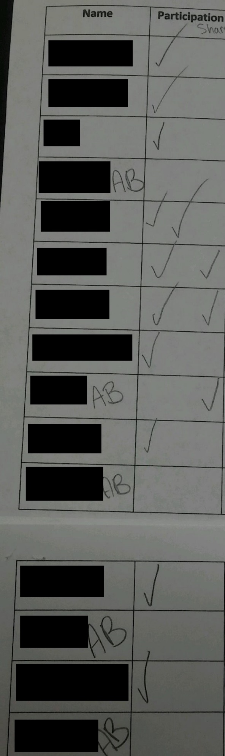
“Participation Checklist”
To the left
When students have already been identified as being above, on or below level, certain teacher expectations can unfairly limit student achievement. By maintaining an open mind and differentiating instruction, educators can provide equitable access to academic achievement. Student achievement is ensured, regardless of prior-indicated level, if you demonstrate multiple approaches to teaching with consideration for learning styles: visual, auditory and kinesthetic. During the decomposing numbers lesson mentioned in the previous paragraph, I was able to meet the needs of various students in the classroom. By including various forms of formative assessment, including observations, worksheets and simple diagnostic interviews with students, I was able to determine student’s comprehension levels following a mathematics lesson. Below, you can witness a chart I created to keep track of the results of a worksheet to demonstrate student understanding. The focus students mentioned in this study are indicated with a * and their worksheets have been inserted below.
Add it up! Worksheet Results
Student Name | Correct placement of addition statement | Incorrect placement of addition statement
(Removed to ensure anonymity) | 12 | 0
(Removed to ensure anonymity) | 12 | 0
(Removed to ensure anonymity)* | 12 | 1
(Removed to ensure anonymity)* | 13 | 0
(Removed to ensure anonymity) | 14 | 0
(Removed to ensure anonymity) | 13 | 0
(Removed to ensure anonymity) | 13 | 0
(Removed to ensure anonymity) | 9 | 4
(Removed to ensure anonymity) | 13 | 0
(Removed to ensure anonymity)* | 12 | 1
(Removed to ensure anonymity) | 13 | 0
(Removed to ensure anonymity) | 12 | 0
(Removed to ensure anonymity) | 8 | 4
(Removed to ensure anonymity) | 13 | 0

Student Work
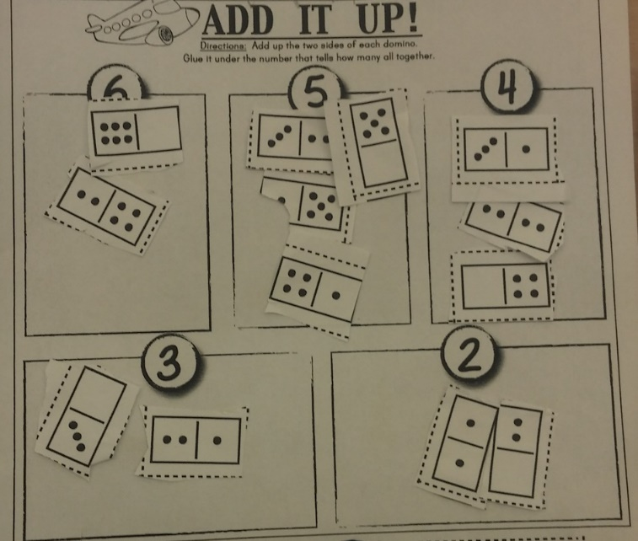
Caleb’s worksheet: misplaced 6 domino in 5 section.

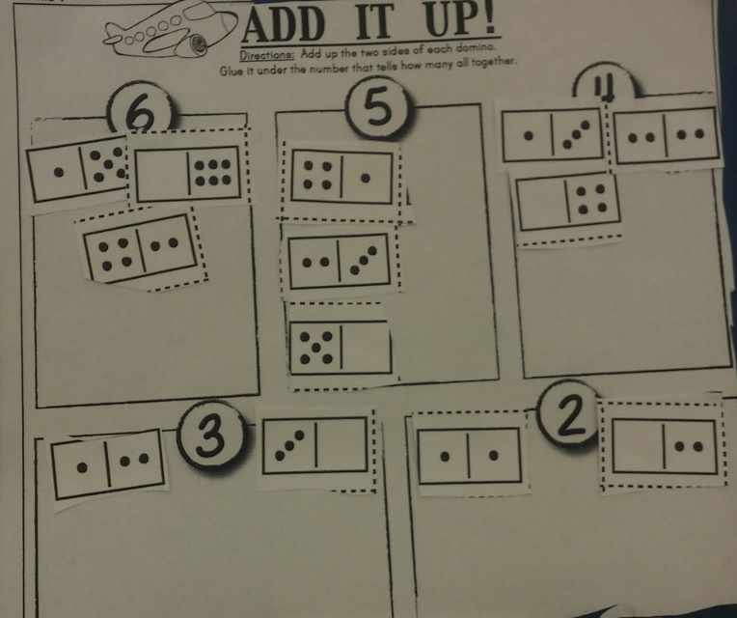
Paris’ worksheet: no mistakes

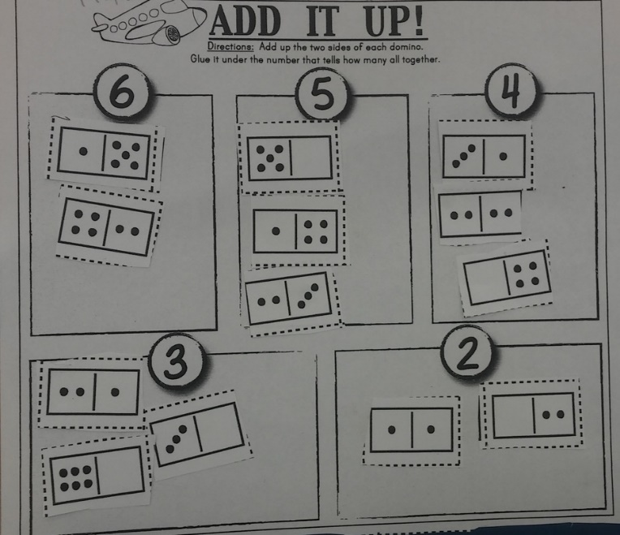
Jose’s worksheet: misplaced 6 domino as 3

Response to Intervention is a schoolwide policy that addresses the unique needs of learners each day in a small group setting. During RTI, the students receive small group tutoring for their sight word knowledge. Caleb works with his peers, which he prefers, and another kindergarten teacher, who recognizes his need for auditory and kinesthetic based learning activities. I tutored Caleb by providing one-on-one interaction through playing the Zap! Game with his sight words. The words are written on cards and the student must respond quickly or he loses the game. Also, a Zap! card can come through the rotation, resulting in an automatic loss. Through the small group intervention and tutoring sessions with me, Caleb was able to maintain growth in his sight words. Below, you can view a chart of Caleb’s sight word mastery progress.

Conclusion.
Through pursuing this inquiry, I have furthered my professional development as an educator. I realized the importance of recognizing student strengths and building upon them, in order to address student weaknesses. As a teacher, I plan to vary my instructional methods in order to reach all students. The importance of differentiation is made clear as it maximizes each students’ growth by acknowledging student’s different ways of learning, interests, responding to instruction and preferred ways of self-expression (Lauria, 2010). By offering different modalities for the presentation of information with consideration for learning styles, I am able to engage all learners in the classroom by addressing their different learning and demonstration of learning preferences. I have discovered the individuality of students and how their unique backgrounds and personalities influence the way they learn. To see such young students making great academic progress is inspiring and reminds me of my own adoration of learning. My teaching will value student’s individuality and address student’s preferences for learning in the classroom.
In my professional development, I strive to reach all students during my lessons. To engage students in each lesson, I have included aspects of learning that will appeal to auditory, visual and kinesthetic learners. I have utilized educational songs, meaningful gestures and visual aides to engage, inform and consider as formative assessment as my kindergarten students are learning. In the future, I plan to continue my inquiry about differentiation for learning styles. I believe it will be intriguing to find the differences between kindergarten learners and intermediate/upper-Elementary students’ learning preferences. Also, individualized homework assignments have a powerful potential to improve student achievement and attitudes, which will allow for a more student-centered classroom to accommodate diverse learning styles and needs (Lauria, 2010). As I develop professionally and further my pedagogy, I plan to inquire into the potential for individualized homework as differentiation to improve student achievement.

References
Collinson, E. (2000). A survey of elementary students’ learning style preferences and academic success. Contemporary Education, 71(4), 42-48. Retrieved February 13, 2016.
​
Lauria, J. (2010). Differentiation through learning-style responsive strategies. Kappa Delta Pi Record, 47(1), 24-29. Retrieved February 13, 2016.

Moustafa, B. (1999). Multisensory approaches and learning styles theory in the elementary school. Summary of reference papers. ERIC. Retrieved February 13, 2016.

