Literacy Portfolio
Mekayla I. Cook
University of South Florida
College of Education

Abstract
In this paper, a young learner has been assessed through various tests, surveys and screenings to develop an extensive literacy portfolio. The student, Lucy Heerdt*, is a kindergartner at a local Elementary school I have been interning with for the semester. The cultural context of Lucy’s learning has been examined, including her school demographics and personal background. Through surveying, Lucy’s initial attitude toward reading and prior experiences have been collected. Lucy’s emergent literacy skills, focusing on phonemic awareness, have been tested. Also, with a spelling inventory, Lucy has been analyzed for her stage in spelling development. Finally, a vocabulary screening was administered to measure the student’s initial implied comprehension. After each assessment, instructional decisions were made to benefit Lucy’s learning. A reflection is included at the end of the paper that addresses how my understanding of my student has changed, what practices I would apply as a teacher and what factors in her current classroom are helping or hindering her development.

Literacy Portfolio
To see the faces of fifteen young students light up with excitement and comprehension during the retelling of their favorite story is an experience only the field of education can offer. Kindergarten students’ enthusiasm for learning is incomparable. To be a part of children’s academic, social and character development is an honor to be cherished. While interning at Wheelus Elementary*, the education of ten boys and five girls lies partly in the hands of a dedicated future teacher and current learner. I am able to benefit from the student’s own process of learning in my educational journey, whether the kindergarteners realize they’re teaching or not. That is the beauty of preparing to be an educator, the pursuit of lifelong learning through experience and continuous adaptation to the needs of students through observation.
School Demographics. Wheelus Elementary’s vision is to “ACHIEVE- A Community of High-performing Individuals Emphasizing the Value of Education.” Of the entire school, 69% of the student body is eligible for free or reduced lunch, classifying Wheelus Elementary as a Title I school. In the past two years, Wheelus Elementary has received a C rating, and B’s the two years prior. Mrs. Smith*’s classroom is dominated by White students (40%), with an even 26% for both Hispanic and African American students. Only one student (6%) identifies as Multi-racial. Schoolwide, the minority rate is at 54%. Of the 678 total student enrollment, 45% of the school is White with Hispanic rates the next highest at 30%. One young male student comes from a home where the dominant language is Spanish, and he is the only English language learner in the class. I am fascinated by his progress, and hope to discover a lot about the education of ELL’s through his learning process. Of the whole class, 66% are eligible for free or reduced lunch. Seven students are able to obtain their lunches at no cost, based on their families’ financial situation. Reduced lunch prices are offered to three students in the class. Four of the young learners have specified Individualized Education Plans (IEP’s). IEP’s are in place to set appropriate goals for student development, and ensure they are met with the support necessary for academic success. A Speech Language Pathologist conducts group therapy sessions with five learners from the class, more students are being tested for eligibility for speech services.
Focus Student. For the purposes of focusing on a single student, I chose the young learner Lucy Heerdt*. Lucy is a five-year old female in Mrs. Smith’s diverse kindergarten class. She is eligible for free lunch and will be benefitting from speech therapy services for her debilitating speech impediment. Part of the behavior management system in Mrs. Smith’s class includes a behavior tracking chart utilizing colors to represent behavior, red indicating bad behavior and green for following all the classroom rules. Students are able to earn a blue or purple day if they show exceptional behavior choices. Lucy is a kind-hearted girl who rarely moves her color to a negative indication. For helping a fellow student up on the playground and escorting him to the teachers during recess, she was able to earn a blue day. Her kind behavior gives her an advantage in social environments, like school. Also, Lucy is a great listener. She is attentive during class and participates in all the activities, granting her leverage while learning. As indicated by the Kindergarten Reading Test (KRT) administered in the beginning of the school year, Lucy has room for improvement in her literacy skills. While being tested on letter identification and sound recognition, Lucy only correctly recognized 15 out of 83 assessment questions. Lucy was unable to accurately identify any factors in the phonemic awareness portion of the KRT. She could not identify rhyming words, initial or final letter sounds. Lucy scored 9 out of 18 possible action prompts correct while being assessed on concepts of print. Also, Lucy will gain improvement in her speech capabilities through intensive group therapy. It is often near impossible to determine what Lucy is trying to say, and she clarifies through miming her intentions. Through additional interview questions I was able to uncover Lucy’s preferences both in and out of school. Lucy enjoys books about the adored Clifford the Big Red Dog and books about animals in general, especially horses. She also chooses to spend her free time playing outside. Lucy can ride a bike with training wheels, demonstrating that she has competent motor skills. In school, Lucy enjoys being able to attend the Art class special on Tuesdays. There is plenty of room for improvement in Lucy’s literacy and academic skills and she has the willingness and support necessary to surpass any learning objective set for kindergarteners.
(* = Pseudonym)

Attitude Toward Reading

The ERAS
A student’s attitude has been credited as being a critical factor in reading achievement. Students need to be interested in the material and engaged with an emotional response to the text. In order to promote reading proficiency by estimating student attitude levels efficiently and reliably, The Elementary Reading Attitude Survey (ERAS) was developed. The survey collects opinion-based data on a scaled level, 1 being the most dissatisfied and 4 indicating happiness. The levels are illustrated with the charismatic cat Garfield’s dramatic facial expressions. Students are scored on their recreational reading preferences, as well as their academic reading attitudes. Together the scores can be combined into a full-scale raw score indicating an individual student’s overall attitude about reading. Tables are provided to compare scores in percentile ranks by grade and scale, as compared to a study administered to over 18,000 students in Grades 1-6 stratified to the American population. The ERAS acts as a tool for teachers and the general public to estimate the attitude levels of students and encourage assessment efforts that considers the role of attitude in student literacy development.
ERAS Administration. In order to administer the ERAS, Lucy and I sat comfortably together during time designated for reading centers. The class was chattering at a tolerable level, offering privacy and stifling any possible peer pressure or hesitation during the assessment. She was informed that the survey was not a test and there was definitely no right or wrong answer. To appeal to her friendly spirit, Lucy was made aware that this was just a way to get to know her better. The questions were read one at a time, twice over to ensure Lucy was able to comprehend what was being asked. The questions all begin with “How do you feel,” so Lucy was reassured that the ERAS was just a tool to get to know her preferences and emotions, not a test. Since Lucy was still learning how to properly and accurately mark with a pencil, she was accommodated accordingly in my circling of the accurate portrayal of her opinion according to the Garfield character she pointed at. Lucy seemed skeptical of the purpose of the assessment, so it’s possible that she tailored her answers to what would be considered appropriate by the adult figure of authority. As a student who just started kindergarten she is unable to read independently, thus her answers involving individual reading capability are mostly rendered invalid. However, she is able to read by looking at pictures and through repetition of retold stories.
Results. Scores of the ERAS are compared by percentile ranks to a national scale that considered the overall ethnic demographics of the United States population when the survey was developed. In response to questions investigating Lucy’s attitude on recreational reading, she claimed a raw score of 37 out of 40 possible points. Lucy seems to enjoy spending free time reading, reading for fun at home or doing school and participating in out of school activities relevant to reading, like going to the bookstore. Lucy’s raw score ranks her in the 86th percentile of the students surveyed. Therefore, her attitude is greater than or equal to 86% of the population surveyed. Lucy’s trend in her willingness to enjoy reading outside of school is a great indication of her potential for literacy growth. Academic reading had a slightly less enthusiastic response from Lucy, though I theorize that her opinions were still tailored to what she considered to be expected of her. She claimed 33 out of 40 potential points on the Garfield scale of happiness for reading for academic purposes. Lucy indicated very low pleasure derived from stories she reads in class and reading out loud in class. Her academic raw score places Lucy in the 63rd percentile rank for comparison. So, most students scored less than Lucy on the academic reading opinion evaluation. In total, Lucy’s full scale raw score sums up to 70. According to the percentile ranking system, Lucy is in the 78th percentile of overall reading enjoyment. Following that statistical guideline, it is indicated that only 22% of students surveyed near Lucy’s grade level scored the same level or higher in overall reading attitude. Lucy has indicated she enjoys reading recreationally and academically at a level higher than the majority of students comparable to her age.
Instructional Decisions. In response to Lucy’s specific literary preferences and academic potential, with consideration for her school and home environments, multiple instructional decisions can be implemented to benefit her learning.
Family Literacy Initiative. During my ERAS interview with the student, Lucy revealed that her Father and Mother both read to her at home. A family literacy initiative allows the gap to be bridged between the home and school communities. According to research, “Schools that value parents as educators and homes as learning environments have great potential for encouraging children’s progress,” (Berger 1995; Barbour 1998; Dever 2001; Darling 2005). It is especially important that emergent literacy students in kindergarten begin parental immersion in learning to begin a lifelong love of education. Lucy does not have a library card for her local public library. The library is a great resource for books, as well as community activities that support learning and involve the whole family. A way to embolden the family literacy initiative is to encourage parents to register their children for a public library card. Through Project EASE (Early Access to Success in Education) the frequency and quality of interactions through book-centered activities involving family participation had great gain for low-achieving students who began with low language skills and strong home literacy support. (Jordan, Snow, Porche, 2011.) As indicated by Lucy’s low Kindergarten Reading Test results and at-home support system, she is an ideal candidate to benefit from parental engagement in meaningful ways to support her literacy development.
Alternative Learning Environments. Lucy’s preferred location for her free time includes opportunities for outdoor activities, like riding her bike. Outdoor environments have proven to benefit children’s abilities to imagine, think and reason. Through heightened logical abilities from nature contact, students are capable of maintaining better concentration and less inattention and impulsivity (Chawla 2015). Lucy’s willingness to listen would allow her to benefit from an outdoor environment that she not only enjoys, but would foster better learning abilities to comprehend literature. Having outdoor reading sessions for read-alouds and independent reading time gives students a pleasurable experience opportunity that contributes to their ability to learn. Lucy would academically benefit from an alternative learning environment tailored to her inclinations; “Children tend to obtain significantly higher achievement test scores and report better attitudes toward learning under instructional conditions that match their environmental preferences” (Dunn, 1987).
The Arts in Instruction. Research has specified that the arts make a significant contribution in twelve academic areas, including literacy skills (McLaughlin, 1991). Students at Wheelus Elementary are offered an art special one day a week, which Lucy has identified as one of her favorite subjects. To meet Lucy’s desires, art projects could be integrated into the classroom that involve responding to literature in creative ways. Hands-on activities that highlight literacy skills and allow students to express their emotional connection to the story will engage students like Lucy. “Reports of the effects of arts education on academic achievement appear to be most notable in programs that are specifically designed to help students with reading problems learn to read through the arts” (Eisner, 1998). Young learners, especially those with initial low test scores, like Lucy, will benefit most from the art’s involvement in literacy education.
Reflection. Through the Elementary Reading Attitude Survey I was able to connect with Lucy and signify that her opinions are important in her education. Through increased knowledge and understanding of Lucy’s specific literature desires and learning preferences, as indicated by the ERAS and interview questions, I am able to adapt instruction to benefit her academics. The assessment contributed greatly to the understanding of my focus student’s strengths, weaknesses and the best methods to help Lucy achieve her learning goals. Further, the initial measurement of the learner’s attitude will provide a reference for determining the effectiveness of instructional programs in improving student’s educational perspectives pertaining to literacy. In my experience with administering the assessment, I learned the best practice in retaining honest student opinions through interviews. I was also able to apply the assessment methods and tools I’m studying in Emergent Literacy to real-life scenarios. In my next assessment administration, I hope to have an assessment method available that is immediately relevant to Lucy’s academic capabilities.

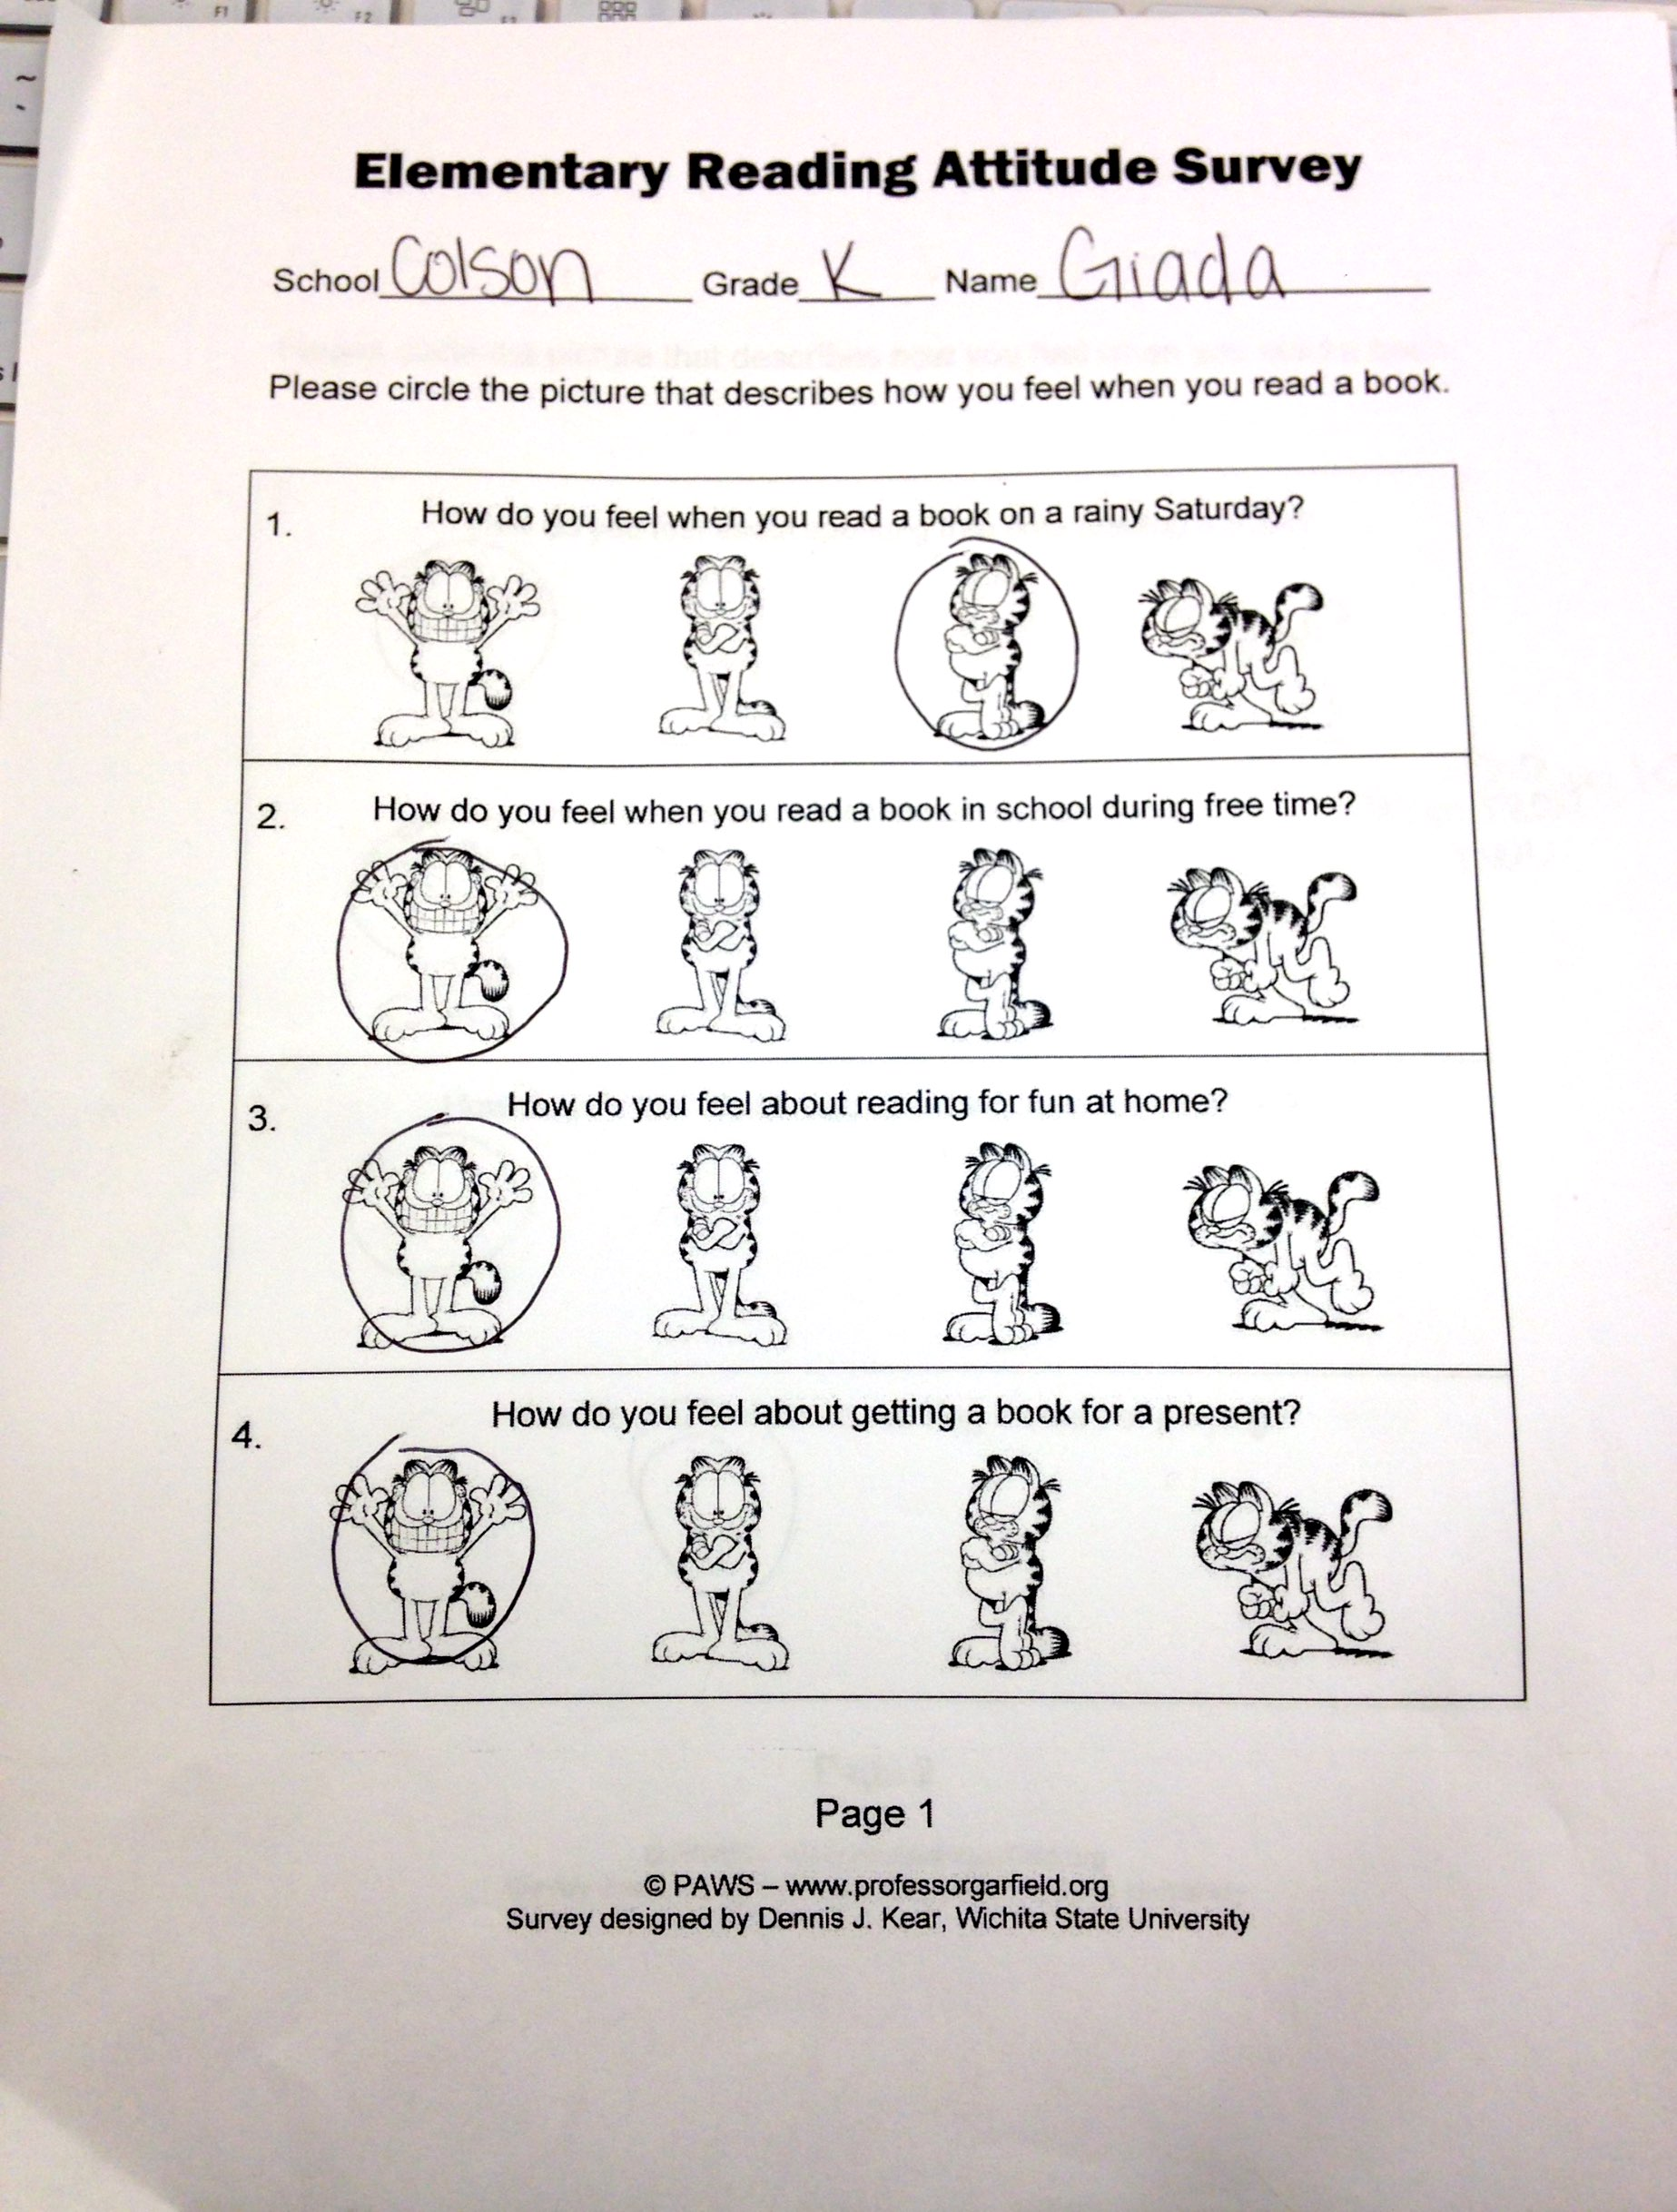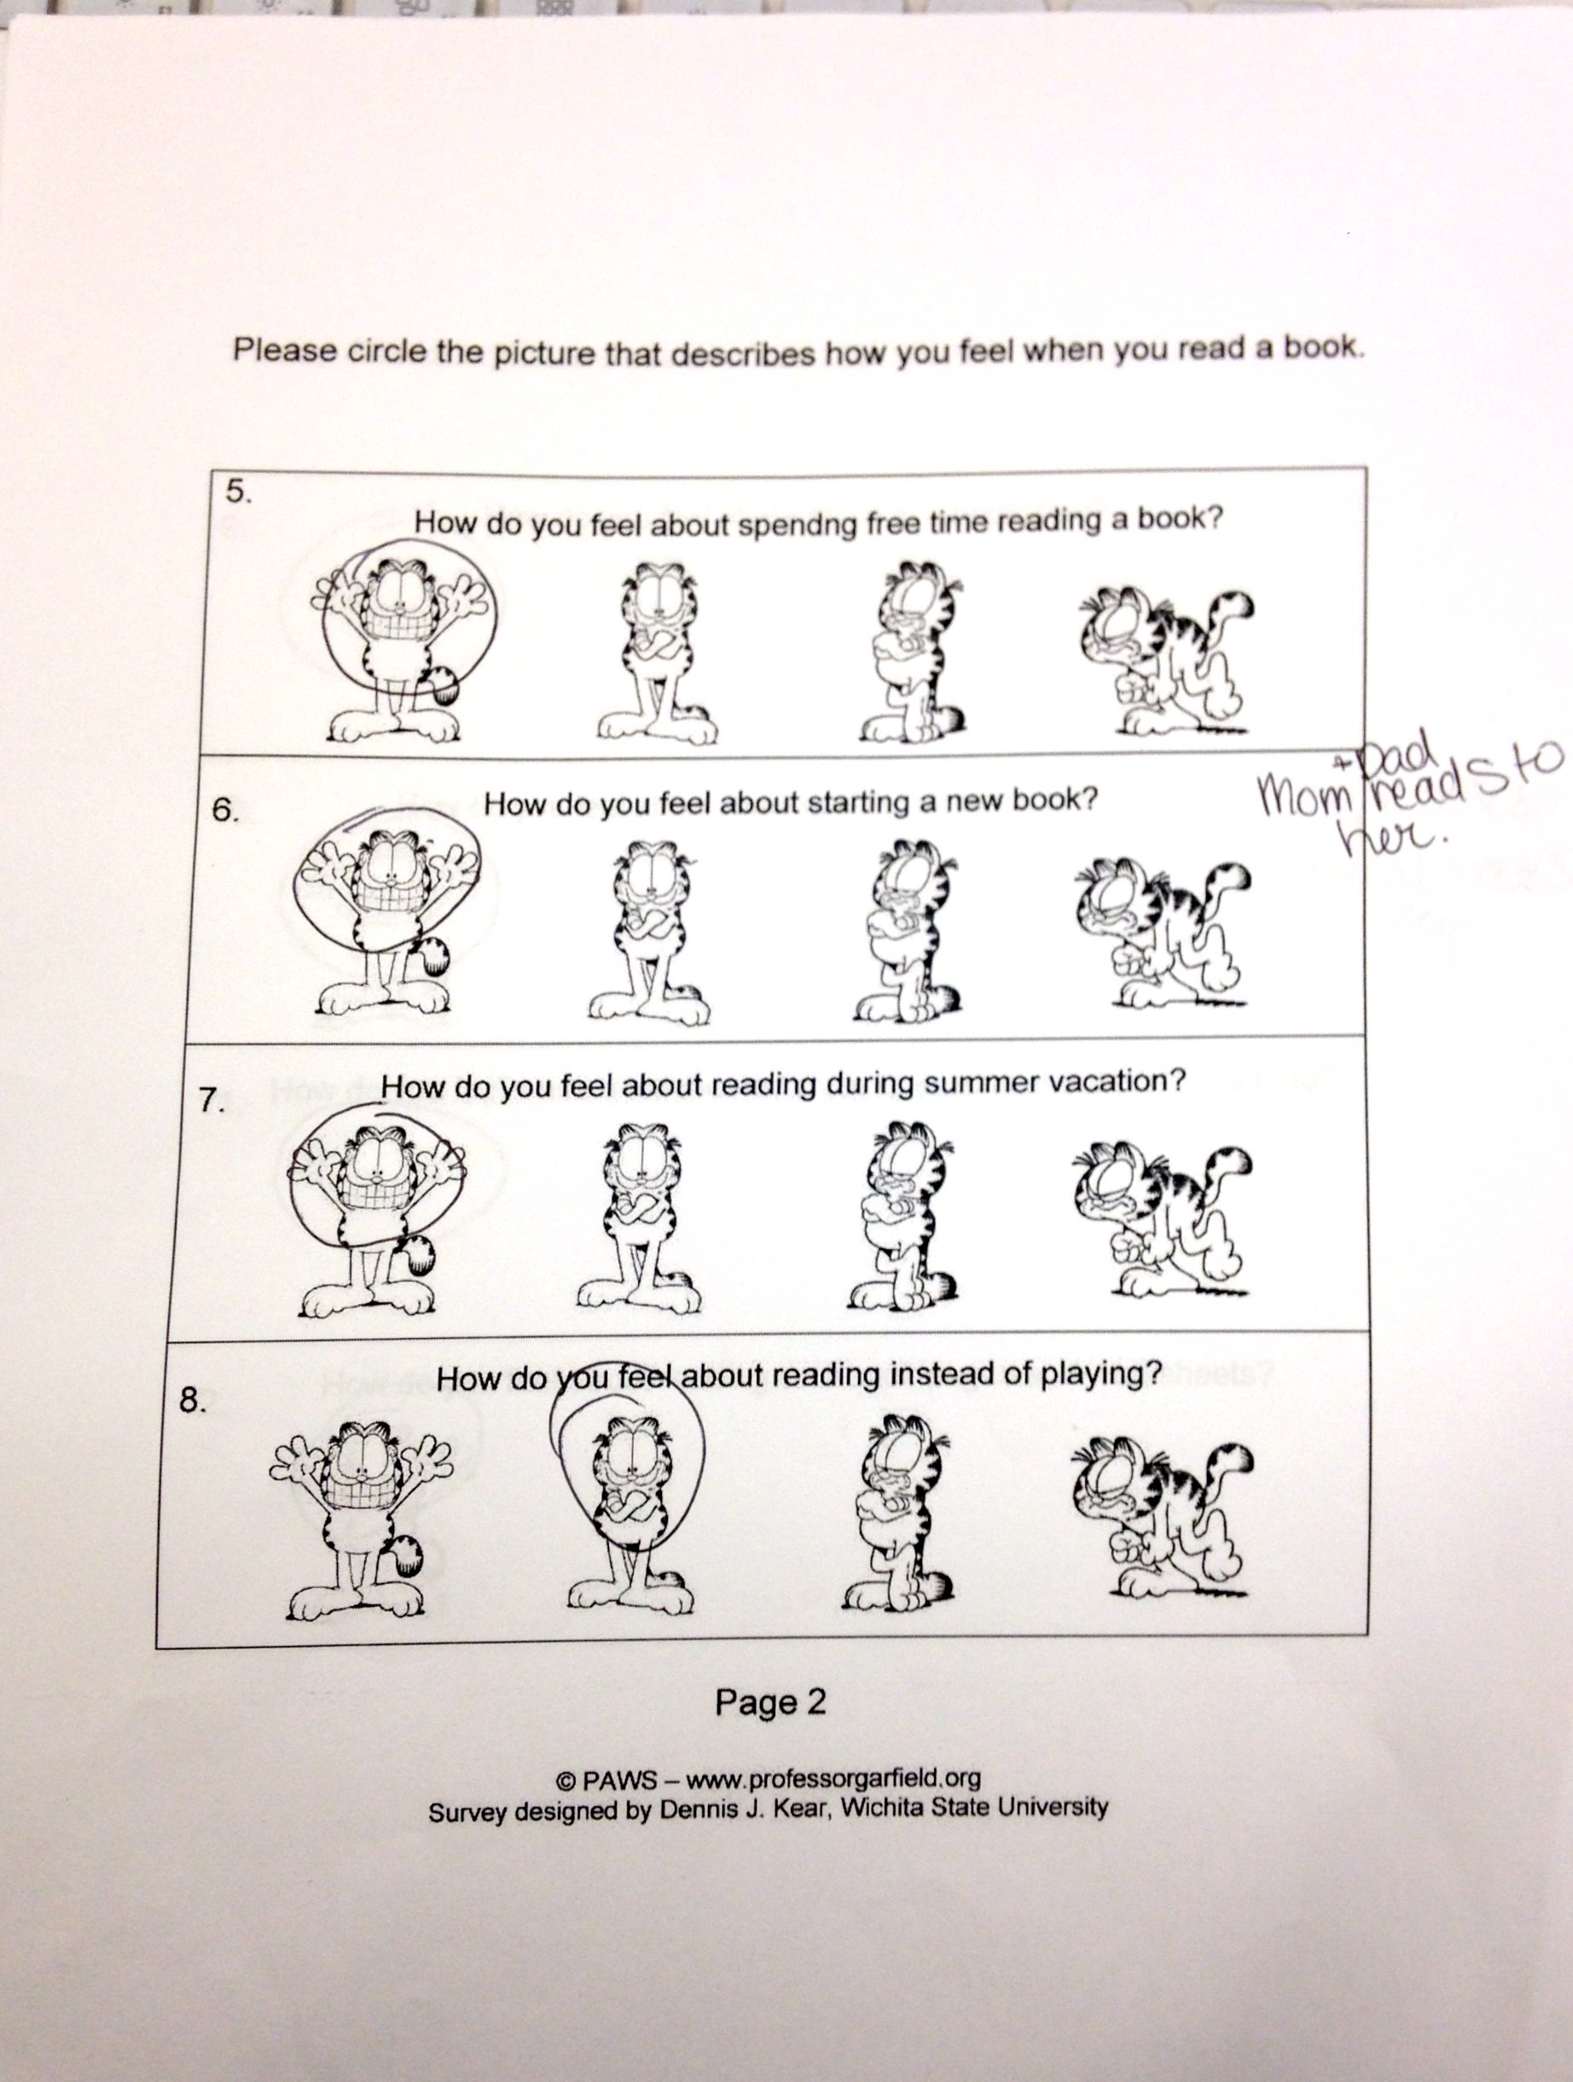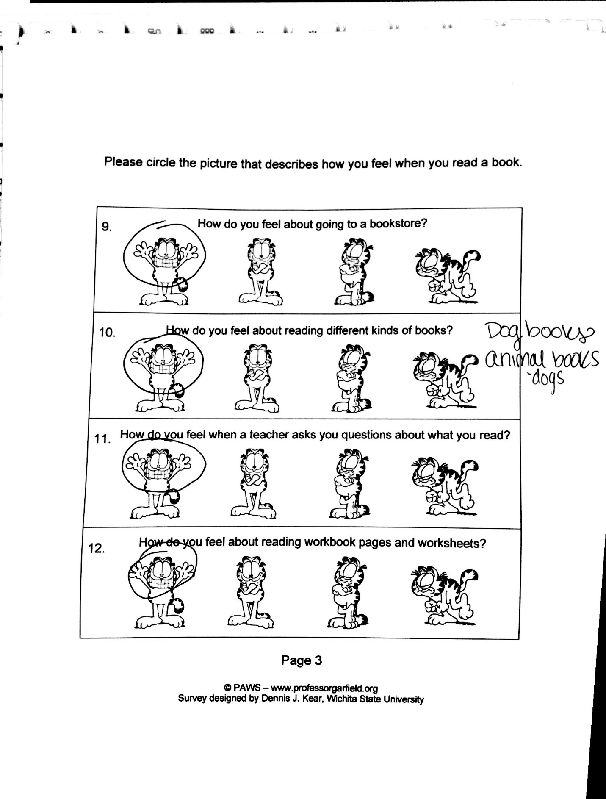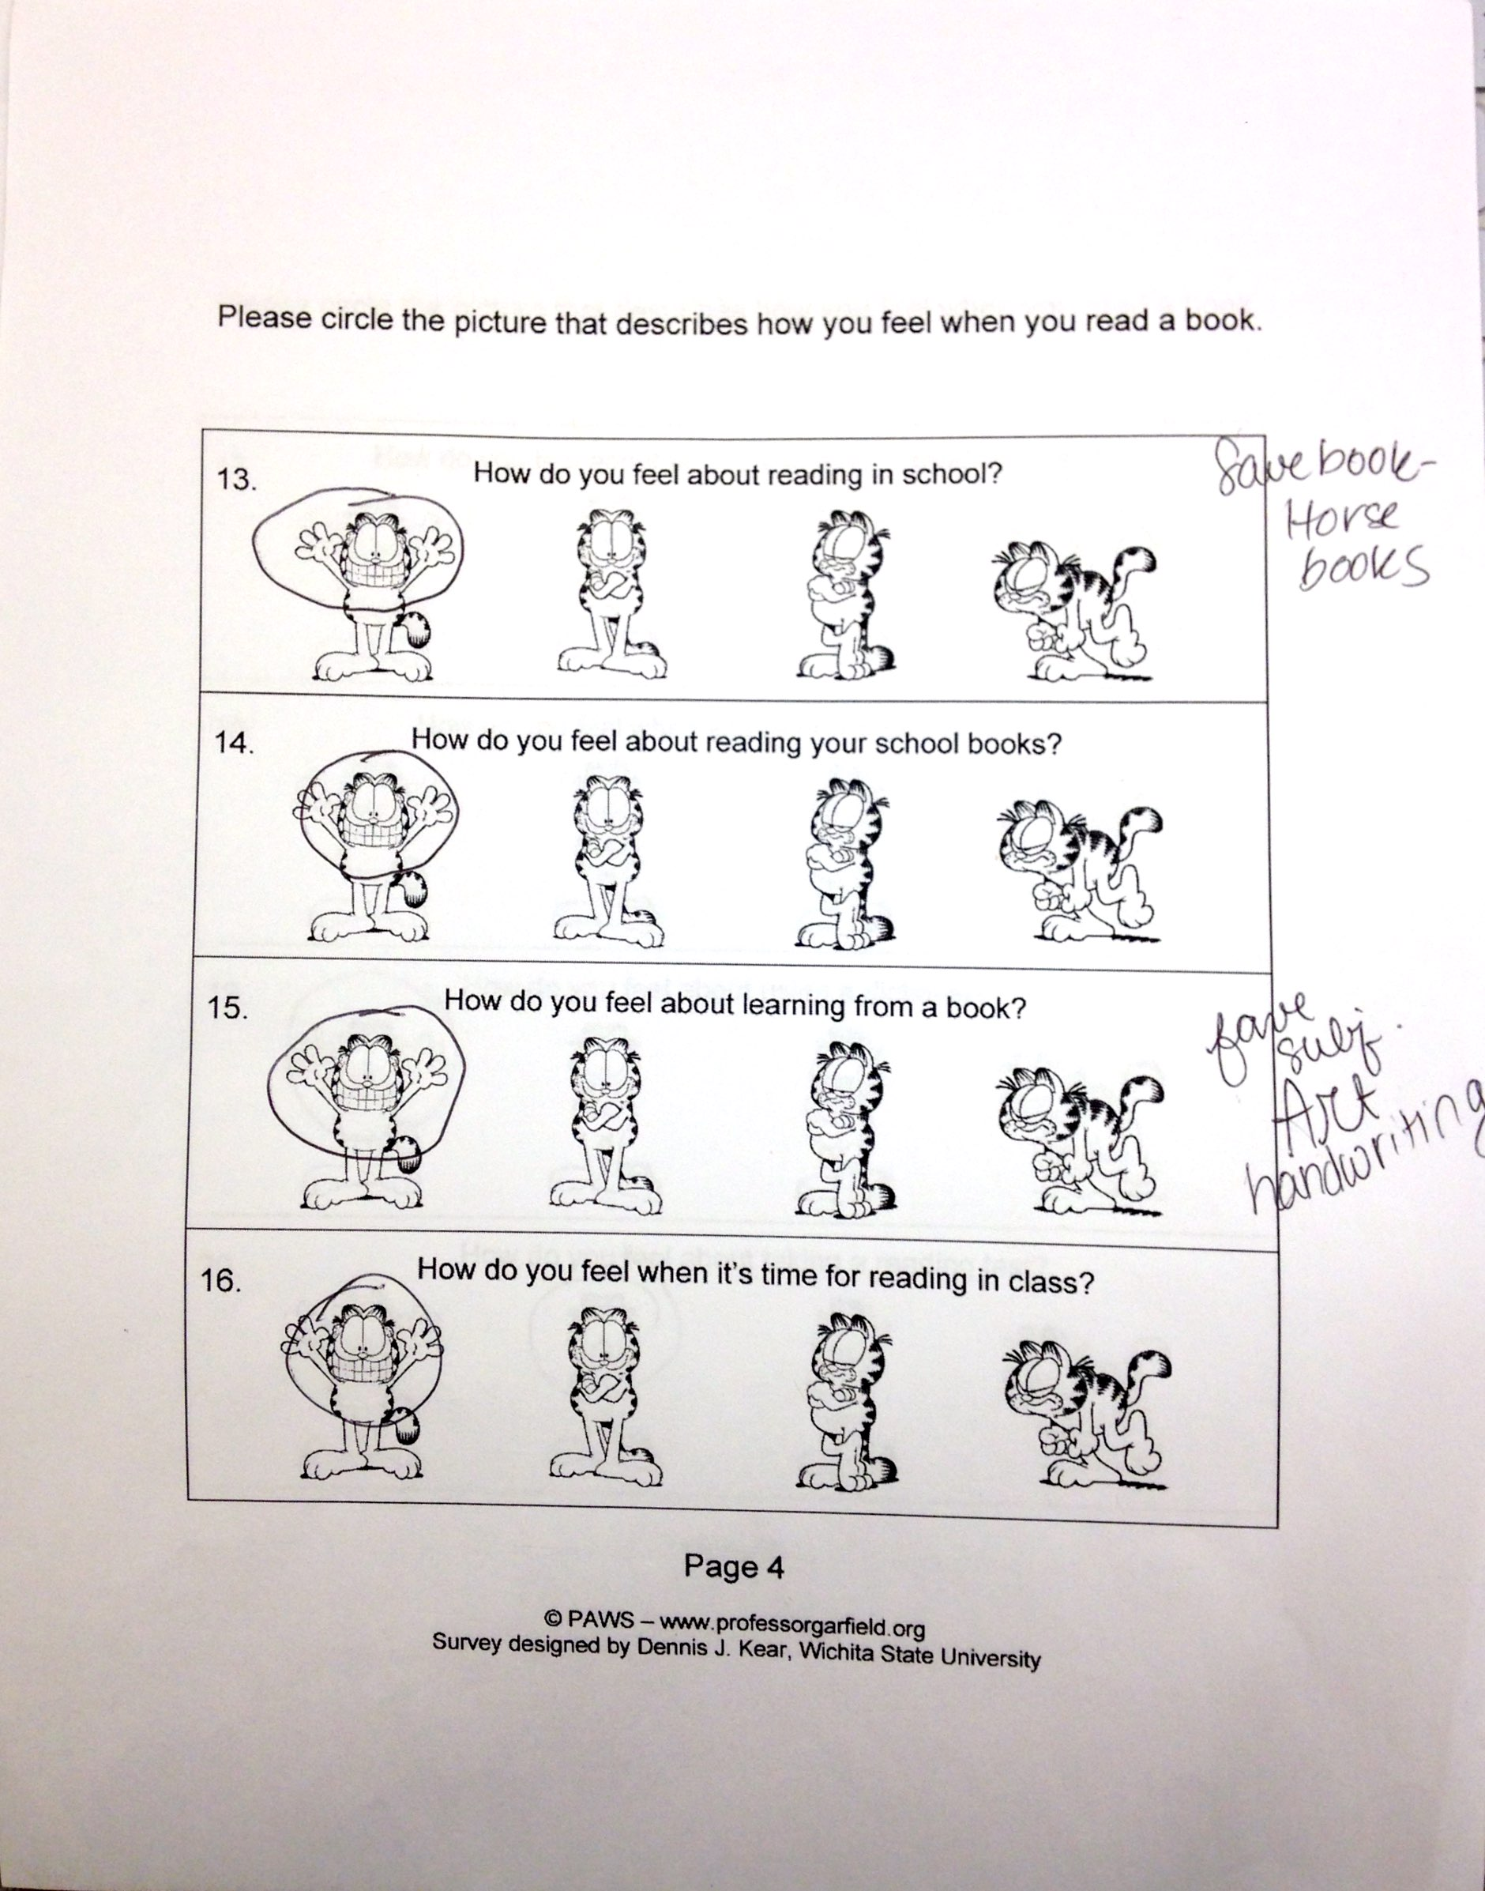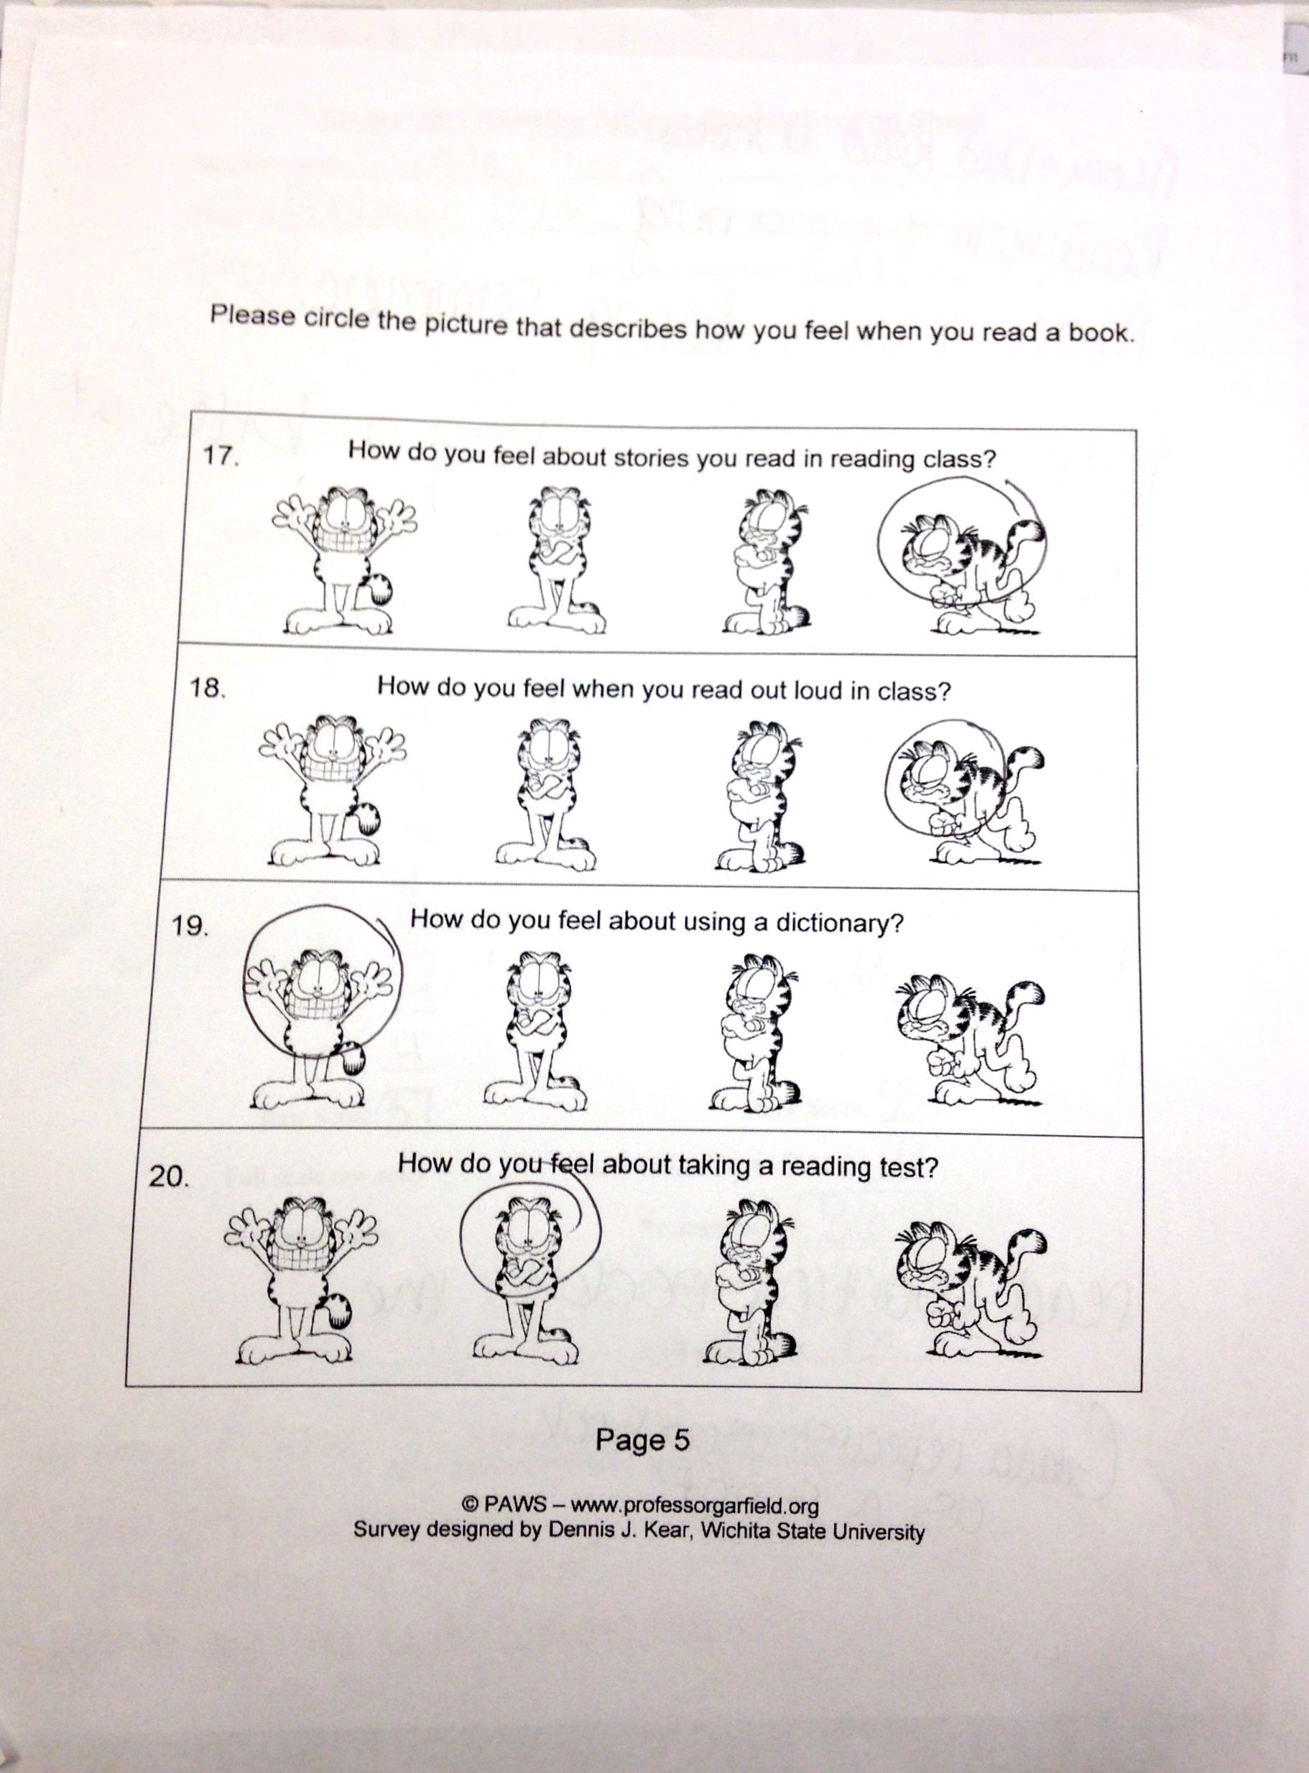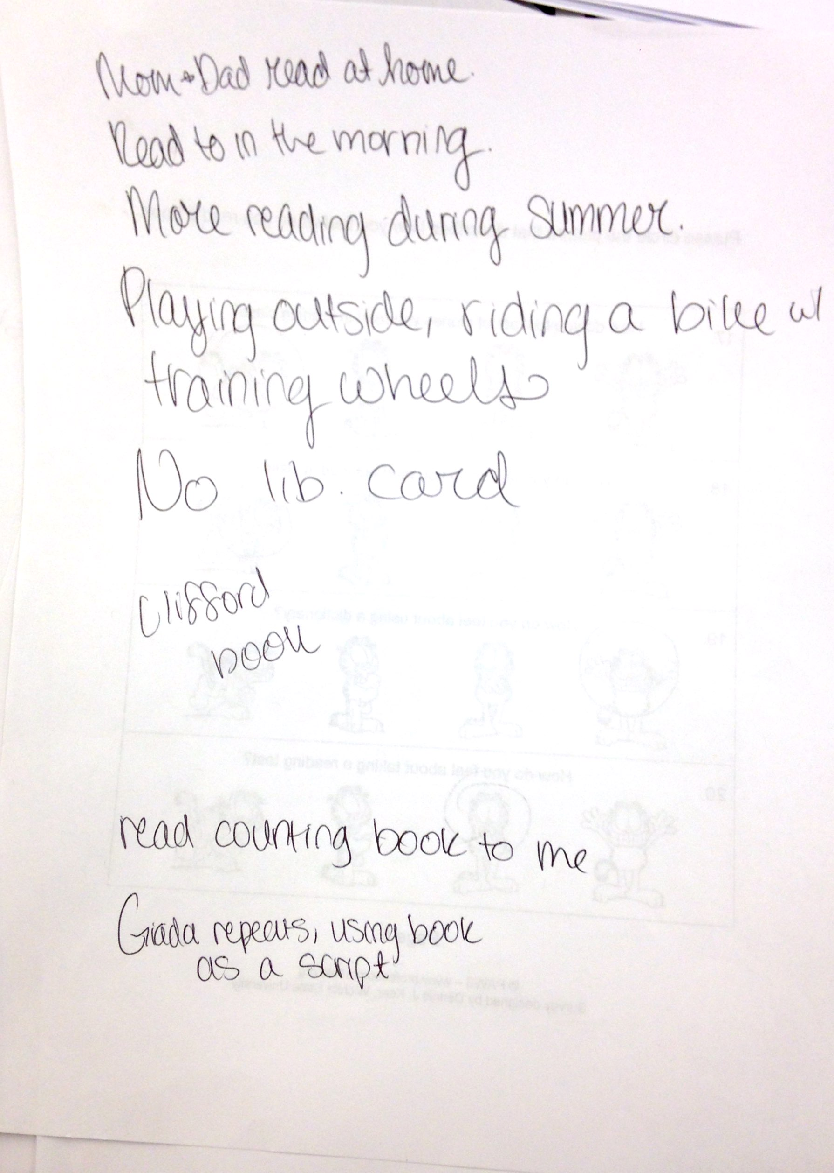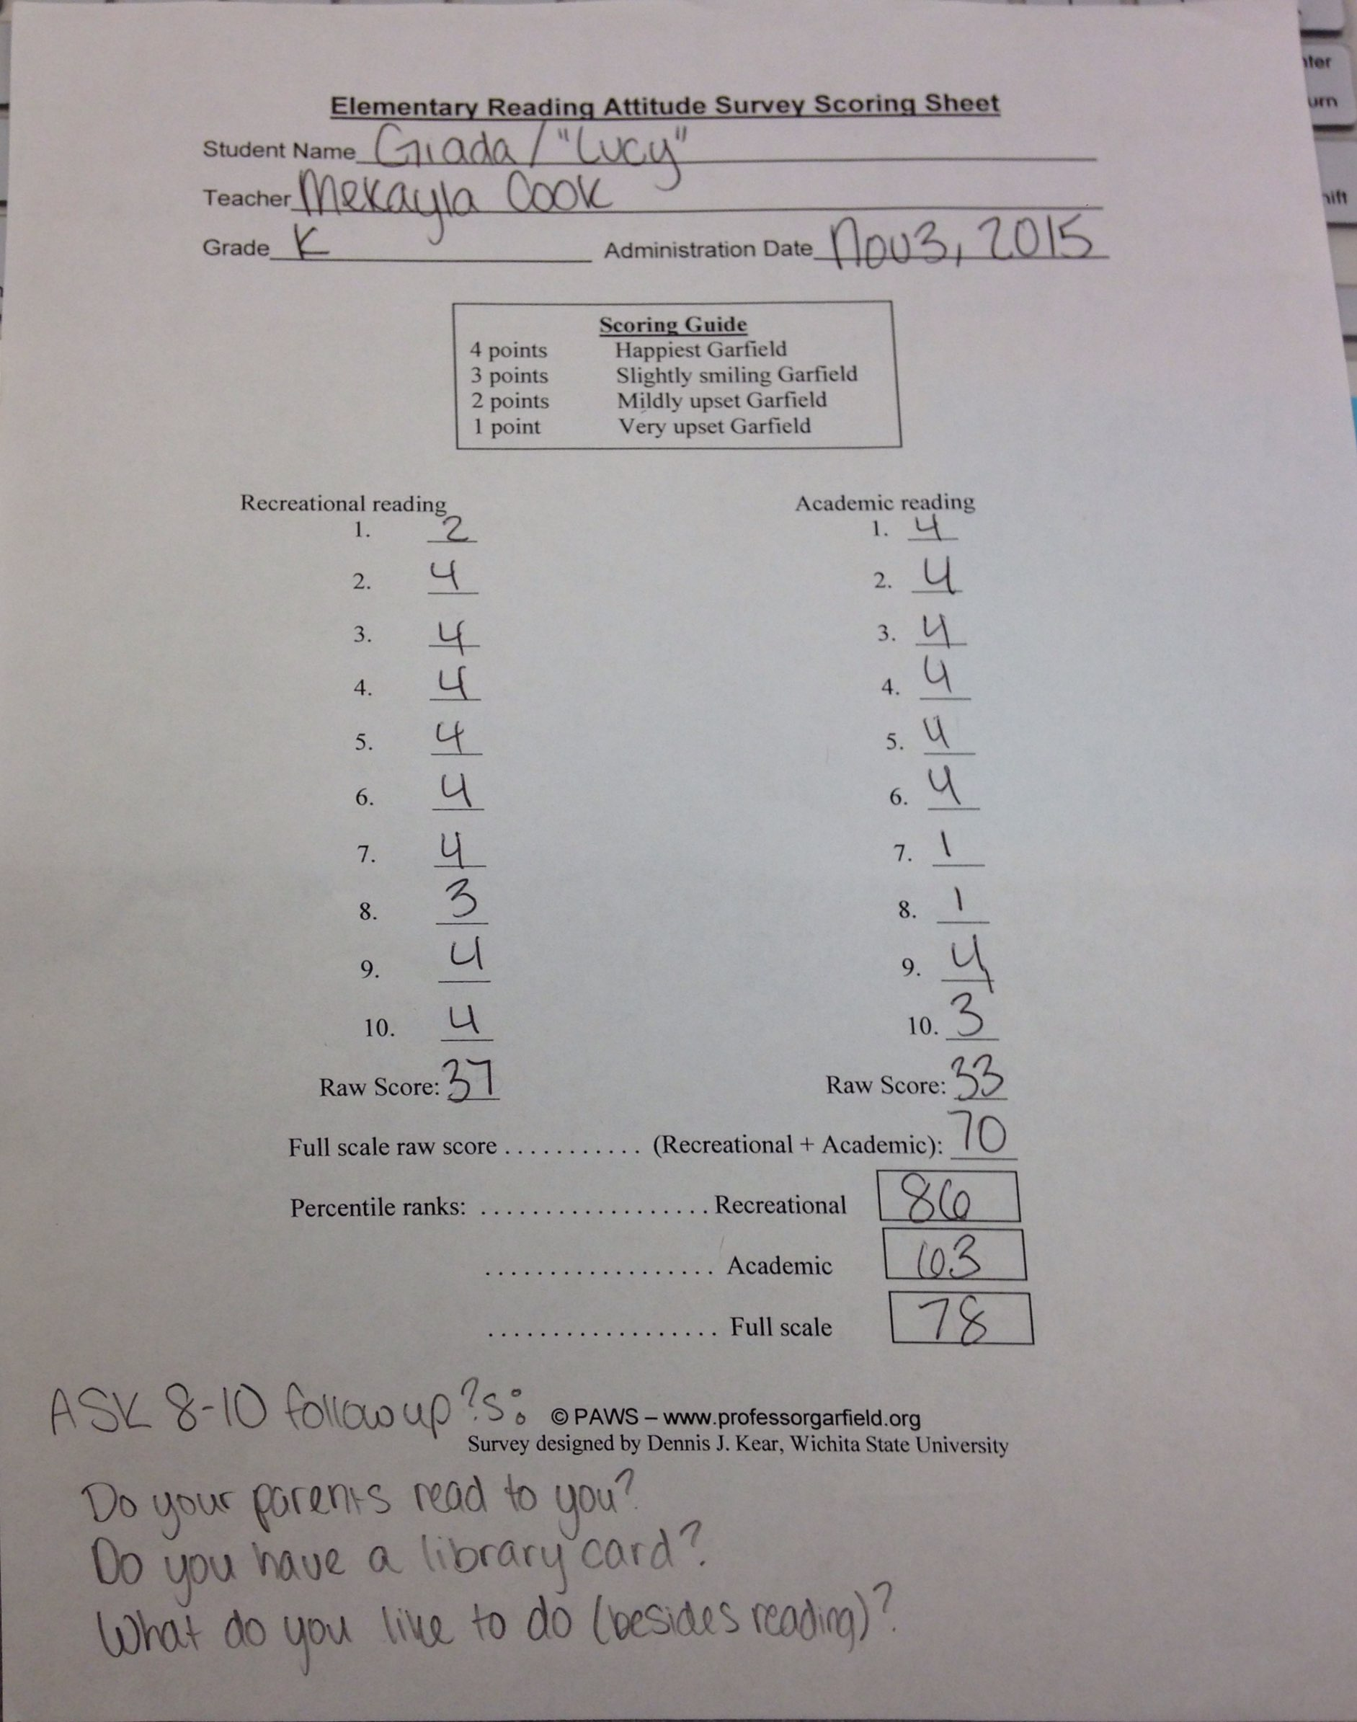

Literacy Practices
Once a week, on Thursdays, I am a part of Mrs. Smith’s classroom from 7:30am to the student’s final dismissal by 2:30pm. I have had the opportunity to observe Lucy from the second week of the school year, throughout the Fall semester. Through individual help, casual discussions, small group sessions and whole class instruction I was able to examine Lucy’s academic and social behavior. Lucy enjoys teacher read-alouds by both Mrs. Smith and I. She is attentive and engaged in the story and answering questions during read-alouds. For her independent reading, Lucy prefers to read the pictures of the Clifford the Big Red Dog series, and enjoys picking out books for her personal reading box. Lucy has not yet grasped the concept of reading because she is still early in Kindergarten, and scored low on her Kindergarten Reading Tests. Lucy scored a 50% on a concepts of print examination, she received a zero on a phonemic awareness pretest and only earned 15 of 83 potential points on a letter identification and sound assessment. Students in Mrs. Smith’s class have discussed the 3 Ways to Read: reading the pictures, retelling the story and reading the words. So far, students are demonstrating the ability to identify visual cues from illustrations. Their inferences show competency in identifying the basic factors, with imaginative plot spins that represent their innocent views of the world. Lucy has memorized the book Brown Bear, Brown Bear What Do You See? by Bill Martin Jr and Eric Carle. The class read the book as a group and then illustrated their own copies. The sound and sentence repetition allows for simple student comprehension and the ability to retell the story. Lucy is strong in her desire to read, as indicated by her Elementary Reading Attitude Survey. However, her low phonemic awareness and spelling skills indicate she has much room to improve in her cognitive recognition for reading. Also, Lucy’s speech impediment influences her reading and phonemic awareness, so through speech therapy she will be alble to achieve reading goals. Going further, I plan to integrate Lucy’s previously indicated interests in animals and Clifford while developing her literacy skills. Also, an intensive focus on letter sounds will help Lucy’s phonemic awareness skills.
Emergent Skills
The Yopp-Singer Test of Phoneme Segmentation. Phonemic awareness has been proven as a vital component to the successful acquisition of reading and spelling skills. The Yopp-Singer Test of Phoneme Segmentation assesses students’ ability to separate specific sounds of a word in order, and the test indicates students who need additional help in certain areas of reading and spelling. Identifying students early allows for intervention efforts with appropriate instructional support. The Yopp-Singer Test has been tested and approved for validity and reliability. According to the article, “A test for assessing phonemic awareness in young childen”, performance on other phonemic tests were compared, the reliability of the assessment was tested and a factor analysis was conducted to determine validity. (Yopp, 1995)To investigate student’s phonemic segmentation, a list of 22 words are utilized. Certain words are easy for students to correlate with the simple, appropriate letter sound, like dog, no and sat. Challenging words, like ice and race, are included to test student awareness.
Assessment Administration. For my administration of the Yopp-Singer Test I sat with Lucy at an isolated desk in the classroom. The test is presented as a game that takes only 5-10 minutes. Lucy was informed we’d be playing a word game, from a script included in the article. She was calm, but seemed distracted by the movements of other students as they were sent to go to the bathroom or get water. Her concentration seemed further inhibited by her frustration, as she is aware she’s not a competent speller yet. Administrator support is given by three guided examples beforehand and feedback throughout the test. I encouraged Lucy’s efforts and refocused her attention when necessary.
Results. As a result of the Yopp-Singer Test of Phoneme Segmentation, Lucy’s previous Kindergarten Reading Test scores were verified, and Lucy is identified as a young learner with minimal phonemic awareness. Lucy was unable to identify any of the 22 words’ correct phonemic segments. Her results indicate she is currently testing phonemically unaware, and will experience trouble in reading and spelling tasks. However, with proper instructional compensation she will be able to achieve phonemic awareness, contributing to her reading and spelling abilities.
Instructional Decisions. In the classroom, instruction can be altered to accommodate Lucy’s unique needs. Upon analyzation of the data provided by the Yopp-Singer test, Lucy will benefit from increased focus on letter identification and sounds. Of all readiness skills studied, letter naming has been the strongest predictor of reading success. (Bear, Invernizzi, Templeton, Johnston, 2012.) After the student can readily recognize letters, emergent learners begin to make connections between letters and sounds. A way to promote letter sound awareness for Lucy would be letter sorts. Teacher-directed sorts beginning with letter sounds like “M”, “S” and “F” will benefit students as they begin to develop phonemic awareness of initial consonant sounds. (Bear, Invernizzi, Templeton, Johnston, 2012.) In the process of spelling and reading acquisition, special attention should be given to the concept of individual phonemes. Research states that rhyme awareness activities offer an easy, natural way for children to focus on speech sounds. (Bear, Invernizzi, Templeton, Johnston, 2012.) By incorporating songs, jingles, nursery rhymes and stories into the curriculum children like Lucy will be able to focus on the sounds of language. Specifically, songs full of rhythm and rhyme by songwriter Raffi, like “Willoughby Wallaby Woo”, are easily incorporated into the classroom and encourage language play. (Bear, Invernizzi, Templeton, Johnston, 2012.) Also, read-aloud books emphasize speech sounds through rhyme, alliteration and assonance. Effective teachers make read-alouds a daily event, as they have been shown to be one of the major motivators for children’s desire to read. (Cunningham, Allington, 2015.) With whole class read-alouds, children are entranced in literature and given the opportunity to recognize phonemic segments by teacher modeling. Phonemic awareness is not best developed in isolation, as it is a skill that evolves naturally with literacy fluency.
Reflection. The Yopp-Singer Test of Phoneme Segmentation brought insight to Lucy’s current literacy position. She has much room to improve, but with the help of this tool it is possible to accommodate instruction accordingly. Furthermore, the assessment revealed the severity of Lucy’s speech impediment. The way she pronounces phonemes are not congruent with what she’s hearing and she may not grasp that abstract concept. With improvement in her speech disorder through intensive group therapy, her phonemic awareness should be positively impacted. A focus on specific letter sounds will also benefit Lucy’s learning process in her acquisition of reading and spelling skills. From my experience, I realized the importance of a concept I had taken for granted. Since I can remember I have been able to accurately pronounce phonemic segments, but I realize now that children are taught phonemic awareness. The importance of such skills are vital to young learner’s development of reading and spelling accuracy. Also, I realized the importance of maintaining children’s focus while testing and minimizing background distractions.
Word Study
Explanation and Description of Spelling Inventory. Investigating a child’s spelling gives instructors insight to the student’s word knowledge. Spelling inventories consist of lists of words chosen to represent a variety of spelling patterns at increasing levels of difficulty. Spelling inventories measure key orthographic features for identifying a stage of spelling and relate to instructional planning. The Primary Spelling Inventory is used to assess kindergarten through third graders in the emergent to late letter name stages. The Elementary Spelling Inventory can be utilized in first through sixth grades that fall in the letter name to early derivational relation stages. Finally, the Upper Level Spelling Inventory for students in grades fifth through twelfth marks the within word pattern to derivational relations stages. Results are scored and analyzed by individual orthographic features that are scored separately for each word. As a result, qualitative information on specific spelling features is provided to establish what students know and need to study next. (Bear, Invernizzi, Templeton, Johnston, 2012.)
Overview of Assessment Administration. I administered the Primary Spelling Inventory to Lucy in the classroom. We sat at a table in the back of the room for privacy. I selected the inventory based off her grade level, kindergarten, and her achievement thus far. Each word on the list was read at least two times to Lucy, beginning with “fan”. Since the student is only a kindergartener and could not yet write every letter, I gave her printed and cut out Scrabble Cheez-Its to arrange the letters for her spelling. Also, she responded orally to ensure that the right letters were chosen. Lucy’s endurance for testing had not yet been established, and she tired quickly. Her frustration was evident, so after the initial five words were misspelled I stopped administering the spelling inventory.
Summary of Results. Lucy’s power score, or the number of entire words spelled correctly during the spelling inventory, totaled to zero of twenty-six. Of fifty-six potential feature points, Lucy was able to gain none. In total, she scored a zero. This places her in the emergent stage of spelling. In response to the data collected, Lucy will need intensive practice in letter identification and corresponding sounds, as well as further phonemic awareness development.
Instructional Decisions. Upon examination of Lucy’s scores, it is evident that she needs additional instruction in alphabetical knowledge. Identifying letters, as well as recognizing the corresponding sounds will increase her ability to spell. Playing games, like Initial Sound Bingo will help the learner discriminate initial letter sounds. Within a small group of peers in the emergent stage, the students will draw a card with a picture of a familiar noun. Then the learners will mark the corresponding square with the initial letter. (Bear, Invernizzi, Templeton, Johnston, 2012.) Also, developing the student’s phonemic awareness is an important step in moving forward. Working on her phonics skills, by fostering her ability to divide oral speech into the smallest units of sound will correlate with letter-sound recognition to encourage Lucy’s spelling development. Up to eight beginning letter sounds can be reviewed at a time to encourage phonemic awareness in the Letter Spin for Sounds game. A spinner with letters and picture cards encourage students to play with peers while collecting cards with items that begin with the letter they spun on. (Bear, Invernizzi, Templeton, Johnston, 2012.)
Reflection. This assessment further clarified Lucy’s need for intensive focus in the classroom. Also, the Primary Spelling Inventory labeled Lucy as an emergent speller. After the spelling inventory I am better able to focus on alphabetic knowledge development with the student and phonemic awareness study, and I am aware of goals to work toward in spelling. Administering the assessment offered great insight to the use of spelling inventories in the classroom. I believe they are a great way to initially assess whole classes at any grade level. After the assessment, more individualized word sorts and spelling lists can be provided to help students’ academic growth. I will be utilizing Primary and Elementary spelling inventories in my future classrooms.
Vocabulary
Explanation of Description of CORE Vocabulary Screening. The CORE Vocabulary Screening measures how well students know the meaning of grade-level words they read silently. The 10 to 20 minute assessment is intended for student in first through eighth grade. The students read a word and then choose a word with the same meaning (synonymous) from three additional words. The original word typically appears in literature and instructional text for their given grade. The synonymous or near-synonymous words come from a lower grade’s typical vocabulary. The screening measures pure vocabulary knowledge with no reliance on text comprehension or context clues. Comprehension relies on decoding skills as well as adequate vocabulary knowledge. The CORE Vocabulary Screening can identify students whose vocabulary level is lower than what’s expected amongst their peers. Two forms are provided, A and B, suggested for use as pre- and post-tests or progress monitoring.
Overview of Assessment Administration. For this assessment, I brought my focus student outdoors. Away from the noisy distractions of the classroom, we sat on a bench in the courtyard and enjoyed the nice day. Lucy seemed much more settled and focused once she adjusted to her new surroundings. I accommodated to Lucy’s reading level, as she is only in kindergarten so this screening would not generally be administered to her. I read the original word aloud from the 1st grade form, repeated it and then read her the three options for synonyms. According to her response, I circled the word she chose. For the second round of assessment, done later in the day, the student and I were in the classroom. We were at a separate desk for privacy, but still within range of the other students.
Summary of Results. Students who score at an Intensive level on the vocabulary assessment scored 49% or less correct word choices. Intensive level students may have difficulty reading grade-level material as a result of insufficient prior vocabularies. Students who score between 50% and 74% correct may experience some difficulty with grade-level material. Learners at the Benchmark level identified 75% or more correct and have adequate vocabulary knowledge for typical reading. On form 1A of the CORE Vocabulary Screening, Lucy correctly identified 36 of 45 synonymous pairs. From this initial screening, Lucy scored at a benchmark level. She was able to correctly identify 80% of synonymous words. On form 1B of the screening, Lucy was able to claim 29 correct matches of 45 potential word pairings, a 64% accuracy. This form identified her at a Strategic performance level.
Instructional Decisions. Most vocabulary development occurs incidentally through oral interactions and reading of text with a rich vocabulary. As part of encouraging further vocabulary development for Lucy, I believe a Buddy Reading system would be of great benefit. Research “findings suggest that buddy reading as a classroom tool can effectively promote literacy and learning in a cooperative setting.” (Flint, 2010.) Pairing Lucy, and other emergent readers with nearly adequate vocabulary knowledge, with upper-level students will result in a symbiotic relationship in which both students’ reading levels will benefit. For Buddy Reading, older students would read and discuss books with the younger learners. Hearing grade-level or higher text read aloud can contribute to vocabulary acquisition. This oral interaction and reading amongst learners will further develop Lucy’s vocabulary knowledge. Additionally, direct instruction and practice can heighten student’s ability to understand word meanings. Research claims that we learn best by real, direct experience with whatever we are learning. (Cunningham, Allington, 2015.) As suggested by Patricia Cunningham and Richard Allington, teaching vocabulary with tangible representations will offer experiences with words that students will engage in. In the classroom, I plan to introduce Lucy to objects she may not have named before, like the hinges and knobs of doors. Finding real life connections in student’s environments for new words will also help their development. Building vocabulary through casual conversation and gameplay with words relevant to the student’s life will ensure learning.
Reflection. I was pleasantly surprised by Lucy’s results on the CORE Vocabulary Screening. This is the highest she has scored on any assessment thus far in my experience with her. From the results of this test, I have concluded that she is extremely academically competent, but is held back by her speech impediment and limited phonemic awareness. It is encouraging to see her success. Also, it is clear that performing assessments separate from the distracting classroom benefits her ability. Moving forward, I hope to perform all assessments outdoors (if the class structure allows it). In giving this assessment, I have recognized the importance of finding student’s strengths. Also, it has revealed to me the reward of encouraging and perseverance while working with low-achieving students. When assessing my students, I hope to provide them with the appropriate situation that maximizes their ability to focus and demonstrate the best of their knowledge.

Reflection
Prior to developing this focused literacy portfolio, I had little understanding of Lucy as a student or her initial literacy skills. Through the various assessments I have grasped a better understanding of Lucy’s general literacy skills including her attitude toward reading, phonemic awareness, spelling ability and vocabulary knowledge. Upon administration of the tests, survey and screening, I was able to consider which strategies of differentiation can benefit learners like Lucy during testing. Following analyzation of her performance, I was able to devise an educational plan to benefit her learning. In constructing these tactics, I realized the value in scholarly written articles and research when planning individualized instruction. With application of the theorized plans, Lucy’s response and development has been investigated. To promote Lucy’s learning, a focus on language acquisition should be placed. As a classroom teacher, I would utilize songs that emphasize rhyme, repetition and expressive intonation. Also, the student would benefit from vocabulary expansion and plenty of opportunities to read and write. In order to continue Lucy’s learning gains, I believe involving the student in her own development could be beneficial. By setting goals that Lucy agrees upon and is aware of, she will have the opportunity to be actively involved in her learning process. She shows remarkable responsibility orientation in her behavior, so I believe Lucy would enjoy the opportunity to be conscious of what she is to learn. In Lucy’s current classroom, her lack of placement in the group speech therapy with a speech pathologist is greatly hindering her academic development. Other students in the class work with a specialist daily, but Lucy’s paperwork to be involved in speech therapy has been a slow, discouraging process. Lucy socializes well with her peers and I believe that works to her advantage. My corresponding teacher is starting to dedicate time to the Daily 5 regimen of literacy and I believe Lucy will profit from the reading practice and option of choice in her own learning. I hope to continue my work with Lucy in order to become a helpful factor in her journey toward academic success.

References

Bear, D., Invernizzi, M., Templeton, S., & Johnston, F. (2012). Word Study for Phonics, Vocabulary, and Spelling Instruction (5th ed.). Boston: Pearson/Allyn and Bacon.

Burningham, L. & Dever, M. T. (2005) An interactive model to foster family Literacy. Young Children, 60(5), 87-94.

Chawla, L. (2015). Benefits of Nature Contact for Children. Journal of Planning Literature. Retrieved September 22, 2015, from http://jpl.sagepub.com.ezproxy.lib.usf.edu/content/early/2015/07/19/0885412215595441.full.pdf html

Cunningham, P., & Allington, R. (2015). Classrooms That Work They Can All Read and Write (6th ed.). Boston: Pearson.

Dunn, R. (1987) Research on instructional environments: Implications for student achievement and attitudes. Professional School Psychology, Vol 2(1), 1987, 43-52. Retrieved September 22, 2015, from http://dx.doi.org/10.1037/h0090528

Elliot W. Eisner (1998) Does Experience in the Arts Boost Academic Achievement?, Arts Education Policy Review, 100:1, 32-40, DOI: 10.1080/10632919809599448

Flint, T. (2010). Making Meaning Together: Buddy Reading in a First Grade Classroom. Early Childhood Education Journal, 38(4), 289-297. doi:10.1007/s10643-010-0418-9

Jordan, G., Snow, C., & Porche, M. (2011). Project EASE: The Effect of a Family Literacy Project on Kindergarten Students' Early Literacy Skills. Reading Research Quarterly, 35(4), 524-546. Retrieved September 22, 2015, from http://onlinelibrary.wiley.com.ezproxy.lib.usf.edu/doi/10.1598/RRQ.35.4.5/abstract

McLaughlin, J. (1990). Building a Case for Arts Education: An Annotated Bibliography of Major Research.
` Yopp, H. (1995). A Test for Assessing Phonemic Awareness in Young Children. The Reading Teacher SELECTIONS, 20-29.

