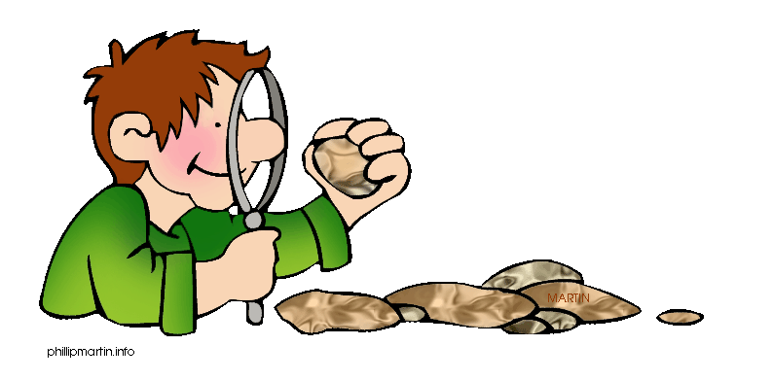
“Rock Hound”: _________________________________________ Date: _______________________
Mining for New Words: A Rocks & Minerals Vocabulary Test
Circle the letter of the best answer.
1. What is “a place where people establish a community,”?
a. Settlement
b. Property
c. Formation
d. Collection
2. Which of the following is NOT a property?
a. Hardness
b. Luster
c. Streak
d. Granite
3. Which of the following is NOT a synonym for stampede?
a. Charge
b. Standing
c. Panic
d. Rush
For questions 4-6, choose the word that best completes the sentence.
4. “While other rocks form the mountains washed towards the sea, gold _________ in California’s streams.”
a. Settlement
b. Formation
c. Collected
d. Luster Continue on back.
5. ________ is an igneous rock that forms below ground.
a. Miner
b. Stampede
c. Mineral
d. Granite
6. The _________ process for metamorphic rock involves high heat and great pressure that changes the texture of the rock.
a. Formation
b. Settlement
c. Properties
d. Collected
Complete numbers 7-10 by filling in the sentence with the best word from the Word Bank.
Word Bank
Luster Minerals Miners Properties

7. Gold seekers like “the 49er’s” were .
8. The of a rock depend on the mineral that makes up the rock.
9. Gold has a metallic , which is shiny and reflects light.
10. can be found in soil, rocks, and water.

Mining for New Words: A Rocks and Minerals Vocabulary Test
Answers:
1. A  2. D  3. B  4. C  5. D | 6. A  7. miners  8. properties  9. luster  10. minerals

Morning Class
Student | Score | Student | Score

Afternoon Class
Student | Score | Student | Score

