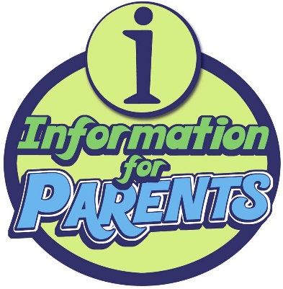
Dear Parent/Guardian,
Thank you for taking an active interest in your student’s education. Without your cooperation, your child would not be able to meet their academic goals and the requirements set by our Common Core standards for 3rd grade. It is my (Miss Cook, your student’s writing teacher) pleasure to work alongside you, your family and your child’s support network to ensure academic, personal and social success for your young learner.
Students will be developing their writing skills in the upcoming unit. My goal for this unit is to provide students with the skills they will need to write and discuss to compare nonfiction and fable texts on the same topic. Through an examination of animals in fables vs. reality (by considering research from nonfiction texts), students will be addressing the following writing standards while participating in discussions, writing and comparing texts:
LAFS.3.SL.1.2 Determine the main ideas and supporting details of a text read aloud or information presented in diverse media and formats, including visually, quantitatively, and orally.
LAFS.3.RI.3.9 Compare and contrast the most important points and key details presented in two texts on the same topic.
LAFS.3.S.L.1.1a-d Engage effectively in a range of collaborative discussions (one-on-one, in groups, and teacher-led) with diverse partners on grade 3 topics and texts, building on others’ ideas and expressing their own clearly.
I have worked in collaboration with your learner’s reading teacher to ensure that students will be making connections between their studies. Lessons during the next unit include an integration of interactive technology, as well as using art to exhibit understanding. I cannot stress enough the importance of the arts in education! Also, I am lucky to be working in a school that provides access to the technology tools we need to prepare students for participation in our technology-centered world.
This upcoming unit for Writing includes a Performance Task instead of a unit exam. I am excited about this option for students’ demonstration of their knowledge! Instead of a multiple choice exam, the students will be writing a newspaper article and contributing to an online class newspaper. (Don’t worry, there will be computer lab time for students who do not have computers/internet access at home.) A handout will be given to your student and e-mailed to my Parent Contacts (A form is available at the bottom of this letter if you would like to join) prior to beginning the Performance Task that will give further details. The Performance Task addresses the following Common Core Standards for 3rd grade writing:
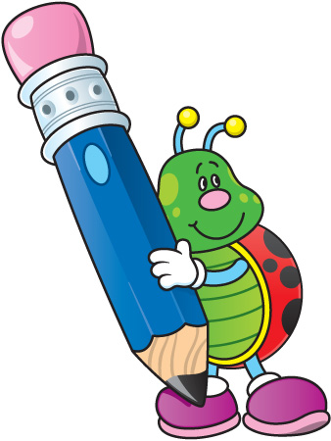
CCSS.ELA-LITERACY.W.3.2
Write informative/explanatory texts to examine a topic and convey ideas and information clearly.
CCSS.ELA-LITERACY.W.3.2.A
Introduce a topic and group related information together; include illustrations when useful to aiding comprehension.
CCSS.ELA-LITERACY.W.3.2.B
Develop the topic with facts, definitions, and details.
CCSS.ELA-LITERACY.W.3.7
Conduct short research projects that build knowledge about a topic.
CCSS.ELA-LITERACY.W.3.8
Recall information from experiences or gather information from print and digital sources; take brief notes on sources and sort evidence into provided categories.
CCSS.ELA-LITERACY.W.3.6
With guidance and support from adults, use technology to produce and publish writing (using keyboarding skills) as well as to interact and collaborate with others.

Thank you again for your involvement! I am blessed to be working with the bright 3rd graders in my classroom. Please do not hesitate to contact me with any questions, comments or suggestions.

______________________________________________
Miss Cook
mekayla.cook@mail.usf.edu
(xxx) xxx-xxxx

Join the Parent Contacts List!

By providing the following information, I am able to send you digital copies of newsletters, assignments and important school information. Your cooperation and collaboration will ensure that your student is on the path to academic success! Please have your young learner return this slip to Miss. Cook. Thank you in advance!

Your Name: ________________________________________

Student’s Name: ________________________________________

Phone Number: ________________________________________
Best hours to contact you: ____________________________

E-Mail Address: ______________________________________________________

