Name: _________________________
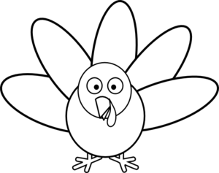
“If my turkey could talk . . .”

Who’s there? | What’re they eating? (Besides me!)
Where?
What happens during dinner? | What happens after dinner?
CHECKLIST/Be sure to include…
Dialogue | 3/+ Paragraphs | 5/+ sentences | The turkey’s P.O.V. | Transition Words

