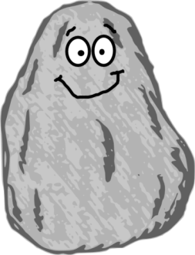
Name of Geologist: _______________________________
Date: _______________________
A Geologist’s Vocabulary

1. What does a geologist study?
_________________________________________________________________________________________
Circle the answer to choose the word(s) that best complete the sentence.
2. Erosion is the wearing away of sand, soil, or rock by _____ or______.
a. water, wind
b. people, animals
c. heat, cold
d. volcano, magma
3. Intrusive rocks form ____________ the earth’s crust, where crystals are _________.
a. as, medium-sized
b. above, smaller
c. over, non-existent
d. below, larger
4. Rocks that form ____________ the earth’s crust are extrusive rocks and have crystals that are _________.
a. as, medium-sized
b. above, smaller
c. over, non-existent
d. below, larger

Continue on back side of paper.
5. The remains or impression of a once-living animal or plant in rock is a _______________.
a. inference
b. fossil
c. crust
d. magma
Read the paragraph below to answer #6.
The students in room 116 wrote amazing essays! Mrs. Donnelly and Miss. Cook had been teaching proper conventions for weeks. The young geniuses’ papers had perfect punctuation, flawless capitalization and excellent spelling. Mrs. Donnelly and Miss. Cook smiled as they gave the students their papers back, they were able to give the students full credit for their conventions.
6. Which of the following is an inference from reading the paragraph above?
a. The students got full credit for conventions on their papers.
b. The students wrote about rocks and minerals.
c. Mrs. Donnelly and Miss. Cook were proud of the students.
d. Mrs. Donnelly and Miss. Cook were upset at the students.
Fill in the sentence in #7 with these 3 words: volcano, crust, magma
7. ______________________ is a hot fluid below or within the earth's ________________________ from which lava and other igneous rock is formed by cooling, usually coming out from the top of a __________________________.
Choose the best answer for #8.
8. What are advertisements used for?
a. To sell a product
b. To fix a problem
c. To find a location
d. To change an issue

A Geologist’s Vocabulary
2/3/2017
Answer Key-
1. what the earth is made of/how its formed, rocks/minerals  2. a  3. d  4. b | 5. b  6. c  7. magma, crust, volcano  8. a
Morning Class
Student | Score | Student | Score

Afternoon Class
Student | Score | Student | Score

